



**Teaching Methods Series**

**Part 2. Methodology of Teaching Business Intelligence**

**Mieczysław L. Owoc, Zdzisław Pólkowski (eds.)**

***In collaboration with:***

***Julian Vasilev***

***Ivan Kuyumdzhiev***

***Krzysztof Hauke***

***Artur Kotwica***

***Maciej Pondel***

***Katarzyna Marciniak***

***Andriy Debrivskyy***



Technical Support: **Diana Niti, NicoletaMarambei, Florian Chitu, Victor Ovadiuc, Vasil Mitev,   
Ivan Nedev, StoyanYovchev**

**Polkowice, Wrocław, Varna, Mosta, 2017**

This work is licensed under a Creative Commons

Attribution 3.0 Unported (CC BY 3.0)



Project implemented in the consortium:



Jan Wyżykowski University

Skalników 6b

59-101 Polkowice

Wrocław University of Economics

Komandorska 118/120

53-345 Wrocław

University of Economics-Varna

Kniaz Boris I Bvd. 77

9002 Varna

Paragon Europe

Constitution Street 295B

MST9052 Mosta



Developing the innovative methodology of teaching Business Informatics

2015-1-PL01-KA203-016636

This project has been funded with support from the European Commission. This publication [communication] reflects the views only of the author, National Agency and the Commission cannot be held responsible for any use which may be made of the information contained therein.

**PUBLICATION FREE OF CHARGE**

**Table of Contents**

Preface (Mieczysław Owoc) 5

1 Introduction to Teaching Business Informatics (Zdzisław Pólkowski, Mieczysław Owoc) 6

1.1 Digital Resources: 7

1.1.1 Video: 7

1.1.2 Documents in pdf and ppt format: 7

2 Innovative Teaching Method (Zdzisław Pólkowski, Artur Kotwica) 7

2.1 What is an innovation? 7

2.2 Active learning and innovative teaching 9

2.3 Transferable Skills That Will Be Most Valuable In The Future 9

2.4 Problem-based Learning as innovative approach 12

2.5 Evaluation of students activities supported by ICT 12

2.6 Digital Resources: 13

2.6.1 Video: 13

2.6.2 Documents in pdf and ppt format: 13

3 Overview of selected Business Informatics contextual components of teaching (Zdzisław Pólkowski) 14

3.1 Hybrid methods of teaching of Business Informatics 14

3.1.1 Distance learning solutions 14

3.1.2 Educational portals 15

3.1.3 Mobile technologies in teaching of Business Informatics 17

3.1.4 Contextual analysis 17

3.1.5 Mobile Business Intelligence 17

3.1.6 Web 2.0 technologies 18

3.1.7 Gamification in education 18

3.2 Digital Resources: 19

3.2.1 Video: 19

3.2.2 Documents in pdf and ppt format: 19

4 Characteristics and Challenges of Business Intelligence Teaching (Mieczysław Owoc, Zdzisław Pólkowski) 20

4.1 Specialty of Business Intelligence Teaching 20

4.2 Main objectives: 20

4.3 Main Challenges of Business Intelligence Teaching 21

4.4 Digital Resources: 22

4.4.1 Video: 22

4.4.2 Documents in pdf and ppt format: 22

5 Usability of teaching methods in Business Intelligence education (Mieczysław Owoc) 23

5.1 Issues of Teaching Methods 23

5.2 Teaching Methods Useful in BI Courses 24

5.3 Digital Resources: 27

5.3.1 Video: 27

5.3.2 Documents in pdf and ppt format: 27

6 Practice of lecturing on Business Intelligence (Mieczysław Owoc) 28

6.1 Basic scenario of teaching 28

6.2 Notes from Lectures on Business Intelligence, (Maciej Pondel, Julian Vasilev) 30

6.3 Digital Resources: 33

6.3.1 Video: 33

6.3.2 Documents in pdf and ppt format: 33

7 Trends and recommendations related to methodology of teaching Business Informatics (Zdzisław Pólkowski, Mieczysław Owoc) 34

7.1 MOOC Courses (Massive Open Online Courses) 34

7.2 Credentialing approaches 34

7.2.1 Alternative Credentialing and Pathways to Higher Education 34

7.2.2 Mozilla open badges 35

7.2.3 Degreed 35

7.2.4 Skills 35

7.2.5 Learning JAR 35

7.2.6 Smarterer 36

7.2.7 Ace prior learning assessment for MOOCs 36

7.2.8 Teach now 36

7.3 Experimentation in New Teaching Models and Learning Spaces 36

7.4 Digital Resources: 37

7.4.1 Video: 37

7.4.2 Documents in pdf and ppt format: 37

8 Chapter 6. Examples of Business Intelligence Solutions (Zdzisław Pólkowski and others) 38

8.1 Powerbi.microsoft 38

8.2 Zoho 39

8.4 Eazybi 40

EazyBI Cloud 40

Private eazyBI 40

8.5 Birst.com 41

8.6 Jaspersoft 42

8.7 Yellowfinbi 43

9 Summary of Business Intelligence Teaching Methods (Mieczysław Owoc) 44

# Preface *(Mieczysław Owoc)*

The varying moods of the university, lecturing are typical for advanced higher and graduate training. In the digital era innovation in instruction is strictly associated with the execution of new learning technologies supporting traditional lecturing. Innovation in lecturing on Business Informatics (and especially in Business Intelligence) denotes presentation of the course content in the original style using nontrivial methods of instruction. In addition, final results generated by Business Intelligence tools are really useful in decision-making processes.

Apart from the activity books - offered as an indispensable element of modern education arising from the DIMBI project - two “handouts” for teachers describing teaching methods were refined. The capacity is standardized for two courses assumed as fundamentals for Business Informatics studies (e.g Data Warehouses and Business Intelligence). This book is dedicated to the presentation of teaching methods implemented in Business Intelligence courses consists of ten chapters and guidelines for educators concluding the teaching methodology.

The first chapter describes selected approaches and teaching methods stressing its differentiation and innovative quality. In the next chapters, important aspects of instructional methods used are presented: challenges and usability. Practical experiences related to the topic are presented in the final chapter (based on Intensive Study Programs performed in the project framework). This chapter embraces potential scenario of the leading courses extended by the lecture notes.

The specialty of teaching methodology oriented on Business Intelligence courses must be emphasized. This domain plays a strictly critical role in the supporting business in the terminal phases of decision making. Therefore, during these courses, technological and managerial skills should be improved in society for the carrying out of business activities.

# Introduction to Teaching Business Informatics *(Zdzisław Pólkowski, Mieczysław Owoc)*

Business Informatics (BI) is a branch that changes and develops dynamically, but on the other hand, the teaching and learning of the processes in this area should still be revised, reconsidered and modified. Business Informatics is interdisciplinary in its nature. Thus this concept can be tested by analyzing its components. The first component, informatics, is broadly defined as the science of processing information. Increasingly, it involves processing and analyzing information digitally, with the aid of computers[1]. Informatics is often used synonymously with the term "computer science," although the latter has a somewhat more specific meaning. Information technology is the second component of business informatics, and this varies slightly from informatics. IT usually refers to the setup, configuration, and maintenance of computer systems, including hardware and software aspects[2].

Traditionally, a teaching method comprises the principles and methods used for instruction to be implemented by teachers to achieve the desired learning or memorization by students[3]. These strategies are determined partly by subject matter to be taught and partly by the nature of the learner. For a particular teaching method to be appropriate and efficient it has to be in relation to the characteristic of the learner and the type of learning it is supposed to bring about [Wikipedia].

The demand for professionals in the field of Informatics and Business Informatics is constantly growing. Multidisciplinary Business Informatics makes it difficult to propose a graduate profile. This problem consists in the uniformity of the possible solution. The result of the preceding statement is that the world of science has sometimes failed to establish a common understanding of the concept of business informatics. Consequently, it is difficult to expect an unequivocal statement as to what kind of competencies a graduate of BI should have. For this reason, we need to use the connections with the industry. It is, therefore, necessary to determine what skills are expected by business practice. This issue is also ambiguous. It results from the large scope of the economy where graduates of Business Informatics work. As an example, we can say that, apart from the IT industry, they are working in the health sector and public administration.

So, the place of the BI field in the scientific world is important for the students too. The question is what kind of skills the student should acquire being a BI graduate. This problem should be treated from the labour market perspective. The discussion about the position of the discipline has not only got academic importance. For graduates, skills obtained as a result of the education process set up their future on the labor market. Every college student should realize a curriculum predetermined and approved by the university. A well-designed program is prepared on the one hand based on market analysis and on the other hand on the needs of the student. This approach enables the identification of the program as a key element of education. The flexibility of the curriculum allows constant adaptation of the content to change dynamically. The curriculum should be flexible. It is a result of the changes occurring rapidly in the world and local economies. Universities using surveys and maintaining a solid relationship with their graduates within graduate clubs should constantly monitor the quality and effects of teaching. The process of data collection from graduates should be anonymous.

If students have graduated in Business Informatics they can obtain: high salaries, high placement rate, exciting and challenging fields, opportunities to grow as technology evolves, hands-on problem solving, chances to be innovative, global opportunities, great chances for promotion, opportunities to continue learning[4].

Approximately five majors, directly or indirectly related to IT, were ranked as the most popular ones in the group of the ten majors in demand, which might account for the increased interest in studying Business Informatics. The first place on the list of the most commonly chosen majors is Informatics, whose popularity has increased the most (following data of the Polish Ministry of Science and Higher Education and the Central Statistical Office in Poland). Many Universities and schools noticed the demand for the specialists. Therefore, they have started or are planning to open studies in BI and DW, and face the problem of a lack of methods and tools. Within the European field, the strategy Europe 2020 and the Agenda for Modernising Higher Education assume the intensification of actions in the area of improving the quality of the education process and developing ICT and popularizing the Open Educational Resources.

## Digital Resources:

### Video:

[Online], Available at: <https://www.youtube.com/watch?v=Nd3VEmupXcM> (Accessed 28.08.2017)

[Online], Available at: <https://www.youtube.com/watch?v=VDTTiPXCNjo> (Accessed 28.08.2017)

[Online], Available at: <https://www.youtube.com/watch?v=idbczqfpAN8> (Accessed 28.08.2017)

### Documents in pdf and ppt format:

[Online], Available at: <http://e.lib.vlsu.ru/bitstream/123456789/3550/1/01318.pdf> (Accessed 28.08.2017)

[Online], Available at: <http://proceedings.informingscience.org/InSITE2011/InSITE11p295-304Korczak273.pdf> (Accessed 28.08.2017)

# Innovative Teaching Method (Zdzisław Pólkowski, Artur Kotwica)

## What is an innovation?

To be called an innovation, an idea must be replicable at an economical cost and must satisfy a specific need. Innovation involves the deliberate application of information, imagination, and initiative in deriving greater or different values from resources, and includes all processes by which new ideas are generated and converted into useful products. In business, innovation often results when the company applies ideas to further satisfy the needs and expectations of the customers.

In a social context, innovation helps create new methods for alliance creation, joint venturing, flexible work hours, and the creation of buyers' purchasing power. Innovations are divided into two broad categories:

Evolutionary innovations (continuous or dynamic evolutionary innovation) that are brought about by many incremental advances in technology or processes and

Revolutionary innovations (also called discontinuous innovations) which are often disruptive and new[5].

Table 1. Innovative teaching methods applied often or sometimes[6].

|  |  |
| --- | --- |
| Method | Often Or sometimes |
| Teamwork | 65.38% |
| Special expert sessions | 44.5% |
| Problem-based learning (PBL) | 48.24% |
| Simulation/ role plays/ learning games | 57.14% |
| Project-based learning (e.g. research project) | 58.24% |
| Work-based learning (e.g. collaboration with companies) | 14.84% |
| Peer-tutoring | 26.93% |
| Distance learning | 17.03% |
| Blended learning (face-to-face and e-learning) | 26.92% |
| Field-work (e.g. excursions) | 30.77% |
| Internship / student’s volunteering | 28.57% |
| Exchange programs | 37.91% |

Table 2. Teaching tools applied often or sometimes[7].

|  |  |
| --- | --- |
| **Method** | **Often Or sometimes** |
| Blackboard | 68.13% |
| Transparencies | 20.33% |
| Presentations with overhead projector | 66.48% |
| Interactive whiteboard | 27.48% |
| Movies | 55.5% |
| Internet | 70.88% |
| Software | 24.72% |
| Virtual learning environments (e.g. blackboard, moodle) | 50.55% |
| Social network (e.g. Facebook, twitter) | 26.93% |
| Textbooks | 71.98% |

## Active learning and innovative teaching

In many universities, professors do not collaborate with students in the research area. But in contrast, there are places in which academics and students share the excitement of discovery together. Academic staff is driven by the student’s passion for pushing the boundaries of knowledge in their fields, and what enthuses their research inspires their teaching. Their research contributes directly to the modules in curricula. Students are seen as partners in the learning process, discussing the very latest thinking in seminars and tutorials, with many having the opportunity to become active members of research teams[8].

Teaching assistants may use three methods to enhance their abilities to teach innovatively:

Ask your students how they learn best. They are the experts on their own learning and therefore are valuable sources of information.

1) Listen to your students. Ask for their feedback on your teaching. Then, incorporate it. By doing so, you will be engaging your student in an innovative way.

2) Take advantage of working in a team. Innovation is not a solitary venture. Use your TA network to brainstorm new ideas and learn what innovative practices are working for your peers.

3) Have fun and be creative. Do not be afraid to take risks and try new things. Learn from your own teaching, if it does not work the first time, adjust and try again[9],[10].

## Transferable Skills That Will Be Most Valuable In The Future

There is a way you can predict which skills will carry the most clout in the future workplace.

Ask yourself whether those skills could be replicated through the use of machines or offshore workers. If your answer is "yes" to either of these questions, Laurence Shatkin, Ph.D., a career information expert, says your future career might be headed for trouble.

To identify these transferable skills, Shatkin used the statistical procedure known as a correlation to measure how closely median income correlates with 35 Occupational Information Network skills and the 747 occupations that are identified by the U.S. Department of Labor.

"When something changes consistently, it results in a higher correlation," Shatkin tells Business Insider. “Correlation doesn’t necessarily mean causation, but it does happen so often together that sometimes it does.”[11]

For example, heavy smokers tend to be sick often. Before researchers had proof that smoke is harmful to the body, they knew that there was a statistically strong correlation between smoke and certain diseases. It is not always true, but it happens enough to pinpoint an affiliation.

The following table shows, from highest to lowest, the correlations between each of the 35 O*NET skills and the median wages paid in the 747 occupations that are included in both the O*NET database and the salary surveys of the Department of Labor. A perfect correlation would be 1.0, meaning that any difference in skill levels between any two occupations is accompanied by a commensurate increase in the wages paid by those occupations[12],[13].

Table 3. List of the most valuable transferable skills[14],[15].

|  |  |  |
| --- | --- | --- |
| **Skill** | **Definition** | **Correlation** |
| Judgment and Decision Making | Weighing the relative costs and benefits of a potential action. | 0.8 |
| Complex Problem Solving | Identifying complex problems, reviewing the options, and implementing solutions. | 0.7 |
| Active Learning | Working with new material or information to grasp its implications. | 0.7 |
| Reading Comprehension | Understanding written sentences and paragraphs in work-related documents. | 0.7 |
| Critical Thinking | Using logic and analysis to identify the strengths and weaknesses of different approaches. | 0.7 |
| Time Management | Managing one’s own time and the time of others[16]. | 0.7 |
| Systems Evaluation | Looking at many indicators of system performance and taking into account their accuracy. | 0.7 |
| Monitoring | Assessing how well one is doing when learning or doing something. | 0.7 |
|  |  |  |
| Active Listening | Listening to what other people are saying and asking questions as appropriate. | 0.6 |
| Writing | Communicating effectively with others in writing as indicated by the needs of the audience. | 0.6 |
| Systems Analysis | Determining how a system should work and how changes will affect outcomes. | 0.6 |
| Operations Analysis | Analyzing needs and product requirements to create a design. | 0.6 |
| Speaking | Talking to others to effectively convey information. | 0.6 |
| Science | Using scientific methods to solve problems. | 0.6 |
| Instructing | Teaching others how to do something. | 0.6 |
| Management of Personnel Resources | Motivating, developing, and directing people as they work; identifying the best people for the job. | 0.6 |
| Persuasion | Persuading others to approach things differently. | 0.6 |
| Coordination | Adjusting actions about others’ actions. | 0.6 |
| Learning Strategies | Using multiple approaches when learning or teaching new things. | 0.6 |
| Social Perceptiveness | Being aware of others’ reactions and understanding why they react the way they do. | 0.5 |
| Mathematics | Using mathematics to solve problems[17]. | 0.5 |
| Negotiation | Bringing others together and trying to reconcile differences. | 0.5 |
| Management of Financial Resources | Determining how the money will be spent to get the work done and accounting for these expenditures. | 0.5 |
| Management of Material Resources | Obtaining and seeing to the appropriate use of equipment, facilities, and materials needed to do certain work. | 0.4 |
| Service Orientation | Actively looking for ways to help people. | 0.4 |
| Programming | Writing computer programs for various purposes[18]. | 0.4 |
| Technology Design | Generating or adapting equipment and technology to serve user needs. | 0.3 |
| Quality Control Analysis | Evaluating the quality or performance of products, services, or processes. | 0.0 |
|  | | |
| Operation Monitoring | Watching gauges, dials, or other indicators to make sure a machine is working properly. | –0.1 |
| Installation | Installing equipment, machines, wiring, or programs to meet specifications. | –0.1 |
| Troubleshooting | Determining what is causing an operating error and deciding what to do about it. | –0.1 |
| Equipment Selection | Determining the kind of tools and equipment needed to do a job. | –0.1 |
| Operation and Control | Controlling operations of equipment or systems. | –0.2 |
| Repairing | Repairing machines or systems, using the needed tools. | –0.2 |
| Equipment Maintenance | Performing routine maintenance and determining when and what kind of maintenance is needed[19]. | –0.2 |

## Problem-based Learning as innovative approach

PBL prepares students to think critically and analytically and to find and use appropriate learning resources. With PBL students Experience ICEDIP:

I = Inspiration: Innovation creates motivation + impulse +momentum,

C = Clarification: Students formulate questions

“What am I trying to achieve, say, solve?”, ”Where could this idea take me?”,

E = Evaluation: Students evaluate their own and their peers work, weaknesses = opportunities,

D = Distillation: Students choose the best ideas

I = Incubation: Students learn to work on problems within a designated time-frame and group setting.

P = Perspiration: Students learn that Perspiration requires: positivism, persistence, commitment, engagement and early response to any shortcomings[20].

## Evaluation of students activities supported by ICT

It is obvious that the effects of students' work should be objectively evaluated. However, in the case of Business Informatics students, it seems to be appropriate to apply tools and methods, which in addition to assessing meet the didactic functions. The use of ICT tools in the estimates can make the student "by the way" to know the possibilities of these tools and will be able to apply similar solutions in their daily work, e.g., to evaluate employees or providers of goods and services.

To evaluate students’ activities, a set of qualitative and quantitative criteria should be prepared and the importance of these criteria should be specified. As the multi-criteria evaluation is a complex one and there are also the qualitative criteria, advanced IT tools with the inbuilt MCDM methods will be applied. Moreover, assuming that the project should be an innovative one in its way of realizing too, the multi-criteria GDSS system (Group Decision Support Systems) with the in-built algorithm of multi-criteria method will be applied.

## Digital Resources:

### Video:

[Online], Available at : <https://www.youtube.com/watch?v=UCFg9bcW7Bk>, Accessed [17 August 2017].

[Online], Available at : <https://www.youtube.com/watch?v=bjTNESASXlU> , Accessed [17 August 2017].

[Online], Available at : <https://www.youtube.com/watch?v=bUCbCoDpwD0>, Accessed [17 August 2017].

### Documents in pdf and ppt format:

[Online], Available at: <https://www.alt.ac.uk/sites/default/files/assets_editor_uploads/documents/eln015.pdf> , Accessed [17 August 2017]

[Online], Available at : <http://conference.pixel-online.net/foe2013/common/download/Paper_pdf/083-ITL13-FP-Sachou-FOE2013.pdf> , Accessed [17 August 2017].

[Online], Available at : <http://repo.uum.edu.my/3201/1/K1.pdf> , Accessed [17 August 2017].

# Overview of selected Business Informatics contextual components of teaching *(Zdzisław Pólkowski)*

## Hybrid methods of teaching of Business Informatics

Hybrid teaching means the teaching where one uses various teaching environments. Most commonly, it means combining traditional methods and the elements of e-learning. Practically, it means that an educational institution, so e.g. a university, introduces Internet as a supportive method enabling the more efficient performance of classical tasks.

The required by student materials or tasks can be uploaded. It is possible to run the examination online (e.g. "test" module on the educational portal). Internet communicators enable fast and less problematic contact with students. Through the use of the hybrid method, teaching will be more efficient than traditional methods and will influence positively the self-esteem of the participants.

The communicating solutions and VoIP system seem to be appropriate elements which will also show the innovative character of the teaching method.

Hybrid education methods will be applied – gamification and flipped classroom. These innovative methods will give the students the opportunity to learn Business Informatics easily in a new form, which does not have an analog in other online courses. Educated students will get new skills which will be useful in their future professional realization this field[21].

Hybrid teaching means the teaching where one uses various teaching environments. Most commonly, it means combining traditional methods and the elements of e-learning. Practically, it means that educational institution, so e.g. a university, introduces Internet as ~~the~~ a supportive method enabling the more efficient performance of classical tasks.

Tutors who teach Business Informatics are usually aware of theoretical concepts and models, but sometimes they are not aware of trends and good practice case study. A significant problem is to be up-to-date. In this part, some recommendations related to hybrid teaching method of Business Informatics have been presented.

### Distance learning solutions

It is worth to take into account that using distance solutions during classes on Business Informatics could be more effective and useful for students than face-to-face communication. Although these kind of systems can give both tutors and students a lot of benefits, their use is still a complicated issue for the complexity of its implementation. The use of solutions available in the CC (Cloud Computing) creates the possibility of using systems for business activity anywhere and at any time. The only conditions that must be met are the hardware (personal computers, laptops, tablets, smart phones) and Internet access.

The proposed concepts show that the laboratory can become virtual to such a degree that almost all the ICT tools will be used as terminals in the public cloud. To use these resources in the cloud, a variety of tools, such as desktop computers, notebooks, netbooks, tablets, smartphones, may be used. The analyzed cases show that obtaining didactic and organizational benefits from implementing distance solutions appear almost immediately. It should be noted that part of distance systems are in the early stages of development. For this reason, users (students and professors) may feel some discomfort due to the slow work, not sufficient technical support from providers of systems. The crucial issue is a lack of integration of all systems. Face-to-face contact will be still important because of the human nature. It is worth mentioning that there are many ethical issues which should be taken into account by professors and students. They should be aware of advantages and disadvantages resulting from using distance systems.

Some tutors who teach Business Informatics should take into account the curricula aspects related to distance learning solutions.

### Educational portals

The educational and communication portal can also be an innovative element which will include the functions for carrying out the tasks in the area of so-called e-learning. The innovative tools for running webinars should be used in the portal.

The origins of remote education are more distant than the Internet. In the eighteenth century, the first correspondence courses using emails were conducted. Later this approach appeared on radio and television as new channels of communication. But the biggest breakthrough was the discovery of the Internet because of the ability to communicate using various methods of communication. The term “e-learning” covers all processes related to learning and teaching thanks to ICT solutions. This interactive process of learning helps to build relationships between the lecturer and the student[22].

The concept of anytime and anywhere is that e-learning promotes life-long learning and eliminates the problems associated with distance. The flexibilities which e-learning offers to students are the main motivating factor in choosing online courses[23].

The method of remote education is profitable for both universities and students (See table).

Table 4. Advantages of e-learning[24].

|  |  |
| --- | --- |
| Benefits for the University | Student benefits |
| Reducing organizational costs of training | The opportunity to study at any place and time |
| Elimination of preparatory activities for classes which there are in the traditional mode | Adapt training to the user profile |
| Increasing efficiency through the preparation of effective teaching materials | Adjusting the level of difficulty and speed to the ability of students |
| Easy and fast modification, expansion and upgrade training offer | Permanent access to the knowledge base which increases the possibility of self-education |
| Easy users monitoring of their progress and the whole educational process |  |

Unfortunately, distance learning systems have also disadvantages (See table 5.).

Table 5. Disadvantages of e-learning[25].

|  |  |
| --- | --- |
| Disadvantages for the University | The disadvantages for the students |
| The high costs associated with the purchase of an  e-learning system and its implementation | Lack of direct interaction with other course participants and professors |
| The necessary cost of IT infrastructure | Problems with self-discipline and internal motivation |
| The lack of "face to face" contact with students |  |

E-Learning includes modern forms, methods and concepts of education using an electronic component (Table 6.), or only subsets of it. For example, e-learning is the ability to obtain or provide educational content on personal pocket devices such as PDAs, smartphones, and mobile phones. Educational content refers to digital learning assets, which include any form of content or media made available on a personal device[26],[27].

Table 6. Methods of teaching in e-learning[28].

|  |  |
| --- | --- |
| Forms of teaching | Description |
| In-Class | Scheduled lecture in the lecture room |
| E-Class | Scheduled virtual lecture (or recorded electronically, to conduct self-study) |
| E-seminar | Scheduled broadcast virtual lecture |
| E-study | Independent learning through the Internet, overseen by the student |
| Chat/Forum | Components to enable informal cooperation while learning |
| Offline | independent learning with the media(CD-ROM, video)supervised by the student |
| Integrated Teaching | A set of teaching materials (teaching by various forms linked in a logical sequence) |

The portal will be created with CMS technology in such a way that after the project has been completed, there will still be the possibility for its further development.

For the creation of the web portal, different approaches are possible. A platform for creating the portal may be used – such as Joomla, Wordpress, Moodle. Another possible approach is a specialized web application (created with PHP/MySQL or ASP.NET or another programming tool).

### Mobile technologies in teaching of Business Informatics

The introduction of the elements of mobile technologies (Mobile Business Intelligence) especially within the area of SMEs will constitute the innovative approach in teaching methodologies of Business Informatics. The innovative approach should be the use of the latest world achievements of Business Informatics functioning in the environment, mobile use of the IT systems, IT security as well as Cloud Computing which means closer relation of this content to the economic practice. Such approach will result in both students and lecturers will have the possibility to broaden their knowledge, acquire new skills and competencies.

### Contextual analysis

According to Lisa Morgan (2015) contextual analysis, with the help of mobile devices and the Internet of Things, is giving businesses the data they need to reach individuals in relevant and meaningful ways[29].

Margaret King states that "Context is the key to everything human beings do. Where you are at the moment dominates and directs every decision we make"[30].

Mobility and the Internet of Things are fueling interest in contextual analysis. Sensors can collect additional pieces of information that help explain a person, place, thing, or situation in greater detail. More generally, interest in contextual analysis is being driven by competitive pressures - the ability to win and keep customers, reduce costs, and drive more revenue. In fact, contextual analysis is impacting everything from hedge funds and lawsuits to public safety and risk management.

Contextual analysis can help organizations better understand why certain things are happening, not happening, or happening not in the way anticipated. Of course, what qualifies as relevant context varies based on the use-case, the environment, and the particular circumstances[31].

### Mobile Business Intelligence

Another area closely associated with BI is Mobile Business Intelligence (MBI). Unfortunately, it is often overlooked in the teaching process. MBI is software that extends desktop BI applications so they can be used on a mobile device. MBI applications optimise traditional BI reports so they can be viewed easily on a small screen and is ideal for displaying key performance indicators (KPIs) and alerts on small screens with simple charts, graphs, and sparklines. An additional benefit of MBI is that it allows data captured by the mobile device to be integrated on-the-fly so that reports are currents and mobile workers can make informed decisions in real time[32].

**In conclusion,** we can admit that trends such as contextual analysis, mobile business intelligence, etc. should be included and updated in the teaching process.

### Web 2.0 technologies

Knowing how to use Web 2.0 technologies is not the primary concern within this research. The goal is rather to foster competence development on how to model a “world of services” and how to find one's role in a global economy. After finishing their studies, some of our students will integrate, automate, or optimize internal and external business processes within organizations, while others will be actively engaged in the business development or even in BPM research. For all of them, the ability to handle the technological achievements of the Web 2.0 related to e-Business and enterprise application integration is a good preparation for their daily business in the future[33].

### Gamification in education

Gamification is the concept of applying game mechanics and game design techniques to engage and motivate people to achieve their goals[34]. Gamification taps into the basic desires and needs of the user's impulses which revolve around the idea of Status and Achievement[35],[36].

The research company Gartner predicted that by 2015, a gamified service for consumer goods marketing and customer retention would become as important as Facebook, eBay, or Amazon, and more than 70% of Global 2000 organizations will have at least one gamified application. One of the examples is Nike+ fitness app, but its real target was to be a commercial of their boots[37].

In 2006, Nike launched Nike+, an online community that allows people to track, share, and compare exercise results while earning "fuel points". After four years, they increased their market share in the running shoe market by 14%[38].

In 2013, a [landmark study by Gamelabs](http://ww2.kqed.org/mindshift/2014/06/27/games-in-the-classroom-what-the-research-says/), which was funded with a significant investment from the Bill & Melinda Gates Foundation in cooperation with the MacArthur Foundation, found that “when digital games were compared to other instruction conditions without digital games, there was a moderate to strong effect in favor of digital games in terms of broad cognitive competencies”.

In STEM, a major barrier for students getting “real world” learning opportunities like labs are high costs, lack of time, and safety issues. Just last year a scientific study published in Nature compared gamified laboratory simulations with traditional teaching methods. [Their results showed](http://orbit.dtu.dk/files/105633882/Improving_biotech_education.pdf) “a 76 percent increase in learning outcomes by using a gamified laboratory simulation compared to traditional teaching, and a 101 percent increase when used in combination”.

This finding is great news for teachers and students of STEM subjects alike. Games are now available to complement theory-heavy textbooks, making these fascinating subjects more fun and interactive to teach and learn. For example, there’s [Cell Craft](http://www.carolina.com/teacher-resources/Interactive/online-game-cell-structure-cellcraft-biology/tr11062.tr), which teaches cell functions while challenging students to create a supercell and save animals species in a hostile environment. There’s also [ChemGameTutor](http://www.chemgametutor.com/), a game that asks students to rescue history’s twelve greatest chemists, which have been captured by a villain. And of course, there’s [Lobster](https://www.labster.com/), a virtual lab startup I co-founded that gives students the ability to complete high-level STEM labs involving real world scenarios[39].

## Digital Resources:

### Video:

[Online], Available at: <https://www.youtube.com/watch?v=jXuOociqj-I> , Accessed [25 August 2017]

[Online], Available at: <https://www.youtube.com/watch?v=nYnbapB5Yl8> , Accessed [25 August 2017]

### Documents in pdf and ppt format:

[Online], Available at: <https://tll.mit.edu/sites/default/files/library/Blended_Learning_Lit_Reveiw.pdf> , Accessed [25 August 2017]

[Online], Available at: <http://www.mobl21.com/Basics_Of_Mobile_Learning.pdf>, Accessed [25 August 2017]

# Characteristics and Challenges of Business Intelligence Teaching *(Mieczysław Owoc, Zdzisław Pólkowski)*

## Specialty of Business Intelligence Teaching

The aim of this task is to identify and refine innovative methods of teaching Business Intelligence related subjects in order to streamline the process of education in the following aspects:

Increase efficiency of knowledge gathering of scholars. We purport to attain a better understanding of presenting material by scholars. We would like students to fulfill defined goals of the courses, gather skills and competencies by devoting less effort compared to traditional methods.

We would like the course to be useful for:

* students with diverse levels of preliminary competencies,
* students who attend remotely in courses,
* students possessing low-performance own computers.

We can define main goals of learning Business Intelligence as:

* Understanding the objectives of Business Intelligence implementation,
* Understanding the operation of knowledge learning from data,
* Gathering skills necessary to collect project stakeholder requirements in terms of BI implementation,
* Understanding the most important characteristics and capabilities of BI tools,
* Being able to map the requirements to the capabilities of BI tools,
* Gathering skills essential to resolve most common troubles and matters concerning implementation of Business Intelligence,
* practical implementation of Business Intelligence solutions in selected business perspective and selected IT tools.

Proposed innovative methods of teaching must be related to specifics of those subjects especially they must support achievement of defined goals.

## Main objectives:

* **improving quality of education** by modernizing learning programs of Business Intelligence as an essential part for Business Informatics,
* **m**aking new **innovative solutions in learning areas** which can be applied to other national and foreign Universities
* providing **new attractive learning programs** in line with expectations of students and employers market based on BI subjects
* developing, testing, applying and distributing innovative practice by creating and promoting a **new methodology** of learning in the BI area,
* creating and sharing of **innovational educational – communication platform** based on modern ICT technology,
* development of a **new interactive manual** to learn BI (Business Intelligence Active Book).

Good starting point is the definition of BI:

**Business Intelligence** (**BI**)https://en.wikipedia.org/wiki/Business_intelligence

Are the set of strategies, processes, applications, information, engineering sciences and technical architectures which are utilized to hold the collection, analytic thinking, display and dissemination of business information BI technologies provide historical, current and predictive views of business operations. Common Office of business intelligence technologies are reporting, online analytical processing, analytics, information mining, process mining, complex event processing, business performance management, benchmarking, text mining, predictive analytics and prescriptive analytics and are capable of managing large quantities of structured and sometimes unstructured data to help identify, train and otherwise create new strategic business. All the defined functions should be presented during BI teaching.

lets It shoud be stressed typical data processing essential in BI:

* Multidimensional aggregation and allocation
* Denormalization, tagging, and standardization
* Real-time reporting with analytical alert
* A method of interfacing with unstructured data sources
* Group consolidation, budgeting and rolling forecasts
* Statistical inference and probabilistic simulation
* Key performance indicators optimization
* Version control and process management
* Open item management[40]

All these mentioned resources and procedures are typical for the Business Intelligence teaching, however, some of them came from the past and are strictly connected with other approaches and technologies.

## Main Challenges of Business Intelligence Teaching

**For some authors, the main challenge is to develop an adequate course for** particular users: <http://webapps.roanoke.edu/businessweb/SEINFORMS%202012%20-%20Proceedings/proc/p120504003.pdf> while the others emphasize the problem with datasets as an input for BI tools (<http://www.enterpriseappstoday.com/business-intelligence/article.php/395806/The-Challenges-of-Teaching-Business-Intelligence.htm>). Other authors try to check the usability of simulation during BI teaching (<https://www.academia.edu/31620302/Teaching_Business_Intelligence_With_a_Business_Simulation_Game>).

More generally we may express challenges as follows:

Presentation of Data Warehousing genesis as a crucial element of the general architecture of Business Intelligence; in every instance we need input data to generate useful for user patterns, letting out or some form of expertise,

- Delivering adequate knowledge about an essence and fundamentals of Business Intelligence; BI is a relatively large discipline with many areas of application so knowledge and improving skill should fit user expectations

-Discussing tools useful in the whole life cycle of Data Warehouse/Business Intelligence systems; important is fixing a list of criteria crucial for selecting the correct software,

- Stressing the importance of defining models prepared during creation of Data Warehouse systems; these examples are critical in potential analysis,

- Explanation of various ways of displaying outputs from BI systems (typical reports, cockpits, generated knowledge bases, etc.); visualization essentially helps users in taking the right decisions.

All the mentioned challenges are rather specific and should be considered in the proposed teaching methodology.

## Digital Resources:

### Video:

[Online],Available at: <https://www.youtube.com/watch?v=mcfkH9PhYIg> , Accessed [25 August 2017]

[Online],Available at: <https://www.youtube.com/watch?v=7yNvO9HFsuU> , Accessed [25 August 2017]

### Documents in pdf and ppt format:

[Online],Available at: <http://www.iraj.in/journal/journal_file/journal_pdf/6-305-14787748804-7.pdf>, Accessed [25 August 2017]

[Online],Available at: <http://www.jite.org/documents/Vol11/JITEv11IIPp121-137Presthus1075.pdf>, Accessed [25 August 2017]

# Usability of teaching methods in Business Intelligence education *(Mieczysław Owoc)*

## Issues of Teaching Methods

The teaching of BI should be produced as the assortment of different approaches, but predominantly innovative techniques are the most. Nevertheless, we may see two approaches to the teaching area: teacher-centered with the dominative role of a tutor who runs knowledge to students and student-centered with more active roles consisting for example in doing tasks, operating in teams by students under teacher supervising.

Top of Form

Traditionally, courses embrace theoretical part as well as practice in parliamentary procedure to join delivering domain knowledge to improving skills and competencies. We can determine the main goals of learning Business Intelligence as:

* Bottom of Form
* Understanding the objectives of Business Intelligence systems implementation,
* Understanding the operation of knowledge acquisition from DW models,
* Gathering skills necessary to collect project stakeholder requirements in terms of BI implementation,
* Understanding the most important characteristics and capabilities of BI tools,
* Being able to map the requirements to the capabilities of BI tools,
* Gathering skills essential to resolve most common troubles and matters concerning implementation of Business Intelligence
* Practical implementation of Business Intelligence solutions in selected business perspectives and selected IT tools.

Proposed innovative methods of teaching must be related to specifics of those subjects especially they must support the achievement of defined goals.

There is a big number of teaching methods (presented in the first chapter) which can be applied in Data Warehouse course. At the beginning, all teaching methods can be categorized in order to present similarities and differences between them. Figure 1. presents a learning pyramid picturing the most commonly used methods of teaching independently of the education domain.



Figure 1. Basic list of teaching methods[41]

List of teaching methods is confronted with student evaluation: more active methods engaged learners to group work attitudes. A part of classic lectures several methods can be specified as reading, audiovisual, discussion and practice doing, debate, brainstorming and so forth

Bottom of Form

## Teaching Methods Useful in BI Courses

A part from classic lectures several methods can be as adopted, such as: reading, audiovisual, discussion and practicedoing, debate, brainstorming and so forth. Table 7 shows suggestions for teaching methods in the BI course. The last column shows whether method has been tested during one or two IS.

Table 7. Detailed list of BI teaching methods[42]

|  |  |  |  |
| --- | --- | --- | --- |
| No. | Name | Innovation | Tested |
| 1. | Debate (informal) on current issues by students from class | Y | Y |
| 2. | Class discussions conducted by a student or student committee | Y | Y |
| 3. | Forums | Y | Y |
| 4. | Construction of summaries by students | Y | Y |
| 5. | Laboratory experiments performed by more than two students working together | Y | Y |
| 6. | Students from abroad (exchange students) | Y | Y |
| 7. | Exchange program with schools from different parts of the state | Y | Y |
| 8. | In brainstorming small group, students identify a list of techniques and strategies that best fit their class | Y | N |
| 9. | Lecture by the teacher (and what else can you do!) | N | Y |
| 10. | Class discussion conducted by the teacher (and what else!) | N | Y |
| 11. | Discussion groups conducted by selected student chairpersons (yes, and what else!) | N | N |
| 12. | Lecture-demonstration by another instructor(s) from a special field (guest speaker) | N | Y |
| 13. | Presentation by a panel of instructors or students | N | Y |
| 14. | Presentations by student panels from the class: class invited to participate | N | Y |
| 15. | Student reports by individuals | N | Y |
| 16. | Student-group reports by committees from the class | N | Y |
| 17. | Small groups such as task oriented, discussion, Socratic | N | Y |
| 18. | Textbook assignments | N | Y |
| 19. | Assignment to outline portions of the textbook | N | Y |
| 20. | Assignment to outline certain supplementary readings | N | Y |
| 21. | Debates (formal) | N | N |
| 22. | Required term paper | N | N |
| 23. | Reports on published research studies and experiments by students | N | Y |
| 24. | Library research on topics or problems | N | Y |
| 25. | Written book reports by students | N | N |
| 26. | Use of pre-test | N | Y |
| 27. | Flowcharts | N | Y |
| 28. | Interviews | N | Y |
| 29. | Audio-tutorial lessons (individualized instruction) | N | Y |
| 30. | Models | N | Y |
| 31. | Open textbook study | N | Y |
| 32. | Committee projects--small groups | N | Y |
| 33. | Notebook | N | Y |
| 34. | Class projects | N | Y |
| 35. | Individual projects | N | Y |
| 36. | Student construction of diagrams, charts, or graphs | N | Y |
| 37. | Students drawing pictures or cartoons vividly portray principles or facts | N | Y |
| 38. | Problem solving or case studies | N | Y |
| 39. | Use of diagrams, tables, graphs, and charts by instructor in teaching | N | Y |
| 40. | Construction of exhibits and displays by students | N | Y |
| 41. | Use of slides | N | Y |
| 42. | Use of motion pictures, educational films, videotapes | N | Y |
| 43. | Role playing | N | N |
| 44. | Service projects | N | Y |
| 45. | Use of community or local resources | N | Y |
| 46. | Surveys | N | Y |
| 47. | Tutorial: students assigned to other students for assistance, peer teaching | N | Y |
| 48. | Coaching: special assistance provided for students having difficulty in the course | N | N |
| 49. | Time lines | N | Y |
| 50. | "Group dynamics" techniques | N | N |
| 51. | Units of instruction organized by topics | N | Y |
| 52. | Use of technology and instructional resources | N | Y |
| 53. | Open textbook tests, take home tests | N | Y |
| 54. | Put idea into picture | N | N |
| 55. | Differentiated assignment and homework | N | N |
| 56. | Join an organization | N | N |
| 57. | Panel discussion | ? | Y |
| 58. | Reading assignments in journals, monographs, etc. | ? | Y |
| 59. | Reading assignments in supplementary books | ? | N |
| 60. | Construction of vocabulary lists | ? | N |
| 61. | Vocabulary drills | ? | N |

Most of the presented methods can not be defined as innovative while the others can be keyed out as innovative (top list). In the next chapter the general idea of practicing the particular methods is connected with the actual implementation of these methods during two Intensive Study Programs in Varna and Wroclaw.

Granting to the lean of the specified methods in the previous chapter (presented in the table) some of them have been tried during one or two Intensive Study Programs. We mostly apply a teacher-centered approach, including student representing different levels of computer science literacy and job troubles. Traditionally, courses embrace theoretical part as well as practice in parliamentary procedure to join delivering domain knowledge to improving skills and competences needed to limit goals of learning Business Intelligence to:

* understanding the objectives of Business Intelligence systems implementation,
* understanding the process of transforming data into knowledge,
* understanding the most important features and capabilities of BI tools,
* gathering skills essential to solving most common problems and issues concerning implementation of BI tools in supporting selected business problems.

Proposed innovative methods of teaching must be linked up to the specifics of those subjects, and they must particularly support achievement of set goals. This list is presented further on – needs (Figure 2.) and favours a focus on the lecture, reading, discussion and practice answering.

## Digital Resources:

### Video:

[Online], Available at: <https://www.youtube.com/watch?v=UCFg9bcW7Bk> , Accessed [25 August 2017]

### Documents in pdf and ppt format:

[Online], Available at: <http://iacis.org/iis/2007/Mrdalj.pdf> , Accessed [25 August 2017]

# Practice of lecturing on Business Intelligence *(Mieczysław Owoc)*

## Basic scenario of teaching

Among many potential ways of presenting knowledge and improving skills necessary in the Business Intelligence area, we propose the simplified version of teaching methods implementation presented in Figure 2.

Figure 2. Teaching methods applied in Business Intelligence courses[43].

1. Top of Form

**First,** we concentrate on lectures. It was a main traditional form of delivering theory from Business Intelligence. In our opinion the sequence of the presented topics embracing:

* Bottom of Form
* databases as the main technology used in supporting a transactional Processing system (lecture no.1),
* fundamentals of Data Warehousing including definitions, architectures and DW environment (lecture no.2),
* details about DW solutions covering: models and basic operations (lecture no.3 and no.4),
* DW system life cycle including different aspects of its maintenance (lecture no. 5) was correct.
* Additionally, during lectures, some discussions about the presented topics allow students to understand BI theory. Some of these lectures were devoted to encouraging students to improve their competences in terms of generating patterns or discovering knowledge on the defined assignment.

**Second,** lab activities allow students to verify their skills in terms of discovering knowledge essential for the defined business problems using available software (PowerBI,).

**Third,** the teamwork of students was used during the BYOD formula. Defined teams of students prepared general assumptions of BI problems based on earlier created DW models for three areas:

- supporting local government in services of the city inhabitants (students representing different cities, shared experiences and opinions from their perspectives),

- oriented on university education analysis of quality of teaching – similarly students from different cities stressed differences as well as commonalities; as a result a universal model of evaluation quality of education was created,

- prepared for business DW model also connected with local infrastructure of student life has been discussed in teams.

Some additional remarks obtained from the lecturers.

cThe cCourses must include the presentation of a selected software application for Data Warehousing. The form should not be focused on software features and capacities. The prospects of a genuine business problem should be mapped into software capabilities to show how they can address business challenges.

• The teacher has to highlight that selected software applications are only example applications. On that point are several possibilities of software selection, but the methodology and approach of problem-solving are general and can be implemented in many ways and in many software environments.

• The laboratory should include students' own work with selected software applications.

Bottom of Form

Indispensable component of the methodology is to present students with a clear balance between theory, real business problems, selected software application features and capabilities and a resolution of the definitional problem.

During the laboratory part, of course, the teacher will divide students into groups. Those groups will have the goal to elaborate on the definition the problem. They will use a computer with preinstalled applications. The teacher will encourage every group of students to discuss the problem first and proposed an approach for solution creation. The teacher must also assist scholars with the problems that they are facing during solution creation.

At the end of laboratory classes, students will present their conclusions and the teacher will help to evaluate the solution prepared by students. Those conclusions will be discussed collaboratively.

In Table 8. a suggested schedule of the Business Intelligence course is presented with applied teaching methods.

Table 8. Teaching Methods Applied in Business Intelligence Course[44]

|  |  |  |  |  |  |  |  |  |
| --- | --- | --- | --- | --- | --- | --- | --- | --- |
| Hours | Day 1 Topics | Applied Methods | Day 2 Topics | Applied Methods | Day 3 Topics | Applied Methods | Day 4 Topics | Applied Methods |
| 09:15-10:45 | Introduction | Informal meeting, Discussion forum, Pre-test | L3: BI3 SOA and Business Intelligence | Lecture, Quizzes, Construction summaries, Experiments. Active books | L5: BI6 Artificial Intelligence Methods in BI | Lecture, Individual reports, Creation charts | Lab4: BI9 Power BI - Introduction | Lab, Software Presentation, Individual projects, Summary reports |
| 11:00-12:30 | L1: BI1 Introduction to Business Intelligence | Lecture, Quizzes, Class discussion, Active books | L4: BI4 Web 2.0 and Business Intelligence | Lecture, Group reports, Experiments, Problem-solving | Lab2: BI7 Decision Trees - Rapid Miner | Lab, Software presentation, Experiments, Individual tasks | Lab5: BI10 PowerBI - BI Projects | Team work, Project, BYOD, Active books |
| 13:30-15:00 | L2: BI2 Types of BI Systems | Lecture, Library search, Discussion forums. Active books | Lab1: BI5 Statistical Software - PSPP | Lab, Sofware presentation, Data Analysis, Active books | Lab3: BI8 Neural Networks - Alyuda | Lab, Software presentation, Data Analysis, Active books | Final exam | Informal meeting, Test |

The final results of this research can be presented as guidelines for new and innovative teaching methods of Business Informatics (including a BI course):

The description of the methods is the following

Providing real examples with case studies;

Providing the description of these case studies in electronic format before having classes;

Notifying students about the electronic version of the case studies;

Starting the exercises;

Discussion on questions before starting;

Defining research questions;

Using several software products by several tutors;

Discussing the output of the software;

## Notes from Lectures on Business Intelligence *(Maciej Pondel, Julian Vasilev)*

Tutors expressed their own experiences in the following way:

Teacher 1.

Explanation of course goals for students based on the real business life case studies and defining real problems and acting on common solutions. The teacher must provide students with the real business requirements and challenges and direct them in the selected capabilities and features of Data Warehouses and Business Intelligence technologies in order to convince scholars that it is worth studying mentioned subjects.

Problem-based learning is becoming increasingly popular in education as a tool to address the inadequacies of traditional teaching. Since these traditional approaches do not encourage students to question what they have learned or to associate with previously acquired knowledge, problem-based learning is seen as an innovative measure to encourage students to learn how to learn via real-life problems].

The inspiration for students to get excited by studying mentioned subjects.

It is essential that courses include impressive elements that attract students and make them excited to perform the defined exercise with full attention and concentration. In case of Business Intelligence systems, that attractive element can be related to impressive data visualization, mobile access to analysis or gathering data from web sources.(see: Z to A approach)

This approach seeks to explain the application part of a particular concept first. The teacher should explain the application of a particular concept first and explain the effects of such applications. In this case, the motivation is explained in a way that the organization gets extensive benefits out of practicing some techniques . In our case the teacher can explain the benefits of applying decision support organization and later elaborate the whole procedure of gathering data, transformation, and processing to acquire data and valuable knowledge out of it. This overture delivers the accompanying advantages:

* Makes a particular concept clear
* Students develop an interest to know exactly the concept.
* Creates long lasting memory/correlation of a concept
* Interactive approach

The use of multimedia is crucial in the current teaching process. Multimedia is the combination of various digital media types such as text, images, audio, and video, into an integrated multi-sensory interactive application or presentation to convey information to an audience. It will help the teacher to represent in a more meaningful way, using different media elements. These media elements can be converted into digital form, modified and customized for the final presentation. By incorporating digital media elements into the project, the students are able to learn better since they use multiple sensory modalities, which would make them more motivated to pay more attention to the information presented and retain the information better

Using multimedia materials we streamline the knowledge stream. We abandon traditional one-way communication from teacher to student and replace it with more effective interactive learning where students interact with prepared multimedia materials to take questions and challenge teachers in society to better understand presented topics. Scholars are likewise requested to elaborate solutions for defining problems and present those answers in the same manner the instructor did it. It ensures information and knowledge flow in all available instructions:

Teacher 🡪 Student

Student 🡪 Teacher

Student 🡪 Student

**Using Mind map**

Top of Form

The mind map is an innovative teaching method. This is a simple technique for getting data in diagrams, instead of penning it in sentences. The diagrams always take the same basic format of a tree, with a single starting point in the middle that branches out and parts again and once more. The tree is named up of words or short sentences connected by cables. The cables that connect the words are part of the meaning . Mind maps are also very quick to review, as it is easy to refresh data in the student’s mind just by glancing once[45].

Bottom of Form

Top of Form

Mind maps can also be effective mnemonics and remembering their shape and structure can provide the clues necessary to recall the information inside it. They absorb much more of the brain in the process of taking in and connecting facts than conventional lines. The key notion of mind mapping is that the student learns and remembers more effectively by employing the wide range of optical and sensory tools at his/her disposition. Movies, music, color, even touch and smell play a part in the learning armory, since it helps to recall information for a long time.

* Bottom of Form

The IT tools selected as the platform for presentation and for students’ own work should support the following innovative elements:

It should be available in SaaS model by one of the leading IT vendors

It should allow students to build Data Warehouse and perform whole BI processes without installation of complex tools on servers or client’s machine

It should allow the achievement of similar benefits as in the case of complex DW / BI platforms

Due to time limitations, the tool should allow performing whole simplified processes in only a few hours

The tool should allow performance of all activities by a single person on his/her own desktop or and in a web browser

The tool should allow sharing results among students

The tool should allow mobile access to Business Intelligence analysis

Top of Form

Top of Form

Referable to the fact that the majority of Data Warehousing solutions and Business Intelligence solutions are complex, the stems are commonly taught with the function of a complex platform requiring a massive effort on installation, maintenance, and usage. The most advanced stage is related to usage in the DIMBI project self-service Business Intelligence tool. They support the innovative aspects mentioned above. Apart from the innovative aspects, the most important standard for instrument selection is the existence of the free version of the tool.

Bottom of Form

Bottom of Form

Top of Form

We find it crucial that the system is available for free. Even the most advanced and advantageous system can be considered useless in the learning process if it is not easily approachable. That is why, in the tool selection process, we should make sure that the tool is usable:

Bottom of Form

in an open source model (GNU GPL, LGPL or Mozilla Licence)

under MIT, BSD, Apache or Academic Licence

as a commercial one but with a free edition that has defined limitations

**Teacher 2.**

The methodology of teaching BI should be agile and dependent of students’ knowledge level.

Providing case studies

Using step-by-step instructions

Using several software products

Providing case studies without step-by-step explanations

**Teacher 3.**

Teaching methods for BI should include all three types of examination. Oral – testing communication skills, practical – testing students abilities to use BI tools, written exam to assess their theoretical knowledge.

It is essential for students (studying BI) to be able to communicate with their possible future employers so they could get a closer idea of the decision-making process. The socio drama method may be applied in teaching BI.

The methodology of teaching BI should be agile and dependent of students’ knowledge level.

1. Lectures

2. Exercises

2.1 Groups size

2.2 Tools used

2.2.1. Software

2.2.2. Hardware

2.2.3.Teaching methods

2.3 Meet real life customers

3. Students projects

4. Control methods

## Digital Resources:

### Video:

[Online], Available at: <https://www.youtube.com/watch?v=7yNvO9HFsuU>, Accessed [08 August 2017].

### Documents in pdf and ppt format:

[Online], Available at: <http://iacis.org/iis/2007/Mrdalj.pdf> , Accessed [08 August 2017].

[Online], Available at: <http://ceur-ws.org/Vol-1427/paper4.pdf> , Accessed [08 August 2017].

# **Trends and recommendations related to methodology of teaching Business Informatics *(Zdzisław Pólkowski, Mieczysław Owoc)***

Modern teaching methods should take into account the possibility of obtaining adequate confirmation of qualifications. At universities, there are many proven traditional solutions in this regard. It is worth mentioning that in the world there are many interesting and innovative solutions to achieve a similar effect as in the case of traditional methods.

It seems that this is the direction which the Universities of the Third Age in Europe are taking. Students of the third century, albeit still to come, but then there are also those who are alone cannot attend lectures or workshops. Adapted courses on the Internet would be an interesting option for them.

So, in this part, some other trends and recommendations have been presented. These can be taken into account during the teaching of Business Informatics as well.

The following presents a selection of systems and tools for validation of the knowledge, skills, and competence.

## MOOCs (Massive Open Online Courses)

MOOCs (Massive Open Online Courses) are an example of innovative teaching methods. MOOCs significantly increase chances of students finding the knowledge which theyare seeking. Anyone with Internet access can take part in free courses offered by the best educational institutions.

MOOC means:

M = Massive (Mass) adapted to simultaneously teach large numbers of students in mass classes

O = Open (Open): accessible to all, in most cases free

O = Online (Online): the contents of each course are available on the network

C = Course (Course): has a specific structure

MOOCsfocus on individuals who want to gain knowledge, to become part of a community of like-minded people, and after completing the course, they can receive a certificate. Learning using MOOC courses requires a lot more self-discipline, time management skills and intrinsic motivation than traditional education. All these features are highly valued by employees of HR departments, who are increasingly refering to MOOCs and gain valuable knowledge through them. Courses MOOC is a relatively new phenomenon in education. They appeared in education in 2008. The year 2012 was already identified as the "year of MOOC courses"[46].

## Credentialing approaches

### ****Alternative Credentialing and Pathways to Higher Education****

Massive Open Online Courses (MOOCs) have led to significant discussions about alternative learning pathways and institutions have responded with education programs that not only provide a variety of learning options but embody alternative credentialing. Alternative credentialing can be described as alternate methods of assessment for learning (with the traditional degree as the metric), and recognition of that learning in credentials other than a degree. Badges were one of the first alternatives. Now we have programs by MOOC providers such as Udacity with their Nano-degrees, Coursera with its Specialisations, and red X's Professional Certificates. What’s new this past year is the increase of alternative programs offered by higher education institutions, such as Bootcamp programs, MOOCs for credit, and mini-degrees as in MIT’s MicroMasters[47],[48].

### ****Mozilla open badges****

Mozilla’s [Open Badges](http://openbadges.org/en-US/about.html) project recognizes that learning today happens everywhere and seeks to implement a system that acknowledges this reality. In the Open Badge system, a “Badge Issuer” such as an after-school program, free online course or vocational institute can award a badge to a learner, which they can display across a range of sites like LinkedIn, Facebook, Wordpress, and Tumblr[49].

### ****Degreed****

If you’ve taken a few courses at a traditional university, but you also have a few MOOCs under your belt, [Degreed](http://degreed.com/about) will provide you with an overall score, as well as scores for each academic discipline, based on your total academic experience. Degreed[50] is a free service that, in effect, “jailbreaks” a user’s education experience by validating what they have already known and opening the door to new employment and educational opportunities.

### ****Skills****

With [Skills](http://www.skills.to/about), users can tag themselves and their friends with a variety of skills and interests, whether they involve actual jobs, hobbies or future dreams. The idea is that the tags act as a sort of “social endorsement” tool. With a Chrome or Firefox browser extension, Skills tags can even be viewed directly in your Twitter feed. A good website to identify skills is: <https://www.kent.ac.uk/careers/sk/skillsmenu.htm>

### ****Learning JAR****

At [Learning Jar](https://learningjar.com/about.html), users can learn new skills that others have posted and post their own path to learning a skill. Promoted as a site for auto tactile's, the 2012 [SXS Wedu-LAUNCHedu](http://sxswedu.com/launch-edu) winner has users complete challenges to demonstrate the skills they have learned and create a portfolio to share that work with everyone from friends to potential employers.

### ****Smarterer****

Another badge-based system, [Smarterer](http://smarterer.com/about/how_it_works) tests users on a specific skill via multiple choice questions and award a badge displaying how much they know. The more than 500 subjects available include topics like Photoshop, Powerpoint, Java, corporate finance and accounting, and after you have completed a test, the site lets you know what you still need to learn so you can improve.

### ****Ace prior learning assessment for MOOCs****

The American Council on Education’s [prior learning assessments](http://www.acenet.edu/higher-education/topics/Pages/Prior-Learning-Assessments.aspx) program has been around for over 60 years as a method of evaluating workforce and military training for higher education credit. Recently, however, ACE announced it would [evaluate MOOCs](http://www.acenet.edu/news-room/Pages/ACE-to-Assess-Potential-of-MOOCs,-Evaluate-Courses-for-Credit-Worthiness.aspx) for prior learning credit recommendations. So far, the organization has arrangements in place to evaluate MOOCs from [Udacity and Coursera](http://www.educationdive.com/news/four-udacity-courses-to-be-reviewed-by-ace/90262/) for credit.

### ****Teach now****

Since 2003, the National Center for Alternative Certification has offered full descriptions of alternative routes to teacher certification in all 50 states for free via [www.teachnow.org](http://www.teachnow.org/). The organization also now offers a $5,000 [online certification program](http://www.teach-now.com/) that takes advantage of a flipped classroom model and uses curriculum based on InTASC standards[51].

## Experimentation in New Teaching Models and Learning Spaces

There are claims that the education system is ‘broken’, a term that is not constructive or accurate. A more fitting description is one that outlines how the traditional education model is transforming in response to digital technology and culture. As a result there are a variety of new models; school models in the K-12 sector that aim to adapt to the changing culture and improve a system that is not serving students adequately, as well higher education institutions who are reinventing their learning spaces—a more subtle approach to changing the traditional learning model from one that is instructor-focused and passive to one that is student-centered and active.

Examples of new models: **Sal Khan’s Lab School**, a school to ‘investigate and explore new methods of learning and teaching’. In higher education, there’s Purdue University’s IMPACT http://www.purdue.edu/impact/ **Impact program**, which includes new classrooms and active learning spaces that support blended learning. Others, Vanderbilt University[52] with their emphasis on creating new learning spaces, and University of Central Florida’s large-scale program that is increasing the number of students it serves while lowering costs by offering students F2F courses along with an ever-widening menu of online and blended courses[53].

## Digital Resources:

### Video:

[Online], Available at: <https://www.youtube.com/watch?v=eW3gMGqcZQc>, Accessed [08 August 2017].

[Online], Available at: <https://www.youtube.com/watch?v=sAVtiuHCfCM>, Accessed [08 August 2017].

[Online], Available at: <https://www.youtube.com/watch?v=pnpFPX34Agk> , Accessed [08 August 2017].

### Documents in pdf and ppt format:

[Online], Available at: <https://net.educause.edu/ir/library/pdf/PUB7102.pdf> , Accessed [08 August 2017].

# Chapter 6. Examples of Business Intelligence Solutions (Zdzisław Pólkowski and others)

## Powerbi.microsoft[54]

Power BI is a suite of business analytics tools that deliver insights throughout your organization. Connect to hundreds of data sources, simplify data prep, and drive ad hoc analysis. Produce beautiful reports, then publish them for your organization to consume on the web and across mobile devices. Everyone can create personalized dashboards with a unique, 360-degree view of their business. And scale across the enterprise, with governance and security built-in[55],[56].

Power BI turns industry data into smart decisions. Your industry generates a huge amount of information every day. But are you putting that data to work for you? Browse our industry solutions to see how Power BI makes it easy to combine your data, find new insights, and share them with others[57].

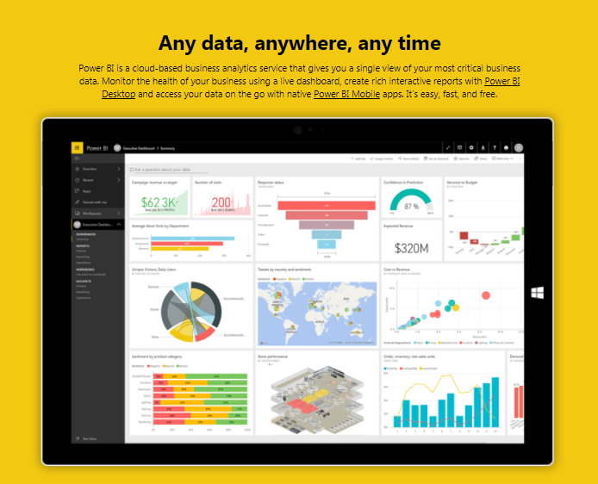

Figure 3. Power BI Microsoft**[58]**.

## Zoho[59]

This software provides an easy method to importing & synchronizing data comprising a large amount of data sources into Zoho Reports for reporting and analysis. This includes Local & Cloud databases, Feeds, Cloud Drives, Files, NoSQL, Popular Business Applications, Your custom made applications etc., [Know more about the featured list of data connectors](https://www.zoho.com/reports/featured-connectors.html). Type in a name for the database you want to create. Providing description is optional. You can browse & load the file directly from your local drive or copy-paste the data using the Posted Data option. You can also import data directly from web URL feeds using the 'Web' option. Zoho is a free trial for 30 days for free.

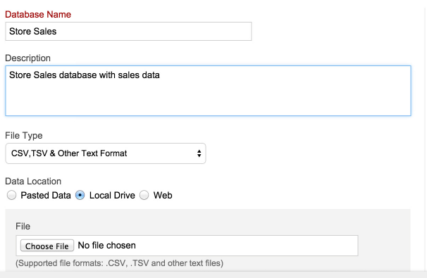

Figure 4. Creating Reporting Database[60].

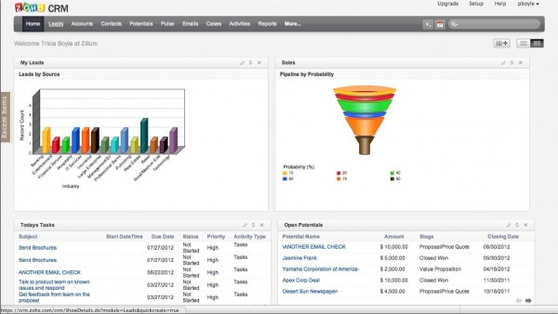  
  
Figure 5. Example diagrams in the Zoho[61].

## Eazybi[62]

EazyBI Cloud -the Easiest Online Business Intelligence Tool, Web-hosted, easy-to-use, a self-service business intelligence software suite for data visualization, reporting, and analysis.

Private eazyBI is an installable, business intelligence tool that you can use on your own servers. Use Private eazyBI as your data analysis and reporting extension for your existing corporate applications to create flexible reports and dashboards or to perform extensive analysis and insight mining. Just map your existing database tables to EazyBI dimensions and measures, and you are ready to go. Private eazyBI is easy to install and easy to upgrade. Customize its visual appearance by adding your logo, headers, footers, colors etc. Private eazyBI also allows you to develop additional integrations with other applications.

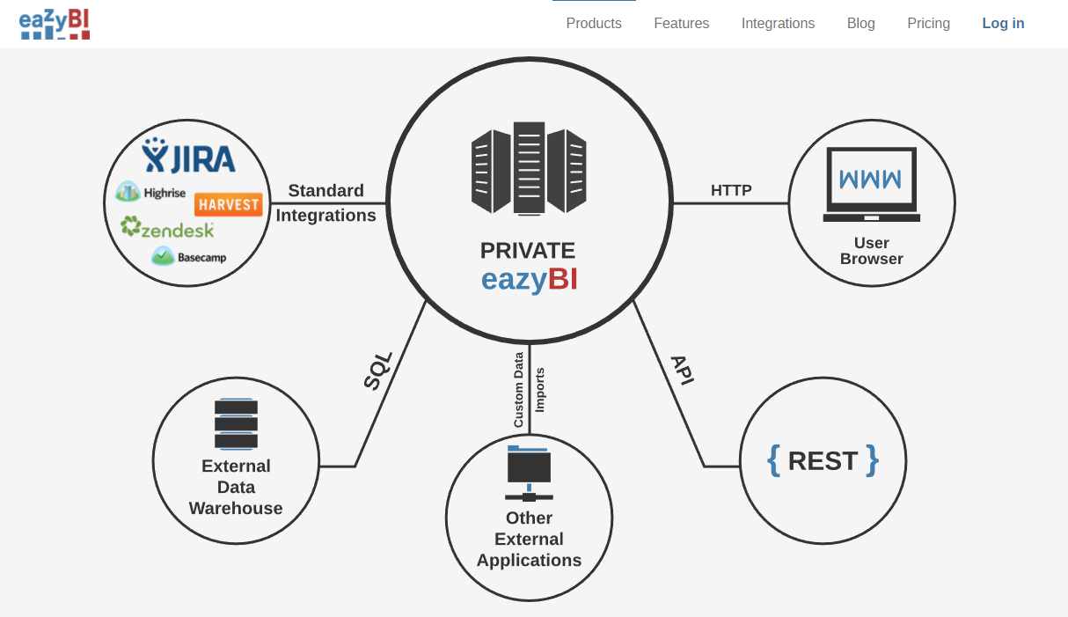

Figure 6. Private eazyBI[63].

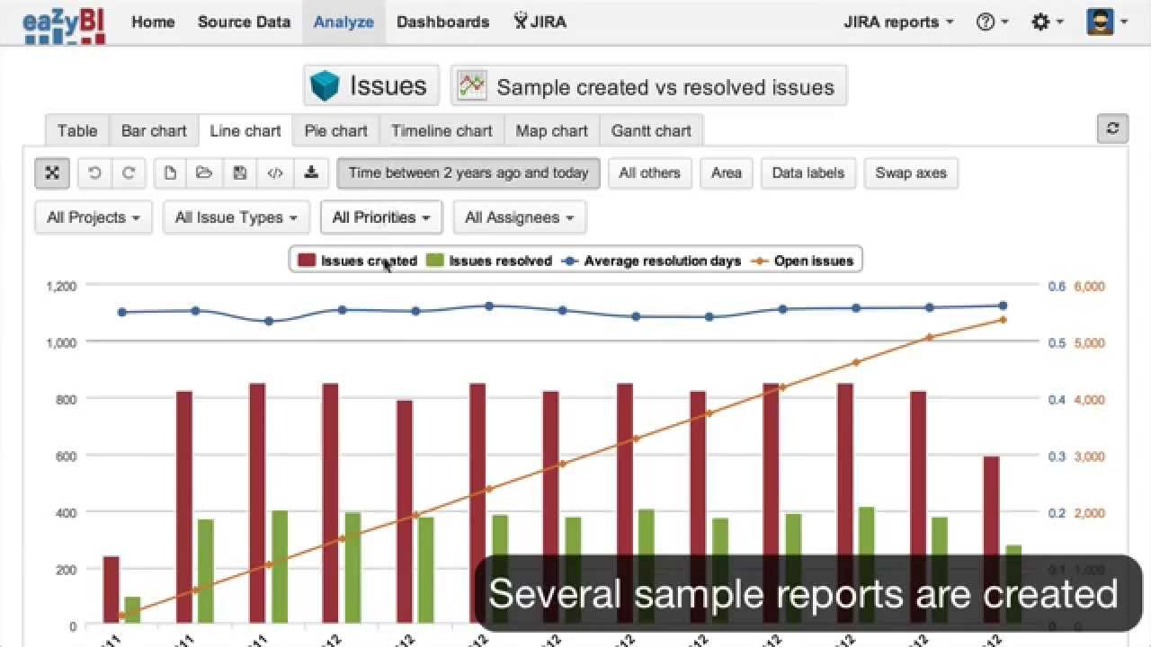  
Figure 7. Example diagrams in the EazyBI[64].

## Birst.com[65]

Birst is the only enterprise business intelligence platform that connects together the entire organization through a network of interwoven virtualized BI instances on-top of a shared common analytical fabric. Birst enterprise BI delivers the speed, self-service, and agility front-line business workers demand, and the scale, security, and control to meet rigorous corporate data standards. Birst delivers all of this and much more with low TCO via public or private cloud configurations[66].

Access data with preset, “smart” analytic connectors

Prepare data with instant feedback in a consumer-grade UX

Relate data accurately with smart suggestions

Visualize analytics and discover new insights

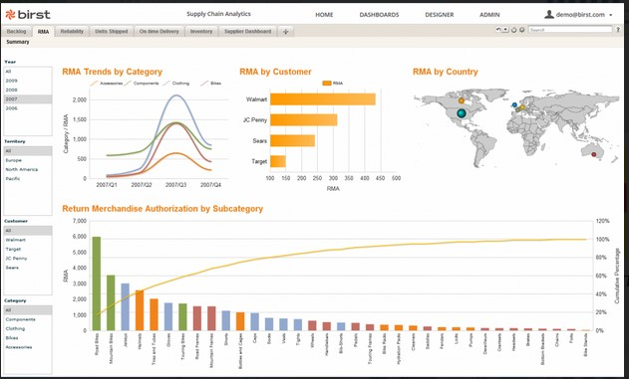  
  
  
Figure 8. Example diagrams in the Birst[67].

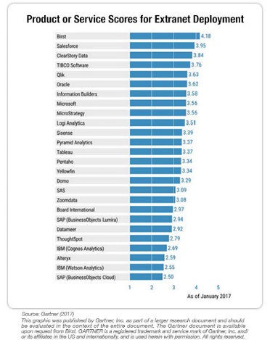

Figure 9. Product or Service Scores for Extranet Deployment[68].

## Jaspersoft[69]

The Intelligence Inside.

Millions of people everyday can make faster decisions by having access to timely, actionable data inside their apps and business processes through an embeddable reporting and analytics platform.

That product, unlike traditional BI tools, allows anyone to easily self-serve and get the answers they need inside their preferred app or on their favorite device. BI platform, unlike desktop visualization tools, scales architecturally and economically to reach everyone[70].

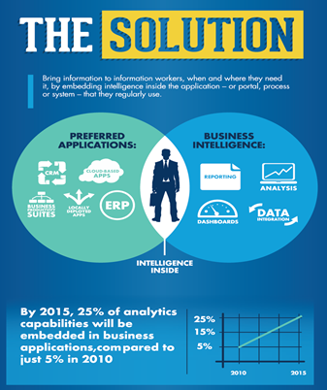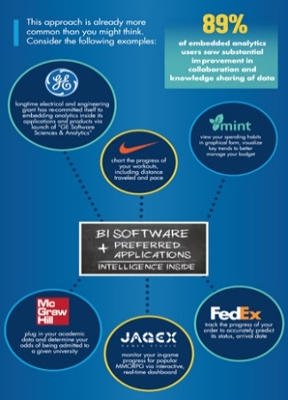

Figure 10. The intelligence inside of applications and business processes.[71]

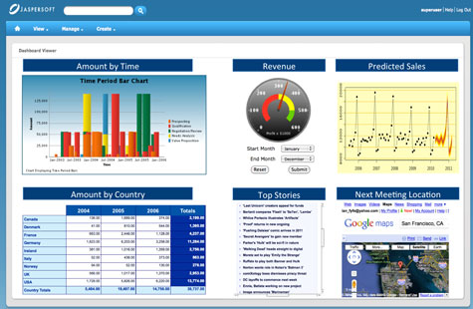  
  
Figure 11. Example diagrams in the Jaspersoft[72].

## Yellowfinbi[73]

Yellowfin is a modern analytics platform that connects people and their data. Yellowfin releases new features half yearly. That is a whole lot of innovation. Better decisions start with awesome dashboards, data visualization, and storytelling.

Dashboards that put all your data in one place.

Yellowfin supports all types of dashboards – strategic, analytical and operational – to meet all your enterprise needs.

Create interactive presentations and control the narrative, while allowing your audience to explore[74].

  
  
  
Figure 12. Yellowfin Business Intelligence[75]

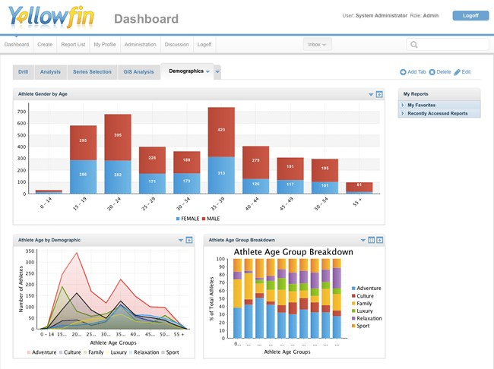  
  
Figure 13. Example diagrams in the Yellowfin BI[76]

# Summary of Business Intelligence Teaching Methods *(Mieczysław Owoc)*

Guidelines for new and innovative teaching methods of Business Informatics (Business Intelligence perspective)

The description of the methods is the following:

Providing real examples with case studies;

Providing the description of these case studies in electronic format before having classes;

Notifying students about the electronic version of the case studies;

Starting the exercises;

Discussion on questions before starting;

Defining research questions;

Using several software products by several tutors;

Discussing the output of the software;

Commenting on outliers, limitations, practical implications, interpretations of the output;

Preparing the full description of the case study for the e-books

Discussing the inclusion of new case studies with a short description, a dataset, research questions and not giving step-by-step information for solving them.

Presentation of usability of the methods and tools in order to support business analysis including advanced reporting, data mining, OLAP processing etc.

Some of the mentioned innovative teaching methods are tested and validated during the intensive study programs, which are carried out within the DIMBI project. As a result we may summarize that they are appropriate in teaching business informatics.

1. Ermolaeva L., Business-Informatics, 2014, [Online], Available at: <http://e.lib.vlsu.ru/bitstream/123456789/3550/1/01318.pdf>, Accessed [17 August 2017].
2. Masic F., Information Systems in Dentistry, 20 March 2012, [Online], Available at : <https://www.ncbi.nlm.nih.gov/pmc/articles/PMC3545321>, Accessed [17 August 2017]
3. [Online],Available at: <http://www.bchmsg.yolasite.com/methods.php> , Accessed [25 August 2017]
4. Idaho State University, Business Informatics, ISU, [Online], Available at: <http://www2.isu.edu/cob/businessinformatics.shtml>, Accessed [08 August 2017].
5. Swiss IT Intelligence Communities, Das Yin & Yang der Innovation Eine Reflexion über drei Jahrzehnte , 9 June 2015, [Online], Available at : <http://www.prozessfux.com/wp-content/uploads/2015/01/06_Yin-Yang_Innovationen.pdf> , Accessed [17 August 2017].
6. Innovative teaching methods applied often or sometimes, [Online], Available at: http://www.inotles.eu/survey-teaching-es, Accessed [08 August 2017].
7. Teaching tools applied often or sometimes, Inotles, Survey on teaching ES, Inotles, [Online], Available at: <http://www.inotles.eu/survey-teaching-es>, Accessed [10 August 2017].
8. Good example related to collaboration academics and students you can find in Jan Wyżykowski University, [Online], Available at: [www.erasmus.polkowski.com.pl](http://www.erasmus.polkowski.com.pl), Accessed [10 August 2017].
9. University of Exeter, Active learning and innovative teaching, University of Exeter, [Online], Available at: <https://www.exeter.ac.uk/undergraduate/study/innovative/>, Accessed [10 August 2017].
10. Bildfell A., What is Innovative Teaching and How can We Implement it into Our Classrooms as the Post-Secondary Level?, Carleton, 1 Sept 2015, [Online], Available at: <https://carleton.ca/tasupport/2015/what-is-innovative-teaching-and-how-can-we-implement-it-into-our-classrooms-at-the-post-secondary-level/>, Accessed [17 August 2017].
11. Vivian Giang, “19 Transferable Skills That Will Be Most Valuable In The Future” [Online], Available at: https://finance.yahoo.com/news/19-transferable-skills-most-valuable-171700250.html, Accessed [17 August 2017].
12. [Online],Available at: <http://careerlaboratory.blogspot.com/2012/08/transferable-skills-with-biggest-payoff.html> ,Accessed [25 August 2017]
13. Giang V., 19 Transferable Skills That Will Be Most Valuable In The Future, Business Insider, 2013, [Online], Available at: <http://www.businessinsider.com/valuable-transferrable-skills-of-the-future-2013-8?IR=T>, Accessed [10 August 2017].
14. [Online],Available at: <http://careerlaboratory.blogspot.com/2012/08/transferable-skills-with-biggest-payoff.html> ,Accessed [25 August 2017]
15. List of the most valuable transferable skills, Shatkin L., Transferable Skills with the Biggest Payoff, Career Laboratory, 2012, [Online], Available at: <http://careerlaboratory.blogspot.com/2012/08/transferable-skills-with-biggest-payoff.html>, Accessed [10 August 2017].
16. Brisbane B., Kallangur Dental Surgery, [Online], Available at: <https://kallangurdental.com.au/careers/>, Accessed [17 August 2017].
17. MyMajors, [Online], Available at: <https://www.mymajors.com/career/geographers/skills/> , Accessed [17 August 2017].
18. Dillon S., How To Guarantee A Payin’ Gig When 40% Of Aus Jobs Won’t Exist In 15 Years ,4 July 2017, [Online], Available at: <https://www.pedestrian.tv/news/how-to-guarantee-a-payin-gig-when-40-of-aus-jobs-wont-exist-in-15-years/> , Accessed [17 August 2017].
19. O Net Online, [Online], Available at: <https://www.onetonline.org/find/descriptor/browse/Skills/2.B.3/> , Accessed [17 August 2017].
20. Powershow.com, [Online], Available at : <http://www.powershow.com/view/3b417c-ZjAwZ/Innovative_teaching_methods_What_is_innovation_powerpoint_ppt_presentation> , Accessed [17 August 2017].
21. DIMBI application form, [Online], Available at: <http://dimbi.paragonweb.eu/index.php>, Accessed [08 August 2017].
22. Akademia Górniczo-Hutnicza, Wprowadzenie do e-learningu, Centrum e-Learningu AGH, Kraków 2008, [Online], Available at: <http://www.cel.agh.edu.pl/wp-content/uploads/2009/11/wprowadzenie_do_e-learningu.pdf>, Accessed [08 August 2017].
23. Jain K.K., Ngoh B.L. (2008): Motivating Factors in e-learning -a Case study of UNITAR [April 25, 2015] Available at: <http://www.studentaffairs.com/ejournal/Winter_2003/e-learning.html>, Accessed [08 August 2017].
24. Own elaboration.
25. Own elaboration.
26. Mobl 21 (2015): Mobile Learning Basic [March 20, 2015],[Online], Available at: <http://www.mobl21.com/Basics_Of_Mobile_Learning.pdf>, Accessed [22 July 2016]
27. Savulescu C., Deaconescu I. C., Blidaru C. E., Polkowski Z. , Security in e-learning systems, ECAI 2015 - International Conference – 7th Edition, Electronics, Computers and Artificial Intelligence, 25 June -27 June, 2015, Bucharest, ROMÂNIA.
28. Own elaboration.
29. Morgan L., How contextual awareness is redefining Business Intelligence, InformationWeek, [Online], Available at: <http://www.informationweek.com/big-data/big-data-analytics/how-contextual-awareness-is-redefining-business-intelligence/d/d-id/1322862?image_number=1>, Accessed [22 July 2016]
30. Director of The Center for Cultural Studies & Analysis, in an interview.
31. Morgan L., How contextual awareness is redefining Business Intelligence, InformationWeek, [Online], Available at: <http://www.informationweek.com/big-data/big-data-analytics/how-contextual-awareness-is-redefining-business-intelligence/d/d-id/1322862?image_number=1>, Accessed [22 July 2016]
32. Rouse M., Mobile business intelligence, Search Business Analytics, [Online], Available at: <http://searchbusinessanalytics.techtarget.com/definition/mobile-business-intelligence>, Accessed [22 July 2016].
33. Flieder K., Mödritscher F., Teaching Business Informatics with Web 2.0 Technologies, Conference ICL2010, September 15-17, 2010 Hasselt, Belgium, [Online], Available at: http://www.icl-conference.org/dl/proceedings/2010/contributions/Contribution208.pdf, Accessed [08 August 2017].
34. DataCandy, Is Gamification the Future of Engagement?, 20 May 2015,[Online], Available at: <https://www.datacandy.com/is-gamification-the-future-of-engagement/> , Accessed [17 August 2017].
35. Burke B., Gartner Redefines Gamification, Gartner, 4 April 2014, [Online], Available at: <http://blogs.gartner.com/brian_burke/2014/04/04/gartner-redefines-gamification/>, Accessed [08 August 2017].
36. Badgeville, Gamification, [Online], Available at: <https://badgeville.com/wiki/Gamification>, Accessed [22 July 2016].
37. [Online] ,Available at: <http://www.gartner.com/newsroom/id/1629214> , Accessed [25 August 2017]
38. Badgeville, Nike+, [Online], Available at: <https://badgeville.com/wiki/Nike>, Accessed [24 July 2016].
39. Bodekaer M.,How Gamification Is Revolutionizing Science Education, June 19 2015, [Online] Available at: <http://blog.uncollege.org/how-gamification-is-revolutionizing-science-education>, Accessed [24 July 2016].
40. [Online],Available at: <http://www.enmain.com/blog/what-is-business-intelligence/> , Accessed [25 August 2017]
41. National Training Laboratories, Bethel, Maine, [Online]. Available at: <https://drwilda.com/tag/national-training-laboratories/> Accessed [20 August 2017]
42. [Online], Available at: <http://www.bchmsg.yolasite.com/methods.php> ,Accessed [25 August 2017]
43. Teaching methods applied in Data Warehouse courses, own elaboration.
44. Teaching methods applied in Data Warehouse Course, own elaboration.
45. [Online],Available at: <http://paperity.org/p/34933324/a-remanufacturing-process-library-for-environmental-impact-simulations> ,Accessed [25 August 2017]
46. Pokrzywnicka A., Kursy MOOC - przełom w uczeniu się dorosłych, europa.eu, 2015, [Online] Available at: <https://ec.europa.eu/epale/pl/blog/moocs-game-shifter-adult-learning>, Accessed [2016].
47. [Online],Available at: <https://onlinelearninginsights.wordpress.com/tag/online-teaching-and-learning/> , Accessed [25 August 2017]
48. Morrison D., Three Trends that Will Influence Learning and Teaching in 2016

    , 10 Jan 2016, [Online], Available at: <https://onlinelearninginsights.wordpress.com/2016/01/10/three-trends-that-will-influence-learning-and-teaching-in-2016/> , Accessed [17 August 2017].
49. [Online],Available at: <http://www.educationdive.com/news/the-death-of-degrees-9-alternative-credentialing-approaches/102618/> ,Accessed [25 August 2017]
50. [Online], Available at: <https://degreed.com/online-learning>, Accessed [08 August 2017].
51. Riddell R., The death of degrees? 9 alternative credentialing approaches, Education Dive, 21 Feb 2013, [Online], Available at: <http://www.educationdive.com/news/the-death-of-degrees-9-alternative-credentialing-approaches/102618/>, Accessed [17 August 2017].
52. [Online], Available at: <https://cft.vanderbilt.edu/guides-sub-pages/learning-spaces/>, Accessed [24 July 2016].
53. Morrison D., Three Trends that Will Influence Learning and Teaching in 2016, OnlineLearningInsights, Jan 10 2016, [Online], Available at: <https://onlinelearninginsights.wordpress.com/2016/01/10/three-trends-that-will-influence-learning-and-teaching-in-2016/>, Accessed [17 August 2017].
54. Power BI Microsoft, [Online], Available at: <https://powerbi.microsoft.com/en-us/>, Accessed [21 August 2017].
55. [Online],Available at: <https://almvm.azurewebsites.net/labs/vsts/powerbi/> , Accessed [25 August 2017]
56. [Online],Available at: <https://www.zoho.com/reports/import-export.html> , Accessed [25 August 2017]
57. [Online],Available at: <https://resemblesystems.com/powerbi/> , Accessed [25 August 2017]
58. Power BI Microsoft, [Online], Available at: <https://powerbi.microsoft.com/en-us/features/>, Accessed [21 August 2017].
59. Zoho, [Online], Available at: <http://www.zoho.com/> , Accessed [21 August 2017].
60. Own elaboration based on information, [Online], Available at: <https://www.zoho.com/reports/import-export.html>, Accessed [21 August 2017].
61. Software Advice, Example diagrams in the zoho, [Online], Available at: [http://www.softwareadvice.com/crm/zohocrm-profile/#](http://www.softwareadvice.com/crm/zohocrm-profile/), Accessed [21 August 2017].
62. Eazybi, [Online], Available at: <https://eazybi.com/products/private_eazybi/>, Accessed [21 August 2017].
63. Private eazyBI, [Online], Available at: <https://eazybi.com/products/private_eazybi>, Accessed [21 August 2017].
64. Example diagrams in the EazyBI, [Online], Available at: <https://www.youtube.com/watch?v=gc5Y3XdhKT4> , Accessed [21 August 2017].
65. Birst, [Online], Available at: <https://www.birst.com/> , Accessed [21 August 2017].
66. [Online], Available at: <http://www.centelli.com/birst-partnership.html> , Accessed [25 August 2017].
67. Example diagrams in the birst, [Online], Available at: <https://blog.dbi-services.com/birst-an-attractive-all-in-one-business-intelligence-solution/> , Accessed [21 August 2017].
68. Gartner, Product or Service Scores for Extranet Deployment, [Online], Available at: <https://www.birst.com/solutions/>, Accessed [21 August 2017].
69. JasperSoft, [Online], Available at: <https://www.jaspersoft.com/why-jaspersoft>, Accesed [21 August 2017].
70. [Online],Available at: <https://www.izeno.com/partners.html> , Accessed [25 August 2017]
71. JasperSoft , The intelligence inside of applications and business processes, [Online], Available at: <https://www.jaspersoft.com/why-jaspersoft>, Accessed [21 August 2017].
72. Example diagrams in the JasperSoft, [Online] Available at: <http://www.computerweekly.com/feature/Review-Jaspersofts-Business-Intelligence-Suite-Enterprise-Edition/> , Accessed [21 August 2017].

   
73. Yellowfin, [Online], Available at: <https://www.yellowfinbi.com/platform> , Accesed [22 August 2017].
74. [Online]Available at: <https://www.oneadvanced.com/globalassets/resources/advanced_fact_sheet_tableau_web.pdf> , Accessed [ 25 August 2017]
75. Yellowfin Business Intelligence, [Online], Available at: <http://www.waterloodata.com/main/yellowfin-business-intelligence/> , Accesed [22 August 2017].
76. Yellowfin BI, Example diagrams in the Yellowfin BI, [Online], Available at: <https://www.yellowfinbi.com/blog/2011/12/yfcommunitynews-business-intelligence-release-notes-what-s-new-in-yellowfin-6-109821>, Accesed [22 August 2017].