**Active Books Series**

**Part 2. Business Intelligence**

**Julian Vasilev, Zdzisław Pólkowski**

**(eds.)**



Technical Support: Diana Niti, Nicoleta Marambei, Florian Chitu, Victor Ovadiuc, Vasil Mitev, Ivan Nedev, Stoyan Yovchev

**Wrocław-Varna, 2017**

This work is licensed under a Creative Commons

Attribution 3.0 Unported (CC BY 3.0)



Project implemented in the consortium:



Jan Wyżykowski University

Skalników 6b

59-101 Polkowice

Wrocław University of Economics

Komandorska 118/120

53-345 Wrocław

University of Economics-Varna

Kniaz Boris I Bvd. 77

9002 Varna

Paragon Europe

Constitution Street 295B

MST9052 Mosta



Developing the innovative methodology of teaching Business Informatics

2015-1-PL01-KA203-016636

This project has been funded with support from the European Commission. This publication [communication] reflects the views only of the author, National Agency and the Commission cannot be held responsible for any use which may be made of the information contained therein.

**PUBLICATION FREE OF CHARGE**

**Active Books Series Part 2. Business Intelligence**

UJW

ISBN 978-83-61234-92-0  
Publishing house "Knowledge and business" Varna

ISBN 978-619-210-016-2

Editors: Julian Vasilev, Zdzisław Pólkowski

Reviewer: Marian Niedzwiedzinski.

This book or part of it cannot be distributed electronically or hard copy without the written permission of authors.

**Acknowledgements**

The authors thank Erasmus Students from the University of Pitesti in Romania: Dospinoiu Nicoleta, Neblea Lavinia, Floroiu Dragos, Perjoiu Alin, Lazarescu Andrei, Puiu Bogdan, Bortosu Bogdan, Dionis Vlas, for support in organizing, conducting the tests of distance ICT solutions, and for help in preparing this work. This work is the result of an international research project called ‘The Optimisation of Business Processes by Virtualization in SMEs’. This work was also possible thanks to the grants for Erasmus students from the European Union Commission: Erasmus for Young Entrepreneurs. An Extended version of this work is available at: http://ijo.iaurasht.ac.ir/article_529145_0.html[1]

**Contents**

PREFACE 6

*1* Introduction *(Julian Vasilev)* 7

*2* Fundamentals of Business Intelligence *(Todorka Atanasova, Julian Vasilev)* 8

*3* Types of BI systems *(Ivan Kuyumdzhiev, Julian Vasilev)* 9

*4* Distance Management by ICT *(Zdzisław Pólkowski, Małgorzata Nycz)* 13

4.1 Distance management context 13

4.2 Distance management solutions using ICT 15

4.3 Trends in distance management of SMEs 16

Resources 17

*5* Service Oriented Architecture (SOA) *(Małgorzata Nycz, Zdzisław Pólkowski)* 18

5.1 The evolution of the information age 18

5.2 SOA interpretation 19

5.3 The Introduction of SOA to Company 23

Resources 25

*6* Web and BI *(Małgorzata Nycz, Zdzisław Pólkowski)* 26

6.1 Web evolution 26

6.2 Trends in BI 33

Resources 36

7 Cloud Computing and BI *(Zdzisław Pólkowski, Małgorzata Nycz)*, 37

7.1 Genesis of Cloud Computing 37

7.2 Cloud Computing models 38

7.3 Cloud Computing and Virtualization 39

7.4 Trends in CC and BI 43

Resources 45

8 Mobile solutions in small and medium enterprises *(Zdzisław Pólkowski, Małgorzata Nycz)* 46

8.1 The necessity of mobile processing 46

8.2 Examples of mobile solutions in SMEs 47

8.3 The direction of mobile solutions in SMEs 50

8.4 Mobile Business Intelligence 52

9 Integration of ERP, BI and CRM systems *(Zdzisław Pólkowski, Małgorzata Nycz)* 54

9.1 Systems differentiation 54

9.2 Definitions of BI, ERP, CRM 54

9.3 The differences between BI, ERP, CRM 58

9.4 Integration of BI, ERP and CRM systems 61

9.5 Further development and recommendations for BI, ERP, and CRM 62

Resources 63

10 Business intelligence in sales analysis using statistical software *(Julian Vasilev)* 65

10.1 Research assumptions 65

10.2 Testing research questions 65

10.3 Selecting cases for the year 2007 68

10.4 Research performing 69

10.5 Tasks for self-preparation 71

Resources 72

*11* Business intelligence in sales analysis using decision trees *(Julian Vasilev)* 73

11.1 Research assumptions 73

11.2 Initial research questions 73

11.3 Working with Rapid Miner 73

11.4 Personal work with decision trees 74

Resources 75

*12* Business intelligence in sales analysis using neural networks *(Julian Vasilev)* 76

12.1 Research assumptions 76

12.2 Initial research questions 76

12.3 Working with Alyuda Neurointelligence 77

12.4 Presenting the result in scientific papers 78

12.5 Personal work 79

Resources 79

13 The Basics of Working with Power BI *(Maciej Pondel)* 80

13.1 Characteristics of Power BI 80

13.2 Power BI Desktop Introduction 81

13.3 Working with Power BI Desktop 82

13.4 Typical scenario of analysis creation 83

Resources 89

*14* Analysis with Power BI *(Maciej Pondel)* 90

14.1 Building models 90

14.2 New columns and measures 91

14.3 Relationships 93

14.4 Creation of visualizations 94

Resources 105

15 Summary *(Mieczysław L. Owoc)* 108

List of Tables 109

List of Figures 110

# PREFACE

This interactive book for teaching Business Intelligence is a result of the project “Developing the innovative methodology of teaching Business Informatics” (dimbi.eu). The project has been financed within the framework of the Erasmus+ Program, Key Action 2 “Cooperation for innovation and the exchange of good practices – Strategic Partnerships for higher education”. The Partnership was composed of Jan Wyżykowski University (Polkowice, Poland) - Leader, University of Economics (Varna, Bulgaria), Wroclaw University of Economics (Wroclaw, Poland) and Paragon Europe (Mosta, Malta).

Our project, related to fast-growing field Business Informatics, aimed at supporting the development of higher education and the introduction of innovative tools at European level.

Many professors and researchers from four organizations in three countries have contributed to this book. Also, the group of 30 international students have tested the solutions included in the book during the Intensive Study Program in Varna (Bulgaria) and Wroclaw (Poland). Two international conferences have promoted results of the project.

This active book is the tool creating the environment for learning and teaching, where various content is generated in a dynamic way as to the needs of the learner and the teacher. The substantiative level, methodological one, multimedia one, as well as the level of accessibility is correlated with the educational needs of the students, their learning styles, labour market, the requirements of foreign partners and the recommendations within the National Qualification Framework.

This book has a unique character. It can be used as a teaching material in Business Intelligence by university professors or scientists or as a self-learning material by students. It is also handy useful for business or anyone else interested in Business Intelligence.

Finally, I would like to thank all the contributors for their quality chapters, the students from Bulgaria, Romania and Poland for their help, and reviewers for their support.

I hope you enjoy reading.

Dariusz Zając, PhD

Project Manager

Chancellor of the Jan Wyżykowski University

Polkowice, Poland

# Introduction *(Julian Vasilev)*

Business Intelligence (BI) is a research field and business practice. This book contains 13 chapters extending the traditional view on business intelligence and some sophisticated techniques are given. Short summary ends the manual. This book may be useful for practitioners working with big datasets and who are willing to find some hidden dependencies in their datasets. The application of several BI software tools is given. The book is also useful for students, teachers and researchers who want to know and learn how to use the latest applications of BI in business.

# Fundamentals of Business Intelligence *(Todorka Atanasova, Julian Vasilev)*

Achieving company business intelligence represents the focus of attention for modern managers through its capabilities for effective management. The full picture of businesses can be achieved through business intelligence at any given moment. All relevant information can be represented which contributes to the improvement of the quality of the decisions taken and realization of intelligent management.

Business intelligence should be considered as a general term, which encompasses company infrastructure, applications, and different information for processing, practical experience and instruments used to achieve optimal managerial decisions in a competitive environment. Several basic factors determine the necessity to transfer towards company business intelligence. One of the main ones is the presence of big data volume and at the same time information little used by management. It is also necessary for different data to be organized in a way to allow for integrated processing, which is realized with the transfer to BI. Another factor is that by transferring towards BI business processes will be improved because they must be monitored and optimized. The transfer towards BI can be considered a strategic initiative for company prosperity. BI is helping senior company management as well as management from the middle and operational levels showing them basic business indicators.

Data created from company business applications is used in BI as well as outside data (business rules, policies, market indicators, and competition data) which is also used. Its type can be different (structural, semi structural and not structured) depending on whether it is a semantic model and formal structure. Structured information (databases, data warehouses, electronic tables) has clearly defined structure and semantics. It is processed through traditional information technologies. Semi structured information has part of the content structured and the other part has no clear model or semantics or it can be absent. Not structured information is due to the communication between people and represents email messages and social networks, recording of voice, biometrical presentations. Its processing is not conventional but is necessary due to its high informative nature. Special information technologies are applied including Artificial Intelligence technologies. Using all types of information, influencing the management decision, represents the modern approach towards BI.

Business intelligence in companies is done by business intelligence systems. The realized approach towards work with these systems in the Internet environment, as well as mobile access, brings us to the new form of BI – web BI.

# Types of BI systems *(Ivan Kuyumdzhiev, Julian Vasilev)*

An information system is a set of interrelated components that collect, process, store, and distribute information resources to support decision making and control in an organization.

Information resources are data, information, and knowledge. Data is discrete, objective facts about events. Information is organized meaningful data. Knowledge is the application of expert opinion, skills and experience with data and information for decision making. Business intelligence is the ability to convert all of the data from a particular organization into knowledge[2].



Figure 1 Management level of information.

The types of enterprise information systems are:

* Enterprise resource planning systems (ERP),
* Supply management systems (SCM),
* Customer relationship management systems (CRM),
* Knowledge management systems (KMS).

**ERP systems** manage information about organizational resources such as raw materials, products, staff, and customers as part of delivery of a product or service. ERP systems are a set of integrated software modules and a central database. Supported business processes include the following:

* Financial and accounting,
* Human resources,
* Manufacturing and production,
* Sales and marketing[3].

**CRM systems** manage the personal details of customers, their product order history and how they have responded to marketing campaigns. Sales Forces Automation helps sales staff increase their productivity by focusing sales efforts on the most profitable customers. Customer Service provides information and tools to increase the efficiency of call centers, help desks, and customer support. Marketing supports direct-marketing campaigns (campaign data, content, data analysis).

**Information systems for managing** the decision-making support include the following:

* Transaction Processing Systems (TPS),
* Business Intelligence Systems (BI),
* Management Information Systems (MIS),
* Decision Support Systems (DSS),
* Executive Support Systems (ESS)[4].

**BI** is data and software tools for organizing, analyzing, and providing access to data to help managers and other enterprise users make more informed decisions about best practices, corporate organization, and specific infrastructure. BI draws information from all sectors of a business and helps companies make better decisions based on the available information[5].

**The purpose of BI:**

* Draws information,
* Analyzes the information,
* Displays the analysis in an understandable manner.

**Examples of BI questions:**

* How are we doing? Good or bad?
* Aim for goals and targets - where do we want to be and where are we now?
* What is our status compared to last time?
* Quality control - is everything working smoothly?
* Are we in sync with all legal regulations? Audit?
* How are we doing compared to similar organizations?

**Commonly used tools in BI are:**

* Scorecards. A scorecard is a data visualization tool that helps organizations, individuals, or groups of individuals to reach goals by displaying progress towards objectives against the objectives themselves.
* Dashboards. A dashboard is data visualization tool that displays the current status of metrics and key performance indicators.

**Types of BI systems include the following:**

* Spreadsheets – These interactive computer applications manage information in a visual format, organized by rows and columns.
* Reporting and Querying Software – These tools extract, sort and summarize data. There is a variety of software programs used to present this data, including open-source and commercial software types.
* Online Analytical Processing – This processing approach quickly answers analytical queries that are multidimensional. The types of applications in this processing include business reporting, marketing, budget, and forecasting.
* Data Mining – Data mining is the bridge between statistics and computer science. It is used to uncover patterns in large sets of data.
* Data Warehousing – This comprehensive database is used for reporting and data analysis. The information is uploaded from a separate operational system.
* Process Mining – This process management technique logs various events to determine business processes.
* Digital Dashboards – A single-page interface in real-time that show at-a-glance information.

How to decide which BI solution is better than another one?

The CRM approach tries to analyze data about customers' history with a company, to improve business relationships with customers, specifically focusing on customer retention, and ultimately to drive sales growth[6].

**Salesforce.com** is one of the best-selling CRM solutions. Salesforce entered the BI platform market in October 2014, with its launch of Salesforce Wave Analytics. Wave offers standard point-and-click interactive visualizations, dashboards and analysis that form the basis of packaged, closed-loop, front-office analytic applications initially focused on sales. The platform is natively mobile.

However, consistent with its low complexity , the platform currently lacks certain features of data discovery — such as advanced data exploration and manipulation for the business analyst, extensive geospatial capabilities, self-service data preparation and hybrid cloud, among others, although many of these features are on the Wave roadmap.

**SAP** delivers a broad range of BI and analytics capabilities for both large IT-managed enterprises reporting deployments and business-user-driven, data discovery deployments. Companies often choose SAP as their enterprise BI standard, particularly if they also standardize on SAP for the enterprise data warehouse and ERP applications. The top reasons why customers select SAP are functionality and the integration with enterprise applications[7].

**Pentaho** is a company that offers Pentaho Business Analytics, a suite of open source Business Intelligence (BI) products which provide data integration, OLAP services, reporting, dash boarding, data mining and ETL (Extract, Transform, Load) capabilities. Pentaho offers native integration with technologies such as Hadoop, Spark, Cassandra. Pentaho is able to blend and analyze traditional SQL-based repositories, ad hoc files, NoSQL databases and unstructured data (such as social media feeds, log data and machine data streams from Internet of Things - IoT).

# Distance Management by ICT *(Zdzisław Pólkowski, Małgorzata Nycz)[8]*

## Distance management context

H. Fayol (1916) suggested four management functions: planning, organizing, leading and controlling. Planning is deciding where to take a company and selecting steps to get there. Organizing means bringing together physical, human and financial resources to achieve objectives. Leading involves motivating employees. Controlling involves measuring achievement against established objectives and goals[9]. These functions may be supported by Information and communication technology (ICT). The key task of ICT is to support employees and employers in business processes in both big companies and SMEs.

Using information systems effectively requires an understanding of the organization, people, and information technology shaping the systems. An information system provides a solution to important business problems or challenges facing the firm [10](see Figure 1).



Figure 2. ICT system, organization, people and technology[11].

Companies deal with the following four areas: ICT strategy, Management & Support, Information Systems and ICT Infrastructure (see Figure 2).



Figure 3. ICT system, company, people, and technology[12].

According to Mráz (2012), Information Systems (IS) represent the ICT area and manage the provided functionalities. Other company ICT elements provide functionality to information systems. The ICT Strategy defines the basic, long-term rules for the form and utilization of information systems. Management & Support serve the management securing individual processes. ICT Infrastructure is a logical-physical foundation upon which the individual information systems are created. To meet new requirements consistently and in a pre-determined process, it is necessary to design IS implementation and development in a long-term perspective. ICT areas enable companies to focus on their principal activity, on the smooth provision of functionalities to the user[13].

There are a lot of publications on hybrid or blended solutions, especially related to hybrid computing [(Rekimoto](https://scholar.google.pl/citations?user=wKJLtK8AAAAJ&hl=pl&oi=sra) & Saitoh, 1999)[14] blended learning ([Garrison](http://www.sciencedirect.com/science/article/pii/S1096751604000156), [Kanuka](http://www.sciencedirect.com/science/article/pii/S1096751604000156), 2006) [15] but there are only a few related to blended or hybrid management. Mostly they regard hybrid economy (Altman, 2007)[16], blended management styles (bitshifts-trends, 2013)[17] a blended approach to leadership (Boundless, 2016)[18]. It is, however, difficult to find publications on blended management, hybrid-management or B-management.

ICT in business is researched in literature from several perspectives. One of them investigates how ICT helps businesses to function efficiently. Currently, in the context of ICT and the present situation, business people, IT specialists or any other authorities must take the past into account. Both the past and the current situation are needed to improve future operational efficiency. The general goal is to make informed predictions or forecasts using ICT to improve the business and to avoid problems that could affect the development of these kinds of solutions. Business people and IT specialists also use forecasting to extrapolate how trends will change, or as a benchmark for a long-term perspective of e-management. Various systems and tools have been launched for employers and employees: webinars, mobile solutions, software to monitor employees, video meetings, uploading files, projects and teamwork systems, tracking applications, social media, etc.

## Distance management solutions using ICT

For several years, activities have been undertaken on a global scale by software companies, as well as research centers and universities, to implement ICT in SMEs. Resources available online include several professionally developed software solutions. Demonstration versions and tests of those systems are available and can be used at companies.

As a result of the analysis of Internet resources, the distance ICT solutions which have been identified, characterized and tested in the classroom with Erasmus students are outlined below – see Fig.4.



Figure 4. Distance management of SMEs using ICT

## Trends in distance management of SMEs

Although the chapter has demonstrated the effectiveness of the use of distance management ICT solutions, they could be further developed in some ways by testing more available solutions and testing the systems on many subjects such as logistics, e-business, etc.

It is worth mentioning that the authors of this chapter did not find much information in the literature on the approach presented in this work. What is more, it is difficult to find descriptions of concepts and methods related to blended management or B-management, a mixed (integrated, hybrid) management method, combining traditional management methods (direct contact of employers with the employees) with activities carried out remotely using a computer (M-management), see Figure 5.

The ratio of each component is selected depending on the business activity, as well as the employer’s and employee’s needs. This method seems to be effective as it creates a flexible way to manage a company with regard to the objectives, themes and specific business and employees. The advantage of B management is certainly in the remote and direct forms of activating the employees and working together on line. The organization of time in B management has been facilitated thanks to the remote sessions and not forced as in the case of traditional stationary meetings.



Figure 5. Blended Management Methodology[19].

According to the authors, it is possible to use e-management systems in other fields of study. The use of solutions available in CC (Cloud Computing) creates the possibility of using systems for business activity anywhere and at any time. The only conditions that must be met are the hardware (personal computers, laptops, tablets, and smartphones) and the Internet access. The interviews at SMEs and tests confirmed earlier assumptions that the solutions presented in the chapter are currently not used in SME business activities.

The hybrid distance systems or blended management systems can perform all the functions of management: planning, organizing, leading and controlling. However, in the authors’ opinion, that system should just support managers. Face to face contact will be still important because of human nature. During the research, it turned out that there are many ethical issues which should be taken into account by managers. This methodology should be implemented only after special training of managers and employees. They should be aware of the advantages and disadvantages resulting from using distance management systems[20].

## Resources

***Video:***

[Online] Available at: <https://www.youtube.com/watch?v=L1tM0tMJdzY> Accessed [11 August 2017].

[Online] Available at:  <https://www.youtube.com/watch?v=7s_S5Hkm7z0> Accessed [11 August 2017].

[Online] Available at:  <https://www.youtube.com/watch?v=A3_QlYJRVvk> Accessed [11 August 2017].

[Online] Available at:  <https://www.youtube.com/watch?v=ejlqmeACkHg> Accessed [11 August 2017].

[Online] Available at:  <https://www.youtube.com/watch?v=4WEqVqckgXs> Accessed [11 August 2017].

[Online] Available at:  Documents in pdf and ppt format:

[Online] Available at:  <http://www.rgoarchitects.com/Files/SOA.ppt> Accessed [11 August 2017].

**Files in pdf and ppt format:**

[Online] Available at:  <https://www.google.pl/url?sa=t&rct=j&q=&esrc=s&source=web&cd=3&cad=rja&uact=8&ved=0ahUKEwjG8PaHzczVAhXIKcAKHYi3B5oQFgg2MAI&url=https%3A%2F%2Fwww.andrew.cmu.edu%2Fuser%2Fmm6%2F95-843%2FPowerPoint%2F01_Introduction.ppt&usg=AFQjCNEj4aC0vksT7wJG78JuKLQl1CNxDw>, Accessed [11 August 2017].

[Online] Available at:  <http://sunset.usc.edu/classes/cs510_2011/ECs_2011/EC_30_USC_SOA_Presentation_1104_V1.ppt> Accessed [11 August 2017].

[Online] Available at:  <https://www.google.pl/url?sa=t&rct=j&q=&esrc=s&source=web&cd=7&cad=rja&uact=8&ved=0ahUKEwjG8PaHzczVAhXIKcAKHYi3B5oQFghVMAY&url=http%3A%2F%2Fesug.org%2Fdata%2FESUG2005%2FFriday%2F2005-ESUG-Berry.ppt&usg=AFQjCNGEwRe-fQDg35p7DbZKzIHPfMYkkg> Accessed [11 August 2017].

[Online] Available at: <http://download.microsoft.com/download/e/9/d/e9d163db-5c96-46bc-9263-aac62fc38831/service%20oriented%20architecture.pdf>, Accessed [11 August 2017].

# **Service Oriented Architecture (SOA) *(Małgorzata Nycz, Zdzisław Pólkowski)***

## The evolution of the information age

In the early years of the commercial computer industry, applications were bundled with computer hardware, which over time became too expensive for vendors. The first software firms started in 1960 to support universities and businesses seeking to perform specific computing tasks. The software industry began to expand rapidly with the introduction of personal computers in the mid-1970s. This includes businesses involved in the development, delivery and maintenance of computer software, as well as consulting services for product selection, implementation and training.

The expertise and resources required to deploy and maintain increasingly sophisticated business software applications created opportunities for alternative forms of software delivery models. While service bureaus have provided some technology-based services such as for payroll processing since the 1960s, the concept of Application Service Providers (ASPs) emerged as a viable alternative to on-premise software licensing in the late 1990s. Among ASP business models - SaaS and managed hosting services - the market for SaaS solutions has gained far more momentum in the 21st century for reasons described under Business Model.

The growth of memory size for information storing on a global scale within the last years - see: Figure below.



Figure 6. Global Storage Capacity[21].

SOA is a way of thinking about IT assets as service components. When functions in a large application are made into a stand-alone service that can be accessed separately, they are beneficial to several parties[22].

Figure 7. Services[23].

## SOA interpretation

Service Oriented Architecture (SOA) is not:

* Technology,
* The product,
* Protocol,
* Standard.

But SOA is a set of:

* Regulations,
* Acceptable practice,
* Frameworks,
* Architectural patterns.

Service is a well-defined function that does not depend on the context or state of other services while Service Oriented Architecture is a collection of services. For example, they communicate among themselves, there is straight transfer of data, and cooperation of two or more activities. SOA - characteristics and principles are:

* Lack of connections between the activities,
* Transparency of location,
* Independence of protocols.

Service architecture is a way of building software, which is derived directly from the component approach. From a technical point of view, SOA is a form of distributed system architecture with the following characteristics:

* Individual tasks of business processes (for example, checking the validity of a credit card, providing the current table of exchange rates, sending to the client information by e-mail with the report of selected business indicators, etc.) They are implemented by autonomous software components called services.
* Access to services is implemented in a network environment, using local or global networks.
* Independent service, offering small but well-defined functions which can be combined in the process providing new complex services. Such selection and matching service processes are called composition.
* The application running within the organization can call another application as a service, for example, financial application software can check the price of some services or products (stored in the computer system of an institution (e.g. financial ), and even make their purchase using electronic payment; an application in a retail outlet can check the availability of goods in warehouses and book parts for customers.
* Services expose its functionality through a defined interface, understood as a set of functions (methods) offered by the service. Services are autonomous which can communicate with each other using commonly accepted protocols, e.g. SOAP protocol, which uses XML to describe the transmitted messages.
* SOA is not just modern technology, but rather a concept of management, aiming to build a flexible IT architecture company, matched to ongoing, changing business processes. It involves combining the functionality of different applications in a complete, automated business process.
* The basic premise of the concept of SOA is based on the separation of the most commonly used pieces of information systems and giving them a form of independent services available on the network.
* As shared services are then used to perform specific tasks in business processes, the use of SOA allows for faster adaptation of IT to change business processes and even to compose entirely new processes that have not occurred within or between organisations.

The traditional and service-oriented approach to building IT systems:

Table 1. Differences between Homogeneous Technology and Service Oriented Approach

|  |  |
| --- | --- |
| **Preferred homogeneous technology** | **Service-oriented approach** |
| Requires intermediate layer | Designed with possibilities of changes in the future |
| Long development cycle | Flexible connected elements, agile and easy adaptation |
| Oriented code | Integrated around processes |
| Vertically integrated | Oriented meta data |
| Closely connected modules | Short cycle and rapid change |
| The planned "once for all." | It requires the right architecture |
| The traditional approach | Possible use of heterogeneous technologies |

SOA architecture is flexible and easily adaptable. Services are inherently autonomous and use the widely accepted communication protocols (e.g. SOAP).Changes made in the business process may require other services made available earlier in the enterprise. It is easy to create new services and make them available in the local network.

In this case, the company may:

* program the service by itself,
* outsource this task to an outsourcing company
* purchase access to the corresponding service provided by an external company, unless the company's security policy allows you to create such open systems.

The definition of SOA given by Open Group: “SOA is a style of IT architecture that enhances flexibility and adaptability, organisation, and provides a flow of information without borders.”

With such a definition adopted, the implementation of SOA in the organisation is more revolution than evolution. This is not because it is another system produced for the needs of a single organisational unit, but a paradigm shift - towards a holistic view of the organisation. It makes the implementation of SOA an element of architectural order introduced by the enterprise architecture.

Implementation of the SOA can not be treated as just another IT project, but complex activities related to organizational information - hence the need to create the architecture of business processes and the need to establish a body (supervisory architecture), which is adequately secured high in the organization (at the level of top management in the organization).

The evolution of styles processing from the mainframe to SOA is presented in Fig. 8.



Figure 8. From Mainframe to SOA.

Important in the SOA implementation is so-called Publish, Find, Use presented in Fig. 11.



Figure 9. Schema of “Publish, Find, Use” triangle.

The actual value of SOA achieved when the business architecture is combined with IT Architecture is depicted in Fig. 10.



Figure 10. Schema of SOA Combined with IT Architecture

## The Introduction of SOA to Company

Common ways to enter SOA:

Level 1:

* Use SOA technology to solve integration problems:
* Build new technology skills,
* Technology best practices.

Level 2:

* Conduct an SOA pilot project:
* Outsource/Integrate a partner service,
* Turn existing assets into business services,
* Build new technology skills
* Service Governance:
* Architectural decisions
* Best practices and guidelines for service development

Level 3:

* Common business services identification:
* Consolidate redundancies
* Implement an EB
* Service Governance:
* Build a “Reference” SOA
* Service Catalog Mgt.
* Information Management

Level 4:

* General decomposition of business into processes and business devices.
* Service modelling and process modelling.
* Architectural decisions.

The company, which has implemented SOA can implement an application that supports the components of the supply chain through the use of existing applications that highlight the functionality, thanks to the standard interfaces:

Figure 11. Supply Chain of SOA[24].

To implement SOA, a company must have an appropriate architecture of the site, such as:



Figure 12. Example of Architecture In Company.

Members elicit service by sending messages. Messages pass through the rail (service bus) and get to the proper implementation of the service. The architecture includes a service called Engine supporting business rules (allows you to include business rules as part of the service) and infrastructure management service is responsible for, among others, service management, activity tracking, billing for services, and also gives you the flexibility of SOA as a business process, better addressing of cyclically occurring requests, as well as changing individual services without affecting other services.

SOA can be understood differently, depending on the perspective from which we look at:

Figure 13. SOA in the context of business, architecture, implementation

## Resources

***Video:***

[Online] Available at: <https://www.youtube.com/watch?v=L1tM0tMJdzY>Accessed [11 August 2017].

[Online] Available at: <https://www.youtube.com/watch?v=7s_S5Hkm7z0>Accessed [11 August 2017].

[Online] Available at: <https://www.youtube.com/watch?v=A3_QlYJRVvk>Accessed [11 August 2017].

[Online] Available at: <https://www.youtube.com/watch?v=ejlqmeACkHg>Accessed [11 August 2017].

[Online] Available at: <https://www.youtube.com/watch?v=4WEqVqckgXs>Accessed [11 August 2017].

[Online] Available at: Documents in pdf and ppt format:

[Online] Available at: <http://www.rgoarchitects.com/Files/SOA.ppt>Accessed [11 August 2017].

***Files in pdf and ppt format:***

[Online] Available at: <https://www.google.pl/url?sa=t&rct=j&q=&esrc=s&source=web&cd=3&cad=rja&uact=8&ved=0ahUKEwjG8PaHzczVAhXIKcAKHYi3B5oQFgg2MAI&url=https%3A%2F%2Fwww.andrew.cmu.edu%2Fuser%2Fmm6%2F95-843%2FPowerPoint%2F01_Introduction.ppt&usg=AFQjCNEj4aC0vksT7wJG78JuKLQl1CNxDw> Accessed [11 August 2017].

[Online] Available at: <http://sunset.usc.edu/classes/cs510_2011/ECs_2011/EC_30_USC_SOA_Presentation_1104_V1.ppt>Accessed [11 August 2017].

[Online] Available at: <https://www.google.pl/url?sa=t&rct=j&q=&esrc=s&source=web&cd=7&cad=rja&uact=8&ved=0ahUKEwjG8PaHzczVAhXIKcAKHYi3B5oQFghVMAY&url=http%3A%2F%2Fesug.org%2Fdata%2FESUG2005%2FFriday%2F2005-ESUG-Berry.ppt&usg=AFQjCNGEwRe-fQDg35p7DbZKzIHPfMYkkg> Accessed [11 August 2017].

<http://download.microsoft.com/download/e/9/d/e9d163db-5c96-46bc-9263-aac62fc38831/service%20oriented%20architecture.pdf>Accessed [11 August 2017].

# Web and BI *(Małgorzata Nycz, Zdzisław Pólkowski)*

## Web evolution

**Characteristics of Web 1.0**

Experts call the Internet before 1999 “Read-Only” web. The average Internet user’s role was limited to reading the information which was presented to him. The best examples of this 1.0 web era are millions of static websites which mushroomed during the dot-com boom (which eventually has led to the dot-com bubble). There was no active communication or information flow from the consumer (of the information) to the producer (of the information). There was very little in the way of user interaction or content contribution[25].

The first shopping cart applications, which most e-commerce website owners use in some shape or form, basically fall under the category of Web 1.0. The overall goal was to present products to potential customers, much as a catalogue or a brochure does — only through a website retailers could also provide a method for anyone (anywhere in the world) to purchase (their) products.[26],[27]



Figure 14. Schema of Web 1.0

**Web 2.0**

The term The Web 2.0 is used to name the trend, which for several years can be seen in the operation and use of the Internet

It is believed that for the first time this term was used by O'Reilly Media company in 2004, which also organised a series of conferences on this trend.

The fundamental difference between "traditional Internet” and Web 2.0 technology is the significant role of the user.

The lack of active interaction of common users with the web leads to the birth of Web 2.0. The year 1999 marked the beginning of a Read-Write-Publish era with notable contributions from Live Journal (Launched in April 1999) and Blogger (Launched in August 1999). Now even a non-technical user can actively interact & contribute to the web using different blog platforms. This era empowered the common user with a few new concepts like Blogs, Social-Media & Video-Streaming. Publishing your content is only a few clicks away! As a few remarkable developments of Web 2.0 could be classed Twitter, YouTube, Twitch and Facebook.[28],[29]



Figure 15. Schema of Web 2.0[30].

In the "traditional Internet,” users are passive, and their role is limited to the acquisition (reading, viewing) of content published by others entitled to this type of user activity.

In the Web 2.0 users ”are transforming” from passive consumers to creators, or rather co-authors presenting content which affects the behaviour of other network users.

The intention of the creators of Web 2.0 is also to give users the Internet as the greatest opportunity for interaction, integration and use of customised user web pages.

It should be noted that websites cannot be classified in the Web 2.0 without social elements. By designing Web 2.0 solutions people can facilitate networking and exchange of ideas.

Services classified as Web 2.0 can give the user a new value, break the scheme which has so far dominated the market for Internet services and their users should actively participate in shaping the content of the site.

This possibility allows participants to demonstrate great creativity while reducing the costs associated with implementation and maintenance of the site. To a large extent users decide on the final form of the service by reading and posting on the site only what really interests them. Web 2.0 (portal) can occur relatively quickly. However, the Web 2.0 can disappear very fast from the market especially when they do not find favour among potential users.

Web 2.0 used modern technology and recognised web standards such as:

XHTML (Extensible Hypertext Markup Language) - an extensible hypertext markup language. The language used to create pages within the system of the Web. XHTML unlike his predecessor, HTML, is compatible with the XML specification, which greatly facilitates the generation and validation of code created Web pages.

JavaScript (ECMAScript) - object-oriented scripting language interpreted on the client side. This language is one of the most common and most frequently used by Web developers.

XML (Extensible Markup Language) - a platform-independent formal language designed to represent and structure data.

Style Sheets CSS (Cascading Style Sheets) - the language used to describe the presentation of Web pages prepared using XHTML.

AJAX (Asynchronous JavaScript and XML) - Asynchronous JavaScript and XML. The technique of creating web applications where user interaction with the server is done without reloading the entire document. The AJAX includes communication object XMLHttpRequest.

XHTML - page description language contains information about the used tags and styles,

Document Object Model (Document Object Model - DOM) – allowing XML processing sites

Scripting languages such as PHP, Perl, Python or Ruby - scripting languages implemented on the server side.

SOAP - (Simple Object Access Protocol) is a protocol based on XML, which allows components and applications to communicate using the standard Internet HTTP protocol. It enables communication between applications running on different operating systems, with different technologies and different programming languages.

Web services - based on XML, are the basic building blocks for application development and contribute to the spread of technology, distribute processing (are software components that are independent of platform and implementation, providing specific functionality).

Open standards and the focus on the possibilities of communication and collaboration applications and users contributed to an environment where XML Web services are becoming the platform for application integration.

Comparison of Web 1.0 and Web 2.0





Figure 16. Features of Web 1.0 and Web 2.0

By creating Web 2.0 solutions special attention is paid to ease of use, functionality and intuitiveness. Registration on the site should be easy with intuitive navigation, and the used interface should have a minimalist simplicity.

If necessary, refresh page content, the refresh should concern only selected elements. In the case of Web 2.0 space complex and powerful class systems, CMS (Content Management Systems) occupy systems implemented by the recommendations of the Wiki.

Network connections depart from one-to-many relationships to model many-to-many connections or mass. The old models of communication, publishing, distribution and data collection have been modified.

Web 2.0 enables communication between users and allows them to co-create the site. Moreover the traditional power structure is upset and this imbalance leads to decentralisation. The user is located in the heart of Web 2.0. (Followed by the focus on the user). The strength of the network gives the user the opportunity to participate, communicate and cooperate, which in turn gives him the ability to influence. Users become authors, rich interfaces responsive to their individual behaviour. When it comes to a specific product, users can influence its final form, as well as affect the company's position on the market.

In addition to the essential characteristics, Web 2.0 is distinguished by the following additional features:

The team’s accumulation of knowledge (Harnessing collective intelligence) - the creation of structures of cooperation, through which the quality of the software produced increases with the increasing number of users;

Key data (Data Is The Next "Intel Inside") - the use of unique, hard to recreate data sources as a key in the reality in which the increasing importance of information is as important as functionality; Innovation within the team (innovation in assembly) - providing a platform for innovation within the team, allowing you to create new opportunities; User experience (rich user experiences) - going beyond the traditional formulation of web content using the users' knowledge in order to provide the best services and software online;

Software beyond the scope of one device (software above the level of a single device) - software development, the scope of which includes some devices on the network,

Unceasing beta-version (perpetual beta) - the emphasis on continuous development and improvement of services; The long tail (leveraging the long tail) - filling a niche market at a low cost, thanks to the wide and cheap access to services offered by the Internet;

Simple models and economies of scale (lightweight models and cost-effective scalability) - the use of models with a low level of complexity that products were created quickly and at low cost.

**Possibility of using Web 2.0 in business**

Defining Web 2.0 usually mentions some of the uses of which the most common are:

* Social networking,
* Blogs and microblogs,
* Wikipedia and broader tools wiki,
* Multimedia services,
* Citizen journalism sites,
* RSS feeds,
* Virtual networks and P2P networks.

In business practice, rather quickly we noticed the potential that Web 2.0 displays with respect to economic organisations, and particularly with regard to support communication and exchange of knowledge in the organisation.

Most of the solutions classified as Web 2.0 can be used in supporting the activities of companies.

Services (portals) social networks are the clearest and perhaps essential manifestation of the operation of Web 2.0. Social networking is nothing but websites that enable and organise a permanent communication in a certain group of users. The genesis of this type of service is to be found in all kinds of services, enabling communication to a group of users.

Social networking is another kind of incarnation of the IRC (Internet Relay Chat), all chat and online discussion groups, which, as technology developed along with the influx of the whole mass of new features, turned into a new creation.

In addition to supporting communication service users, social networking sites also offer additional features consisting most often of:

* the exchange of multimedia content (movies, music)
* the organisation of services in the form of a bulletin board,
* preparation of business cards to present at the forum to users.

Social networking sites are highly popular both in Poland and around the world. It can be noticed that the new ones on the market are emerging, but not all are successful and are accepted by the users. In many cases, certain services related to the operation of certain economic organisations inspire, support or organise a social networking site.

The social network can also be used to support the functioning of the organisation.

The online community can create employees, customers or contractors of a particular organisation. A forum website may give rise to the exchange of experiences, ideas and concepts.

As part of the service users have an easy way to exchange materials not only text but also multimedia.

Although social networking sites organised around a particular product or a particular brand are common (e.g. In Poland UdaSie.pl <CocaCola> Gwar.pl <Gazeta Wyborcza> or MyDziewczyny.pl <Always>), the use of social networking to support communication within organisations must be still rare.

Implementation of this approach requires changes to both the employers and employees.

Employers are still not convinced of the usefulness of these types of solutions, and they are not based on a proprietary system for sharing and distribution of knowledge.

Workers must deal with the existing barriers and prejudices regarding knowledge sharing.

Table 2. Web 1.0/2.0/3.0 in Business[31]

|  |  |  |  |
| --- | --- | --- | --- |
|  | Web 1.0 | Web 2.0 | Web 3.0 |
| User Interface | Client | Web | Multi-Device |
| Design Priority | Capability | Scalability | Usability |
| Functionality | Aggregate and present | Explore and Predict | Anticipate and Enrich |
| Frequency /Detail | Monthly/Detailed | Weekly Daily/Summary | Real-time |
| Client Use Case | Operational Reconciliation | Enterprise Alignment | Social Empowerment |
| Insight Scope | Mile Deep Inch Wide | Mile Wide Inch Deep | Outcome-specific |
| Uptake /Reusability | <1% / Limited | <15%/ Some | >25%/ Entire Application |
| Foundational Influences | Delivery Only | Creation & Delivery | Creation, Delivery & Management |

**Web 3.0**

The Web 3.0 could be a “read-write-execute” web. However, this is difficult to envision in its abstract form, so let’s take a look at two things that will form the basis of the Web 3.0 — semantic markup and web services.

Semantic markup refers to the communication gap between human web users and computerised applications. One of the largest organisational challenges of presenting information on the web was that web applications weren’t able to provide context to data, and, therefore, didn’t understand what was relevant and what was not. While this is still evolving, this notion of formatting data to be understood by software agents leads to the “execute” portion of our definition and provides a way to discuss web service[32].

A web service is a software system designed to support computer-to-computer interaction over the Internet. Currently, thousands of web services are available. However, in the context of Web 3.0, they take centre stage. By combining a semantic markup and web services, the Web 3.0 promises the potential for applications that can speak to each other directly, and for broader searches for information through simpler interfaces.[33]

In simple words, an example of the advance end from 2.0 to 3.0 are search engines like famous Google or Bing and ten years ago we had to write our questions carefully to find what we want, but today it tries to know the context of our search[34].



Figure 17. Schema of Web 3.0

**Web 4.0**

While we still live in Web 3.0, Web 4.0 is coming soon. In Web 4.0 machines are getting smarter; they start to understand data; they will start to develop the ability to learn and reason, it’s not just web. Cars and home systems are getting smart at an exponential rate. There’s no need to imagine driverless cars, we are already there.

**Web 5.0**

The Web is now neutral in terms of emotion, what we send and what we see is just data. In this Web 5.0, symbiotic or emotional Web is going to send thoughts and emotions.

Many will probably fear this because they probably saw sci-fi shows where people are lost in a hive mind, where they lost their individuality and are controlled by higher entity or their minds are one, but this type of network will not be a hive mind, people and machines in this network will still be individuals and more than that at the same time.

## Trends in BI

The factors that constitute the new normal in BI can be summarised as follows: 

Figure 18. Trends in BI[35]

So far, Web 2.0 has had a greater impact on consumer internet technology, where related product categories include social networking, wikis, social bookmarks, blogs and RSS news feeds. These technologies use technologies such as Asynchronous JavaScript, XML and Ajax.

The success of Google Apps and the entry of many major software suppliers into the web-based application market - including Microsoft with its Live platform and SAP with its hosted AS1 enterprise resource planning tool - points to the potential for much greater penetration of Web 2.0 technologies into enterprises[36].

**Communicating in an organisation using blogs**

A blog is a type of website, on which the author or many authors place additional entries, and they, along with the comments readers, make specific logs. Entries within the blog are ordered chronologically, as the first is always the newest entry.

In economic organisations, blogs can be a great tool to communicate within certain groups of workers. A company's blog, run by manager loopholes project manager can supplement, and in some cases replace the communication tools such as e-mail, newsgroups, and instant messaging. Members admitted to the company's blog can freely comment on the presented documents and statements by other users and can add multimedia content. In this case, it is valuable in terms of both brevity on the blog of information and access to records through a wide range of mobile devices (handhelds or mobile phones, etc.).

From the point of view of the organisation, it is significant that you may also be able to update your blog using the messages SMS or MMS. The company blogs on Noteworthy are easy and systematic archiving of published news. The knowledge contained in the blog is not lost but archived, and interested users have the ability to appeal to previously published and then archived threads.

Among the possibilities of using blogs the potential for marketing and advertising must be mentioned. Public blogs sponsored by economic organisations can contribute to the shaping of the brand. The phenomenon of exchange of views and opinions, called word of mouth marketing can be a good way to build confidence in the brand among its customers.

Buzz marketing is a much cheaper form of advertising, giving relevant information directly to the interested persons. IT managers looking to explore or extend Web 2.0 use - whether at the front or back end of operations - should carefully evaluate the strategic requirements for rolling out such technologies across the enterprise.[37]

"Be aware of the implications of sharing data inside and outside the firewall, as well as what data is being shared." Charman once said14.

"The thing to remember is that the problem with Web 2.0 adoption is not technical, it is cultural. These tools can make life simpler, easier and quicker for users. And those companies that are fully Web 2.0-enabled are going to be in a better position to take advantage of new technology opportunities and do business better than the competition.[38]

So, what will be some of the best ways to apply Web 2.0 techniques to BI environments? Web 2.0 will most impact business intelligence via its ability to allow companies to create more rich Internet applications for reporting and analysis. With Web 2.0-enabled reporting environments, users of any kind – even nontechnical users – can access and interact with information with almost no boundaries[39].

For example:

* Use of wikis, blogs, and other collaborative workspaces will allow users to instantly publish and share reports and other critical business content.
* Incorporation of RSS feeds into data marts and warehouses will serve as an additional information source in reports and analyses, providing an endless stream of real-time information.
* Development of BI environments using advanced Internet frameworks will accelerate deployment, improve system performance, enhance the robustness of the user interface, increase the speed of data delivery, and ease integration with other business applications.
* Combining BI with various external sources – through the use of mashups – will expand the depth and breadth of the corporate information that already exists. Mashups can also be utilised to enable rapid creation of composite BI services.
* Use of “tagging” techniques will make reporting content available and easy to find over “every day” Web sites such as Yahoo and Google. This will facilitate collaboration with customers and external business partners[40].

**Mashup**

The idea of mashups is very simple: combine data from multiple services to provide more valuable information. The figure in the next slide shows a retail example of a BI mashup that combines geographic map information with business intelligence in particular retail stores. In this case, the user can see the inventory and order values for each store in the San Francisco geographic area. Each store location is visible on the map, and as the user rolls his/her mouse over the store, the business intelligence is displayed in a simple, concise graph to show the required information[41],[42].

## Resources

***Videos:***

[Online] Available at: <https://www.youtube.com/watch?v=bsNcjya56v8>, Accessed [15 August 2017].

[Online] Available at: <https://www.youtube.com/watch?v=oZQd1c3YVuI>, Accessed [15 August 2017].

[Online] Available at: <https://www.youtube.com/watch?v=Ylz_PfJvwg0>, Accessed [15 August 2017].

[Online] Available at: <https://www.youtube.com/watch?v=Atc-kZTuL8Q>, Accessed [15 August 2017].

***Documents in pdf and ppt format:***

[Online] Available at: <http://books.infotoday.com/books/Engard/Engard-Sample-Chapter.pdf> , Accessed [15 August 2017].  
[Online] Available at: <http://www.outsource-uk.co.uk/images/library/files/Outsource_Business_Intelligence_Insights_for_2017.pdf>

Accessed [15 August 2017].

[Online] Available at: <http://download.101com.com/pub/tdwi/files/bi-market-trends.pdf>

Accessed [15 August 2017].

[Online] Available at: <http://ai.fon.bg.ac.rs/wp-content/uploads/2015/04/Evolution-of-the-Web-Fall2014_eng.pdf>

Accessed [15 August 2017].

[Online] Available at: <http://www.onlinejournal.in/IJIRV2I4/138.pdf>, Accessed [15 August 2017].

# Cloud Computing and BI *(Zdzisław Pólkowski, Małgorzata Nycz)*[43],[44]

## Genesis of Cloud Computing

Investments in ICT (Information Communication Technology) solutions are complex processes, usually characterized by high costs and long- time implementation. This is because of the reorganization of the management systems, the need to conduct staff training and the raising awareness to reach potential users by indicating the benefits of new solutions. But it should be emphasized that the use of CC (cloud computing) allows employees to save time and work more efficiently. With the increased mobility of employment, employers can offer more flexible working conditions, speed up and streamline many processes, facilitate the tasks of remote workers and at the same time reduce costs. Users also appreciate cloud solutions - as much as 67% of them believe that the mobility and flexibility of modern IT solutions have a positive effect on the balance between private life and professional[45]. Barriers to the development of services in CC must also include those that result from the user’s lack of knowledge or their mentality, and that can’t be ignored[46], but the main disadvantages of CC concern the lack of physical user control of their data. This is directly related to the issue of privacy to ensure proper files belong to specific institutions. Also important is the problem of ensuring the continuity of access to them, as well as security in the event of a server failure. Another issue is how to connect to a computer center via Internet, which, depending on the Internet service provider, does not always work properly. According to Paszkiel & Szczepan (2010) the most important problem to which attention should be paid is the issue of dependence on outer space provided. Moreover, after some time users of CC may become addicted to software, database and systems implemented to collect information, etc. It can lead to a situation where the price of software and maintenance of server infrastructure for a particular institution can dramatically increase over time[47].

In the US, Google, IBM, Amazon, Microsoft and other large IT companies have built their own CC platforms; in China, Lenovo, Baidu, and other companies have also launched "Cloud Services", "Cloud Storage "and other new business[48]. This is possible because large companies have significant financial organizational and technical capabilities.

Small and Medium Enterprises (SMEs) sometimes do not have large IT departments and very often their budget to develop IT is not high. For this reason, the structure of IT systems in SMEs is very simple. They generally do not use sophisticated IT tools that could improve their functioning and reduce operating costs.

CC is a marketing term which is also known as a computing utility that delivers the solutions in the pay-as-you-go model to consumers[49].

In the CC environment SMEs do not have to own the infrastructure so they can abstain from any capital expenditure and, instead, they can utilize the resources as a service and pay as per their usage. By using CC, SMEs can still use IT but the infrastructure development and maintenance are handled by the service provider.

## Cloud Computing models

There are a lot of CC classifications. There are clouds of private, public, "dedicated" and hybrid solutions, which can be classified not only in terms of services offered but also by their location. A great number of SMEs say that they are interested in adopting some sort of cloud-based storage to help them manage their growing need to store documents and data. Many small organizations are considering hybrid file systems, file systems where more infrequently used data resides on the cloud and more active.

The users, who move their IT resources to the cloud soon begin to produce tangible economic benefits. First of all, a starting business is not forced to invest in expanding infrastructure – thus the first real savings appear. With the increase of IT resource utilization, there is no necessity to invest in more servers and software because suppliers of clouds offer the customer high scalability combined with a flexible allocation of resources where the demand actually exists. The owner of the IT structure may adjust parameters to cope with the demand. The implementation of cloud computing services is limited, therefore there is a risk of losing additional income and of losing customers. Flexibility in the response approach, therefore, preserves business advantage over those competitors who do not have such flexibility[50].

**Private cloud**

This is the model dedicated for large departments and organizations. Possessing currently developed IT infrastructure for the security and confidentiality of information is an extremely critical requirement, on which depends the safety of the nation, and the application of the model shared with other organizations is not possible. There are many definitions of the term “private cloud”, but a most key element is the concept of offering IT infrastructure as a service (IaaS). This is accomplished internally (private) in the data center customer[51].

**The community cloud**

The cloud infrastructure is provisioned for exclusive use by a specific community of consumers from organizations that have shared concerns (e.g., mission, security requirements, policy, and compliance considerations)[52]. It may be owned, managed, and operated by one or more of the organizations in the community, a third party, or some combination of them, and it may exist on or off premises.

**Public cloud**

The cloud infrastructure is provisioned for open use by the general public. It may be owned, managed, and operated by a business, academic, or government organization, or some combination of them. It exists on the premises of the cloud provider.

**Hybrid cloud**

The cloud infrastructure is a composition of two or more distinct cloud infrastructures (private, community, or public) that remain unique entities, but are bound together by standardized or proprietary technology that enables data and application portability (e.g., cloud bursting for load balancing between clouds)[53],[54],[55]. Most frequently hybrid cloud computing is the system described as consisting of two interconnected environments physically located in the company and another located in the external data center. These external resources can be made available in the public cloud[56].

## Cloud Computing and Virtualization

Providers offer their services in CC using virtualization tools. Virtualization is a kind of foundation for the cloud. You could say that virtualization is the first step, the entrance into CC[57]. Virtualization can apply to many areas, not only servers but also desktops and applications. The American company analysis at ABI Research shows that the value of the global market for virtual desktops will grow to $ 5 billion in 2016, while in 2009 it amounted to $ 500 million. The largest part of sales will be in the countries of North America and Europe. According to analysts, desktop virtualization solutions are purchased mainly by large companies to cut costs, as well as institutions and companies planning to put their data in the data center because of the security and convenience of access[58]. Virtualization is often confused with cloud computing. Although the two technologies are similar, they are not interchangeable. In Table 3 the differences between Virtualization and CC are presented.

Table 3. Comparative Analysis of Virtualization and Cloud Computing

|  |  |
| --- | --- |
| **Virtualization** | **Cloud Computing** |
| It allows users to optimize the use of resources (if the company has one server, allows you to run on it x additional virtual machines) | Automatically starts or releases resources (depending on the needs of users and load) |
| Virtual server administrator is responsible for routine maintenance (e.g. The updates, configuration, security) | Enables automatic management of updates, fixes, etc. |
| We have the ability to monitor the use of such resources | Offers automatic and central management of resources in the prize (e.g. The solution of conflicts, ensuring business continuity) |
| Impossible to run a simple self-service, additional resources | Provides self-service, immediate startup and shutdown resources |
| Virtualization is infrastructure | Cloud Computing is a way of providing resources and services: Iaas, PaaS, SaaS. |

Source: own elaboration based on[59]

A type of classification exists that refers to the type of solution: we can talk about the so-called Collocation, the infrastructure (Infrastructure as a Service) platform (Platform as a Service) and applications (Software as a Service)[60].

**Collocation** is one of the oldest services in the cloud to rent space in the server; it provides secure hardware with the operating system software. It ensures data security, uninterrupted access to electricity, the Internet, and its servers are air conditioned.

**Infrastructure as a Service** (IaaS) consists of providing modern infrastructure, hardware, software, and service. You can receive the appropriate number of servers, access to massive computing power, large memory use, and you can also gather data on remote disk space.

**Platform as a Service (**PaaS**)** is for the moment the least widespread Cloud Computing service, which involves the provider providing the client with a complete environment. All tools and resources necessary to create, run and manage the application are available on the Internet. PaaS is an interesting option for those who do not have the app yet or want to build it from scratch. The PaaS provider will try to allow users to create a system to guarantee the realization of their ideas [29].

**Software as s Software** (SaaS) is one of the most popular current models of cloud computing, where a particular application (software) is stored and accessed (serviced) by the software vendor. Users have access to the Internet to applications, thus they do not need to install and run them on their own computer or worry about the hardware to provide the required parameters. In the SaaS model of management, responsibilities, updates or technical support rest not on the client’s side as it was before, but on the software vendor.

European Union (EU) and Polish legislators, facing new challenges, adapted the existing IT regulations to the new cyberspace, and formed new ones, often resulting from accessing EU structures. The need to develop an EU-wide strategy on Cloud Computing is highlighted in the [Digital Agenda for Europe (DAE)](http://ec.europa.eu/information_society/digital-agenda/index_en.htm).[61]

If you run a small business, your ability to negotiate is most likely limited to shopping around for a standard Service Level Agreement. If that describes your situation, take a look at [Cloud Computing benefits, risks and recommendations for information security](http://www.enisa.europa.eu/act/rm/files/deliverables/cloud-computing-risk-assessment), published by the European Network and Information Security Agency (ENISA) in 2009. Bearing in mind that the report is for the European audience, it has a useful checklist of questions to ask before going down the road of outsourcing into the cloud[62].

Because of the tremendous business benefits of cloud computing, also in Poland, a large number of companies are considering starting or already using this model of action. Few companies, however, are aware of the risks.

To summarize, it seems obvious that even without startup capital required, SMEs can still quickly ramp up their computing capacity, try out new enterprise applications in areas such as Customer Relationship Management (CRM), Business Intelligence (BI), or experiment with renting entire software development platforms to build and host their own customized applications[63].

**Case study: Developing an online IT SMEs system in Cloud Computing**

Out of the many existing solutions, several have been selected and tested. Due to the insufficient command of English in the Polish SME environment, the research was limited to systems functioning in Polish. Another criterion was that the selected CC systems belong to different models such as IaaS, PaaS, SaaS.

The following CC solutions available in Poland were selected for tests and presentation: e24cloud, Windows Azure, iFaktury24.pl, and EasyShop. All the listed CC systems required installation , configuration and the setting of the initial parameters, at various levels of complexity.

Cloud computing provides **e24cloud** infrastructure as a service (i.e. IaaS model). "e24cloud is suitable for systems requiring both high availability and scalability" - says Michael Grzybkowska, CEO of Beyond.pl, which owns the brand of e24cloud. "Therefore, it is ideal for web hosting, e-commerce, small production environments and other demanding web solutions" - he added. With the approach of pay-as-you-go, cloud computing offers more favorable a price than a dedicated server solution or even powerful hosting - users pay for the computing power that they use. This solution provides advantages for companies in the SME sector. There is also a suitable option for the start-ups that cannot afford to invest in expensive server facilities. Public cloud computing can be used to create and implement websites, e-commerce platforms, and development environments. The server in the cloud is also suitable for advanced multimedia processing[64].

Windows Azureis a public cloud platform from Microsoft, where applications available on the Internet are run. Windows Azure allows customers to extend, or even to transfer services completely from the local data center to a cloud or hosted environment, with fees for only those resources that have been actually used. The flexibility of the platform allows its use in various business categories. The tests carried out came to the conclusion that this platform seems to be too complicated to use by small companies without significant support of IT specialists. What is more, it seems to be rather a good solution to use in medium-sized and big companies, which possess their own IT department. At the moment, claiming that it is a perfect solution for small companies seems exaggerated.

Comarch has provided SaaS applications iFaktury24.pl dedicated to sole proprietorships and small businesses. It allows free invoicing whereas the paid versions of the edition also allow the management of inventory, payroll and keeping books based on the textbook. Comarch has developed a solution in which a browser can use the application without limitations to the location and time. The application allows independent management accounting[65] and exchanging documents in a digital form with other systems. Continuous data backup is provided. It seems to be a very interesting solution for companies that use mobile technologies.

Easy Shop is a trading platform created by one of the largest hosting providers in Poland, using feedback from thousands of customers, active cooperation with the beta site and other crowdsourcing activities. The company Home has built a platform that has proven to be very easy and fast to implement. The tests showed that Click Shop jump-start business in the network, without incurring large costs or exploring extensive documentation. The store interface facilitates managing the inventory, order fulfillment, secure payment system, or integration with price comparison. ClickShop allows store owners to set up the appearance of the shop from the administrative panel. Click Shop enables access to the templates (based on the popular Smarty), and style sheets, enriched with effects generated by the MooTools library[66].

Research and the tests conducted for the purpose of this paper showed that SaaS seems to be the best model for implementation in SMEs. The benefits from SaaS seem to be evident very quickly, and expenditures decrease when using solutions such as Enterprise Resource Planning (ERP), Customer relationship management (CRM), data storage, web servers and email systems, VoIP. Other models, as well as hybrid solutions, can bring many benefits, however they are more complicated to implement, they require greater financial expenses and significant support of IT professionals. The IaaS model proved to work not fast enough in the Polish environment of SMEs. The IP model turned out to be too complex to apply without employing additional specialist staff.

Eventually, SaaS CC solutions - available currently in Poland – were found to be applied really fast and efficiently. Figure 19 shows the recommended model of SaaS CC systems for Polish SMEs in the future. You can see that IT and Telecommunication systems in SMEs will not require a lot of hardware such as file servers, faxes or land line phones. Workstations may function as terminals. The question marks stand for any optional activities possible to perform in CC.



Figure 19. A model of Cloud Computing of IT and telecommunication systems for SMEs in the future[67]

## Trends in CC and BI

The value will start to migrate “up the stack”, from infrastructure as a service (IaaS) to the platform as a service (PaaS) and from generic PaaS to data-optimized PaaS[68].

IDC also expects to see a dramatic increase in the number of data centers as cloud players race to achieve global scale. This will be accompanied by a similar expansion in the variety of workload-specialized cloud infrastructure services, leading to new forms of differentiation among cloud service providers. Finally, a pitched battle will be joined for the developers that can create the cloud-based applications and solutions that will fuel the market’s growth. IDC predicts that by 2017, 80%+ of new cloud apps will be hosted on six PaaS platforms[69].

IDC analysts point out the second wave of the popularity of clouds. While we've all wanted it to be easy to use and cheap, we are now beginning to see the Cloud as an opportunity for interaction of resources, flexibility, the speed of deploying necessary solutions or low TCO (Total Cost of Ownership) (data from the 2013 Pulse IT Buyers)[70].

Due to the very important role of BI in the management of companies and public institutions, some forecasts for BI in CC in the article were presented. BI in the CC field can be an interesting and inspiring area of further research of CC systems.

In the nearest future cloud will finally take hold in BI. Part of the change will be due to market maturity, but the degree of pain for BI teams to maintain infrastructure has reached a tipping point.

This part examines the use of CC systems in SMEs in Poland. Although CC can give SMEs a lot of benefits, its use is still a complicated issue, in particular in IaaS and PaaS, because of the complexity of its implementation. SaaS seems to be the most commonly preferred model for effective and rapid CC implementation. Many companies use SaaS-class solutions without even knowing it. The proposed model shows that SMEs can become virtual to such a degree that almost all the IT tools will be used as terminals in the public cloud. To use these resources in the cloud, a variety of tools such as desktop computers, notebooks, netbooks, tablets, smartphones may be used, a file server or an application server will not be necessary. The analysed cases (iFaktury24.pl, Easy Shop) show that obtaining benefits from transferring the system to the CC is relatively easy, and financial benefits appear almost immediately. It should be noted that CC systems tested in Poland are in the early stages of development. For this reason, users may feel some discomfort due to the slow work, and fewer opportunities than if applied directly in the office. In Poland, there are a lot of Public Cloud Computing solutions to cut the cost of maintaining IT systems in companies[71]. On the other hand, Polish entrepreneurs, especially micro-, small and medium entrepreneurs, either do not have enough information on the present trends in this subject or they are not interested in investing in CC because they are afraid about the data security of their company. They consider having IT systems in CC risky because they can have no influence on these systems, and they will get dependent on the CC provider. Some SMEs limit their CC activities to having a website, e-mail accounts. Very often SMEs benefit from IT outsourcing services in this area, limiting the scope of these services to a minimum. Entrepreneurs should use the opportunities resulting from CC. Unification of legal regulations seems to be the most important challenge for the EU authorities and the Polish state. Apart from the CC issues in IT systems development in Poland, the security of data issues must be considered. The trends observed currently in this area include new regulations in the EU and Poland, which are related to CC solutions. The observed changes in recent years show an increasing focus of State on the individual citizen. Thus, there is no doubt that in the coming years the demand for IT services within public administration will rapidly grow. The reason for this is both the above external and internal demand due to the need to increase the correlation of IT processes and extend cooperation among administrative units. Individual public-sector institutions will be forced to increase the use of information technology to effectively fulfill their duties and augment the use of modern technology to build a digital communication interface citizen- state[72]. Many government units are increasing their quality of services for citizens using IT. The Internet and new IT solutions such as Cloud Computing and Business Intelligence enable government units to quickly set up useful IT systems.

## Resources

***Videos:***

[Online]. Available at:

<https://www.youtube.com/watch?v=QYzJl0Zrc4M> [Accessed 11 August 2017].

[Online]. Available at:

<https://www.youtube.com/watch?v=QJncFirhjPg> [Accessed 11 August 2017].

[Online]. Available at:

<https://www.youtube.com/watch?v=uYGQcmZUTaw> [Accessed 11 August 2017].

[Online]. Available at:

<https://www.youtube.com/watch?v=36zducUX16w> [Accessed 11 August 2017].

[Online]. Available at:

<https://www.youtube.com/watch?v=ae_DKNwK_ms> [Accessed 11 August 2017].

**Documents in PDF format:**

[Online]. Available at:

<http://www.aims-international.org/aims12/12A-CD/PDF/K364-final.pdf> [Accessed 11 August 2017].

[Online]. Available at:

<http://www.cloudingsmes.eu/wordpress/wp-content/uploads/2014/08/FP7-609604-CloudingSMEs-CloudPrimer1.ppsm>[Accessed 11 August 2017].

[Online]. Available at:

<https://www.google.pl/url?sa=t&rct=j&q=&esrc=s&source=web&cd=8&cad=rja&uact=8&ved=0ahUKEwj9gqGK887VAhXBSBQKHbzdB6MQFghpMAc&url=https%3A%2F%2Fwww.itu.int%2Fen%2FITU-T%2FWorkshops-and-Seminars%2Fsg13%2F201404%2FDocuments%2FS1P3_Torbj%25C3%25B6rn_Fredriksson.pptx&usg=AFQjCNHvfgPCcArunsP77G-RMmVYMgLxAA>[Accessed 11 August 2017].

[Online]. Available at:

<http://www.adingor.es/congresos/web/uploads/cio/cio2012/EN_09_Information_Systems_and_ICT/637-644.pdf>[Accessed 11 August 2017].

[Online]. Available at:

<http://www.fsma.edu.br/si/edicao13/FSMA_SI_2014_1_Principal_1.pdf>[Accessed 11 August 2017].

# Mobile solutions in small and medium enterprises *(Zdzisław Pólkowski, Małgorzata Nycz)*[73]

## The necessity of mobile processing

The aim of this chapter is to study some theoretical substructures using mobile technologies and mobile business applications in the practical activity of enterprise and analyze the impact and the need for mobile applications for SMEs. Nowadays very fast technological progress related to both higher-speed mobile broadband networks and increased implementation of smartphones and other mobile devices can be seen. Studies show that by 2020 mobile broadband connections will account for almost 70% of the total global value, up from just under 40% at the end of 2014[74],[75]. Mobile companies have found two good ways of improving their business. One is by capitalizing on the rapid uptake of mobile data and the other by improving their ICT market with new mobile solutions[76].

As previously mentioned, a significant number of scientific and professional publications on mobiles in SMEs have been analyzed in this article. The first mobile phone call was conducted in 1973 by Martin Cooper, an engineer at Motorola[77]. From the first analog telecommunication standard (1G) to the last generation (4G) the approach related to mobile solutions has changed. The new mobile generations try to give the user access to a new global communication environment. Society’s purpose is to provide communication and new electronic services at any time. Mobile broadband as delivered by GSM providers has been a worldwide success. The mobile market has grown from two deployed HSDPA (High-Speed Downlink Packet Access) networks in 2006 to over 420 by 2012 with an additional 190 HSPA+ networks offering speeds up to 84.4Mbps. The last ten years have seen some extraordinary innovations and had a big impact on the way business is done.

The research HR – portal robot.ua confirms that mobile technologies allow employees to improve their quality of work. "The ability to access information and communications, not only in the workplace but also in any place during the working day, helps to work more quickly and solve more problems”. This statement is true for communication, to access working papers and to work with them. A good example to prove this is the territorial sales that have gained new momentum due to the increased mobility of sales representatives.

Mobile solutions can improve the service companies offer to their clients. During meetings with customers, you could access using the internet your CRM system (Customer Relationship Management) which allows you to update customer details while outside the company. Moreover, you can enable clients to pay for goods or services on the spot.

More powerful CC (Cloud Computing) solutions can connect you directly to the company to access your database or accounting systems. This leads to flexibility in using ICT systems in the customers’ office, during business trips. The growth of CC had a positive impact on the mobile solutions because they were providing services over the internet. Some facts to keep in mind before you think of investing in mobile applications:

The cost for a mobile application is far bigger than for a website, and the direct return on the money is very low[78]; Mobile – a long-term investment. Now the market in Eastern Europe is small, but it’s in the first phase, and those who take advantage of it first are the ones that will make the biggest profit; At the end of 2013, it was established that the world average of mobile apps for each device was 26. From all of those 10-15 were busy, popular social networks, messenger, mail services, and weather. An application will have to fight with games and useful services for the remaining 10 places; Mobile phone – it's a much more personal user space than a PC that a person always has it with them . Therefore, one might not like advertising material on the mailbox;

To sum up:

The website must be optimized when viewing from mobile devices because the number of users who spend time on the internet, going to the Network only with tablets and smartphones in recent years has been steadily increasing;

The use of mobile applications for internal business tasks automate and increase productivity – that in which it would start investing immediately; mobile applications are an extension of online services, and they are seen as loyalty programs.. What is also important and expected from the mobile solutions is to bring value and utility in health, education, sports and a range of services.

## Examples of mobile solutions in SMEs

A big breakthrough in the internal market is the introduction of 3 and 4 G technologies, e-government and other such ideas that improve the automation and computerization of urban facilities**[79]**.

Owners of SMEs are usually conservative. Therefore new technologies and innovations are implemented very slowly. At that time, while the west was forming an applications market for vehicles and smart devices, such as Google Glasses or Smart TV, our enterprises were still arguing over the benefits of mobile applications.

Referring to network and connections, employees can download apps to their own mobile device which allow them to communicate with other people by social networks (Facebook, LinkedIn, Twitter) or are able to use their own system or web application, which provides direct communication with customers or suppliers in different directions.

Marketing – a potential customer can see all kinds of advertising on mobile phones. This can be displayed on a wide range of mobile marketing technologies such as: SMS text messages, mobile websites, mobile applications, banner advertising, Quick Response codes (QR-codes), Interactive voice response (IVR) messages and others[80].

Table 4. Communication [81]

|  |  |
| --- | --- |
| **Name** | **Frequency of use** |
| Voice calls | Every day |
| SMS | Every day |
| Multimedia messages | At least once a week |
| Skype | At least once a week |
| Skype calls (phone) | Every day |
| VOIP (Freeconet) | Every day |
| Viber | At least once a week |
| Messenger | Every day |

Table 5. Networking[82].

|  |  |
| --- | --- |
| **Name** | **Frequency of use** |
| Facebook | At least once a week |
| Twitter | At least once a year |
| LinkedIn | At least once a year |
| Instagram | At least once a month |
| Pinterest | At least once a year |

Table 6. Marketing.

|  |  |
| --- | --- |
| **Name** | **Frequency of use** |
| Facebook | At least once a month |
| Twitter | At least once a year |
| LinkedIn | At least once a year |
| YouTube | At least once a month |
| Google+ | At least once a year |
| Pinterest | At least once a year |
| Instagram | At least once a year |
| SlideShare | At least once a year |

Table 7. Commerce.

|  |  |
| --- | --- |
| **Name** | **Frequency of use** |
| Allegro | At least once a month |
| Aliexpress | At least once a month |
| E-bay | At least once a month |

Table 8. Logistics.

|  |  |
| --- | --- |
| **Name** | **Frequency of use** |
| DHL | Unused |
| Kuehne + Nagel | Unused |
| DB Schenker Logistics | Unused |
| CEVA Logistics | Unused |
| C.H. Robinson | Unused |
| DSV | Unused |
| Panalpina | Unused |
| SNCF Geodis | Unused |
| Expeditors International | Unused |
| UPS Supply Chain | Unused |

Table 9. Other solutions[83].

|  |  |
| --- | --- |
| **Name** | **Frequency of use** |
| Monitoring | Every day |
| E-payment | At least once a week |
| Barcode scan | At least once a week |
| Sygic (GPS system) | At least once a week |
| Hotspot (Sharing internet connecting) | At least once a week |

## The direction of mobile solutions in SMEs

Programmers are struggling to create more and more useful applications with more facilities intended to satisfy the demands of their clients. One of their demands will be a universal application that will work not only on a mobile phone, but also on a tablet, on TV and other devices the future will provide us with. Figure 20 presents the evolution of these requests over time. Strengthening the protection of data, with an application store, is also a big issue to be taken into consideration since hackers do not sleep and constantly improve their skills.



Figure 20. A cloud computing structure[84].

New methods of promotion should also be evaluated if one wants an application to be successful on the market since “advertising is the mother of all sales”.

**Business tourism**Carlson Wagonlit Travel has identified five major trends in the business tourism sector: **mobile technologies**, personalization, sharing economies, the new booking services, and new payment solutions.

It has been proved through studies that mobile technology is at the top. The study also reveals that 18% of travelers examined at an airport had at least three mobility supports (smartphone, tablet and laptop) and that this figure will continue to increase in the near future. In the future, travellers will not only be better equipped but also better connected with the provision of many services[85].

Roaming By Me's Pocket WiFi gains a cellular connection anywhere you are, and turns it into your own personal WiFi signal.

Tep is a handheld device which provides wireless internet access wherever the user goes. It works just like any other WiFi hotspot - but it is personal and fits in a pocket.

## Mobile Business Intelligence

Mobile Business Intelligence enables managers and business users to work on huge amounts of data and transform it into valuable information directly from a mobile device. For the analysis of mobile business intelligence, functionality is optimized for touch screens, interactive reports, charts, visualization and data mining. There are also future options such as OLAP analyses (Online Analytical Processing), which enable sorting and the pursuit of data at other levels. The mobile business intelligent (BI) application offers better use for receiving and reporting information because of its facilities: accelerometer, barcode reader, GPS, Bluetooth and voice managing, as shown in Table 10.

Table 10. Mobile BI vs. Traditional BI [86]

|  |  |
| --- | --- |
| **Traditional BI** | **Mobile BI** |
| In use for a long time | Emerging trend in BI |
| Renders on Browsers(mostly) | Renders on Browsers optimized for Mobile devices as well as rendered as in-built apps (Native apps) |
| Portable if laptop is provided, but not handy | Handy and Easy to use |
| Targeted for Analysts who sit in one place and analyze the trends | Targeted use cases:   * Going Green – Paper free * Store level manager managing different stores using inbuilt GPS * Dynamic data writing to database will allow you to access dynamic real-time dashboard |
| Also for Senior management to make some critical decisions |  |

**Others**

Smartphone security technology is also quickly changing from swipe/password/PIN to biometrics for login and payment, particularly fingerprint sensors. Similarly, this progression from swipe sensors to touch and then possibly to ultrasonic is elevating the security level for a host of smart devices. These sensors add another layer of security to smart devices for the cyber-economy[87],[88].

**Enterprise mobile management**

Enterprise Mobility Management is the use of available technology and equipment in order to best achieve the objectives of the company. Mobility access to information applies to laptops, tablets, smartphones, and software in the cloud and access to the Internet and intranet. Thus, in determining the new EMM, there are two top issues - cloud and BYOD (Bring Your Own Device).

**Mobile-connected smart objects**

By 2020, each person will have in his house several hundred smart objects, such as LED light bulbs, toys, domestic appliances, sports equipment, medical devices and controllable power sockets. These household smart objects will be a part of the IoT (Internet of Things), and most will be able to communicate in some way with applications on mobile devices. The Internet of Things is a technology development and market based on the interconnection of everyday objects between themselves and the applications of this technology. The IoT will enable better use of the smart applications and services that will improve and simplify the life of citizens.

It is expected that mobile devices will execute many useful functions such as remote controls or interfacing with social media. It is also important to bear in mind that the key role in all those fantasies is played by the location sensor which provides accurate information about an individual’s position on a map.

There has been a discussion about some significant advantages and drawbacks of mobile solutions in SMEs in this chapter. In order to make a reasonable decision, all of them should be taken into account. The discussion in the paper will enable an individual to determine whether his business is in need of a mobile application for making its service more accessible to actual and future customers, for facilitating work from home for employees, or neither of them. It is not a rule that a business should always be accompanied by a mobile application, even though it is advisable.

# Integration of ERP, BI and CRM systems *(Zdzisław Pólkowski, Małgorzata Nycz)*[89]

## Systems differentiation

Computer systems, global computer networks, as well as large and distributed databases create an environment for the functioning of the e-economy. Currently, a company's success depends on the speed and effectiveness of the use of information to support business decisions[90]. The report, "State of Analytics 2015" shows the growing role of business analytics, which is now no longer identified as the main base for conducting business.

K. Augustine states that "Companies have at their disposal more and more data that can be analyzed to act more quickly and make better decisions. However, the amount of data grows very quickly, which means that companies increasingly have difficulties to make good use of available data.

Today you can see clearly the trend of deepening stratification between companies that have achieved proficiency in the use of analytics, and that analytics devote less attention and resources ".

These technologies include a wide range of ICT applications and complex IT systems (Information Technology), enabling implementation of the processing and transmission of data at a higher level of abstraction than the level of the hardware[91].

## Definitions of BI, ERP, CRM

Business Intelligence (BI) is a term that indicates a set of concepts and methods used to improve the quality of decision-making processes in business[92]. BI can be defined as a platform that presents information in a correct way, useful and specific for each person in a suitable manner to serve in making an efficient decision[93]. Sources for BI technologies can be divided into two categories: internal – like databases, data files from the organization’s assets, and external – from the Internet. BI technology processes data from different data sources by OLAP (Online Analytical Processing) analysis, data mining or reports[94]. BI technology concerns areas such as management, business and IT, see Figure 21 below:



Figure 21. Domains which contain BII4

The main components of BI are data warehouse, business analytics and business performance management, and user interface. Business analytics creates a report as and when required through queries and rules. Data mining is also another important aspect of business analytics. Business performance management is a linkage of data with business objectives for efficient tracking. This business performance is then broadcast to an executive decision-making body through dashboards and share-point[95]. BI systems can perform many functions, see Figure 22.



Figure 22. Examples of BI functions[96]

Enterprise Resource Planning (ERP) is software specialized in business management that finds, stores, manages and interprets data. It provides a view of a business process through the use of databases that are being taken care of by a management system. ERP systems are tools supporting the management of a modern enterprise. Modern ERP has sophisticated software modules characterized by such features and capabilities as the ability to work in "cloud computing"[97] and virtualization. Also, there are modules more frequently used, which have certain features of BI and can very effectively transform data from the ERP into information for the decision-maker. Some systems also have dedicated modules for employees and customers, accessible through the Internet[98],[99].

Example areas of the business management of ERP systems have been presented in Figure 23 below:



Figure 23. Areas of business management[100]

There is no clear definition of CRM. In the literature, you can see the many interpretations of the same issues, but all these definitions have one common denominator - it is customer oriented. You can treat CRM as an application system or software which allows increasing profitability by automating key processes taking place in the company. The idea of CRM from a technical point of view is to replace human activities while striving to achieve optimal results. The technology is intended to improve the work of a man, which in perspective is the easiest channel to reduce costs. The company can manage customer relationships in line with the philosophy of CRM and the need to change existing activities[101]. See figure 24.



Figure 24. Areas of CRM systems, own elaboration111

J. Kisielnicki (2013) notes that thanks to ICT, especially global computer networks companies operating in cyberspace can run a business without the limitations of location, different cultural conditions, a range of consumer behavior, the difference of their lifestyle, language barriers, as well as technology[102]. According to Przybylak (2010) finding solutions using the best elements of ICT systems has led to the emergence of technological structures, consisting of separate, autonomous units, forming a single unit, matching the expanding needs of the business. The process of converting companies to e-business should not be seen as a way to reduce the number of physical devices in your infrastructure but as a full set of tools to support delivery of efficient business support services. For this reason, you should choose the most appropriate in the current situation and develop solutions in accordance with the previously developed strategy of informatization. Such an approach will help maximize the benefits of this technology[103]. Integrated applications can meet the needs of users regarding flexibility, orientation to business processes, usability, personalization, servicing and optimizing the maintenance costs of IT systems. Ebrahim Rahimi and Najibeh Abbasi Rostami (2015) in an article titled “Enterprise Resource Planning and BI: The Importance of Integration” state that ERP and BI can provide significant value for an organization. The integration of ERP and BI can enhance and improve the ability of companies concerning decision-making. This approach leads to optimal use of both ERP and BI[104],[105]. Dunaway & Bristow (2010) think that the ERP system not only affects the company itself, but also the supply chain including external entities, both customers, and suppliers[106].

SearchCrM.com contributor Chris Maxcer (2016) writes that integrating CRM with ERP can help save money and improve relations with customers. Companies want a full view of their customers and connect their CRM and ERP applications in the cloud. They examine the business case for cloud integration of CRM and ERP-reviewing questions about departmental barriers, data memory, staffing, and operations[107].

## The differences between BI, ERP, CRM

In this part of the chapter, the authors try to appropriate the differences between information obtained from an ERP solution and those from a BI and CRM solution. BI, ERP, and CRM solutions are based on modern data warehouses. Thanks to the accumulation of large amounts of information you can carry out a detailed analysis of the results presented in the form of tables or graphs. Of course, it is possible to configure those applications to benefit from a single information database. Unfortunately, some people confuse these concepts. Although the shortcuts are similar, they have a different meaning. The ERP system is responsible for the management of many areas of the company and includes modules in such departments as accounting, warehouse or sales. In contrast to its CRM system, it focuses on managing contractors. It allows you to generate reports on sales to individual customers and management confirmations to make their payments[108]. Companies use BI to increase decision-making capabilities for managerial processes such as planning, budgeting, controlling, assessing, measuring, and monitoring[109].

BI solutions have enjoyed considerable development during recent years and companies offering these kinds of systems have experienced spectacular growth despite the economic downturn. The functionalities provided to the users have become increasingly various, covering a wide range of needs, from simple tabular or graphic reports to the opportunity to follow the organization’s key performance indicators in a synthetic and concise way4. BI tools are usually leveraged by analysts for high-level discussions which involve strategic decisions. A BI tool accesses all of the data in your data warehouse, both strategic (revenue, profit, and growth) and operational (daily sales performance). BI tools enable you to conduct in-depth analyses to generate comprehensive information that can deliver high-level insights[110].

A BI solution extracts information from other systems (e.g. ERP) and provides it to the decision-makers in an intuitive and easy form. CRM very often is located inside ERP. In this way, the indirect benefits of ERP and CRM become more easily visible thanks to the BI system. Implementing a solution integrated with ERP helps companies to observe faster the results of the investment, but also provides other benefits that previously would not have been thought of[111]. It is worth presenting the relationship between ERP, BI, and CRM, see figure 25 below:

Figure 25. ERP, BI and CRM systems[112]

Precise identification of the customer's requirements, habits and expectations allow you to create a personalized offer. Thanks to obtaining a competitive advantage, the contractor will be pleased with a fast and professional service. The concept of CRM also relies on the identification of key stakeholders and focuses on their use. As you can see, these systems overlap in a way so subtlety that it is not easy to find a dividing line between them. They should not be confused, however, because their basic functions are different. In the most private units, there are implemented IT systems such as ERP, CRM, budgeting, financial analysis, sales analysis, marketing analysis, balanced scorecards, etc., to support their everyday work. These systems, or rather their databases, constitute the data sources for the BI processes. That is why we can say that the BI technologies occupy the central place among management information systems in an organization (Nycz, 2013)5.

Considering all the aspects of BI, CRM, and ERP before implementing them, you should first determine the company’s objectives. Making a good choice is key to achieving the goals that were set. If you need an in-depth understanding of your operational performance, BI is the answer. But, if you need knowledge of your operational performance and improvements, the ERP system would be a good solution in this case. CRM seems to combine some advantages of BI and ERP systems. It is important to stress that CRM in many real cases is integrated into ERP and some of the CRM system functions can be found in BI.

Thus, the borders between ERP, BI, and CRM are not clear and not always easy to determine. It is possible that in the future all of these systems will be fully integrated, so attempts to identify boundaries will be purposeless due to the monolithic structure of the system. Ultimately, all the mentioned tools are geared towards business improvement and can deliver significant results10. See table 11.

Table 11. A comparison between ERP, BI and CRM reports.

|  |  |  |  |
| --- | --- | --- | --- |
| **Characteristics** | **ERP reports** | **BI reports** | **CRM reports** |
| Objectives | To analyze indicators that measure current and internal activities or daily reports | To process optimization, analyze key performance indicators, forecast internal and external data, internal and external focus | To analyze indicators that measure current and internal activities or daily reports |
| Level of decision | Operational/Medium | Strategic/High | Operational/Strategic/Low |
| User involved | Operational level of management | Executives, strategic level of management | Operational level of management |
| Data management | Relational Databases, Data Warehouse | Data warehouse/OLAP/  Data Mining | Relational Databases, Data Warehouse |
| Typical operation | Report/Analyse | Analyze | Report/Analyse |
| Number of records/transaction | Limited | Huge | Limited |
| Data orientation | Record | Cube | Record |
| Number of transactions | Many per second | Several per hour |  |
| Frequency of reports | Month / Week / Day | Constant | Month / Week / Day |
| Level of detail | Detailed, summarised, pre-aggregate | Aggregate | Detailed, summarised, pre-aggregate |
| Age of data | Current | Historical/current/prospective | Historical/current/prospective |
| Variability of data / one transaction | For example, 100 bytes | For example, 100 MB | For example, 100 bytes |

## Integration of BI, ERP and CRM systems

Increasingly in companies and public institutions, there are new needs for online integration , using mobile tools and the availability of BI, CRM, and ERP systems. ERP systems of the latest generation offer a combination of all these features, solutions remain flexible and easy-to-use and require lower capital investment compared with older systems. The main task of the ERP system is fast, direct access for each employee to the necessary information, which improves the quality of decisions taken at each point of the use of IS. Also, the ERP solution must be flexible enough to allow adaptation to the constant changes in the business environment without incurring large financial outlays. In the modern ERP, the condition once data entry must be fulfilled. It means that employees cannot repeatedly enter the same data in different organizational units. The use of modern ERP systems has a positive effect on the maintenance costs of SI, and what's more - the system is easy "to learn."

To fully use the potential of the BI and CRM systems, they should be integrated into a central system supporting the management of the organization (ERP), which in companies usually is a key element of the internal IT infrastructure (on premise model). Integration is necessary if the organization wants to implement efficient business processes that go far beyond the area of sales - such as order processing, delivery, management, production planning and forecasting results[113].

The main arguments for the integration of CRM and BI with ERP focus on obtaining in real time a coherent view of customers - the possibility of continuous access to everything relating to customer data and information, which in a certain time is needed for its proper operation. The principle is the completeness and timeliness of data, regardless of whether they reside in the resources of the CRM or ERP databases. A consistent view of the customer allows employees to make the right and quick decisions in the sales process in many different situations.

Another argument for the integration of the three systems is consistency and standards in the wider communications with customers, regardless of who supports the customer or how the customer contacts the company.

Going beyond the area of sales, an often cited benefit of the integration of BI and CRM with ERP, is the ability to improve the area of resource management (supply planning, purchasing materials, queue management of production orders, production planning, optimization of warehouse space, etc.), which results from the automation of information flow between sales and production. Especially it is evident in the case of companies with a longer period of sales or manufacturing companies that can plan resources by the status of opportunities. The integration allows you to indicate the logic of actions in the area of production and resource management – to specify operations to be performed as soon as the business opportunity goes to the next stage, when it is lost or when the end is transformed into a real order[114].

In a fully integrated IT system, the ERP will contain actual transactions (results), CRM contains forecasts (future information), and BI can support accurate simulations including estimates and serve to make an efficient decision. Users can also perform master maintenance easily, thanks to the integrated management of customers, potential customers, and vendors. It is worth stressing that integrating the systems can avoid the duplication of data input and master registration to maximize the benefits of ERP and CRM. In today’s market environment, where the advance of globalization demands faster managerial decisions, the visualization of information is increasingly important. Under such conditions, customers place a premium on simulation features that use the results obtained from ERP systems with predictions of CRM systems. Based on the following ERP, a BI and CRM deployment model has been presented below; see Figure 26.



Figure 26. Integration of ERP, CRM, and Bi systems21.

## Further development and recommendations for BI, ERP, and CRM

In the past, BI was used mainly by company executives, providing them with yearly reports on various concerns of the company. As the workforce becomes more mobile, BI is moving outside the boundaries of the office. Modern business leaders demand real-time BI that is always accessible from anywhere at any time using any device. They demand BI that gets the right information into the right hands precisely when it's needed. Below there is a list of next trends that we can expect to see in the next years.

The users are tired of waiting for the IT department to deliver the BI, CRM, ERP applications they need. They are now bypassing the IT department altogether to get what they want. To stop users from using outside services, IT departments will have no choice but to deliver self-service BI, CRM, ERP options that let users create the sub-applications they require. This process either involves giving users the development tools to create their applications or simply creating a variety of canned reports for end users[115].

After discussions between researchers and analysts, the agreement has been reached: The cloud is the future, even though the public is still reluctant to this idea because of its drawbacks. This combination of BI, CRM, ERP, and cloud is very promising with nearly 100% uptime and scalability without all the time and money required to maintain in-house hardware. However, the security issue of this system is still a big matter that raises concern for many firms and companies, who are reluctant to entrust their private data in the hands of the cloud providers.

In the case of social media, the best collaboration platform that can be easily accessed is the internet. This concept translates seamlessly to BI, CRM, ERP. Interacting directly with a coworker through an IT application would be an evidently useful thing. Sharing ideas or pointing out interesting trends found in the data will be possible as well. This will soon be accessible not only to large companies but also for the small ones that do not have enough money to invest in such applications.

In the next years, there will not be any limitation set by device or location. It will be cross-platform, offering instant access from all laptops, smartphones, tablets and other future inventions that will be provided with internet connection. Now, mobile ICT is making a backward step because of building separate mobile apps for laptops, smartphones, and tablets. What they should do involves creating ICT apps that adapt to the device from which they're accessed. They must look like a PC application when accessed on a PC but look completely different when accessed on a laptop, tablet or smartphone.

While traditional BI is typically a one piece product, embedded BI integrates analytics and reporting capabilities directly into your everyday business applications. Essentially, embedded BI brings BI to the end users, working it into their daily routine. This approach is far simpler for users and can lead to better user adoption[116].

The chapter presents analyses of BI, CRM, and ERP systems. At the stage of analysis, the needs to create the fully integrated information system were specified. The study shows that the growing need to use methods and tools for the analysis of business processes in information systems is very important in the departments responsible for making decisions (management, accounting, human resources, payroll). The proper implementation of ERP, BI and CRM systems requires the use of structured methods and procedures for the implementation of different phases. To deliver complete information about the whole enterprise, though, it is necessary to implement the BI system. This paper also shows how to create it.

BI, CRM, and ERP are broad subjects about which many question marks can be raised, especially when referring to the future improvements of all of them. Due to the use of BI and the major advantages that they bring to a business company, there has been and will still be a lot of research in this field rather than in ERP or CRM. Studies and experiments on BI are not only conducted in industries’ laboratories but also in universities, and therefore, due to this association between industry and academia, there will be big advances in this field, maybe different to the one mentioned previously, which will occur sooner than expected. In spite of all the developments that BI will gain in the coming years, we should not forget that the better the gains and the results are, the more they will cost.

## Resources

***Videos:***

[Online], Available at: <https://www.youtube.com/watch?v=mqbiwYT2oWc>, Accessed [11 August 2017].

[Online], Available at: <https://www.youtube.com/watch?v=958o2lpfp9c>, Accessed [11 August 2017].

[Online], Available at: <https://www.youtube.com/watch?v=tGRr3QCyzdg>, Accessed [11 August 2017].

[Online], Available at: <https://www.youtube.com/watch?v=mqbiwYT2oWc>, Accessed [11 August 2017].

***Documents in pdf and ppt format:***

[Online], Available at: <https://www.researchgate.net/profile/Zawiyah_Yusof/publication/275536314_Integration_of_Business_Intelligence_and_Enterprise_Resource_Planning_within_Organizations/links/5669517a08ae9da364bb333d.pdf>, Accessed [11 August 2017].

[Online], Available at: <http://downloads.esri.com/support/ProjectCenter/tw_1111_Mark_Causley_PRES_1.pdf>, Accessed [11 August 2017].

[Online], Available at: <http://adp.dit.ie/media/newsdocuments/2006/irishmarketingreviewvolume18number122006/mr-58.pdf>, Accessed [11 August 2017].

[Online], Available at: <http://www.scientificpapers.org/wp-content/files/1102_Business_intelligence.pdf>, Accessed [11 August 2017].

[Online], Available at: <http://164.100.133.129:81/eCONTENT/Uploads/ENTERPRISE_RESOURCE_PLANNING.pdf>, Accessed [11 August 2017].

[Online], Available at: <http://library.ku.ac.ke/wp-content/downloads/2011/08/Bookboon/Marketing/customer-relationship-management.pdf>, Accessed [11 August 2017].

# **Business intelligence in sales analysis using statistical software** ***(Julian Vasilev)***

## Research assumptions

***Source files***

The dataset is provided by IBM on their web site <https://www.ibm.com/communities/analytics/watson-analytics-blog/guide-to-sample-datasets/> as a CSV file <https://community.watsonanalytics.com/wp-content/uploads/2015/03/WA_Retail-SalesMarketing_-ProfitCost.csv>.

The dataset is filtered in MS Excel. All cases without numeric values are removed. Coding of variables is done. All variables are described in a new SAV file. The dataset is copied into the SAV file. PSPP (Foundation 2016) is used as free statistical software.

MS Excel -> WA_Retail-SalesMarketing_-ProfitCost.xlsx

PSPP -> WA_Retail-SalesMarketing_-ProfitCost.sav

***Initial research questions***

It is assumed that the following variables: year, product line, product type, product, order method type and retail country influence revenues. The research hypotheses may be defined in other ways. We assume significant differences in average revenues in different years. We assume significant differences in average revenues in different product lines.

Statistical methods (Pallant 2011) are applied with statistical software (Hadzhiev 2009). Statistical methods may be used to check (accept or reject) the research questions.

A new variable “REV” is created. It measures revenues in thousands USD. The new variable is calculated to decrease the analyzed numbers, to ease calculation procedures and to ease the interpretation of the output. The command in PSPP is the following Transform/Compute.

Target variable: REV.

Numeric expression: Revenue/1000.

## Testing research questions

***Testing if the year is a factor influencing revenues***

The research hypotheses testing may start with checking the difference between revenues in different years. In this case, it is assumed that the “year” influences revenues. To check the influence of each year, we have to count how many cases are included in each year (Analyze/Descriptives/Frequencies).

Table 12. Frequencies by years[117].

|  |  |
| --- | --- |
| **Value** | **Frequency** |
| 2004 | 6784 |
| 2005 | 7303 |
| 2006 | 5990 |
| 2007 | 4666 |
| Total | 24743 |

We need to compare revenues in different years. We may use two approaches.

**Using One-way ANOVA**

One-way ANOVA is a method which may find the existence of dependency between several variables. It is applied when the dependent variable is on an interval scale and there is a reason to consider that it is a normally distributed variable[118] and the independent ones are on a nominal or ordinal scale[119].

The command in PSPP is the following (Analyze/Compare Means/One-way ANOVA). The factor is “year”. The dependent variable is “REV”. The descriptive statistic is chosen. The PSPP output gives information

Table 13. Descriptives

|  |  |  |  |  |
| --- | --- | --- | --- | --- |
|  |  | **N** | **Mean** | **Std. Deviation** |
| **REV** | 2004 | 6784 | 134.78 | 269.02 |
|  | 2005 | 7303 | 158.73 | 335.12 |
|  | 2006 | 5990 | 249.73 | 518.30 |
|  | 2007 | 4666 | 239.46 | 413.42 |
|  | Total | 24743 | 189.42 | 390.75 |

Table 14. ANOVA[120]

|  |  |  |  |  |  |
| --- | --- | --- | --- | --- | --- |
| **REV** | **Sum of squares** | **df** | **Mean Square** | **F** | **Sig.** |
| **Between groups** | 60606046.91 | 3 | 20202015.64 | 134.45 | 0.000 |
| **Within groups** | 3717157601.26 | 24739 | 150254.97 |  |  |
| **Total** | 3777763648.17 | 24742 |  |  |  |

There are differences between average revenues in different years. These differences may be due to stochastic factors or there may be significant differences due to factors that had influence during an analyzed year (e.g. parliamentary elections or new legal regulations). They form the differences among years. This method may be used by pairs of years. In this case, it is recommended to use the statistical standard hypotheses testing methods.

Presenting the result

A one-way analysis of variances (ANOVA) is conducted to explore the impact of “year” on “REV”. There is a statistically significant difference at the p<0.05 level in revenues for the examined four years: F (3, 24739) = 134.45, p<0.01[121].

**If you write a scientific article...**

Table 15. In scientific research

|  |  |
| --- | --- |
| **You have to do the following steps** | **You have to write in the article** |
| 1) Say some words about the data set – column names, the number of rows, where did you get the dataset from. | 1) A sample dataset from IBM web site is used (<https://community.watsonanalytics.com/wp-content/uploads/2015/03/WA_Retail-SalesMarketing_-ProfitCost.csv>). The dataset contains data about sales. The dataset contains the following column names: year, product line, product type, product, order method type, revenue, and retailer country. The dataset consists of 24 743 rows. |
| 2) Define research (business) questions | 2) We assume significant differences in average revenues in different years. |
| 3) The argument the method that may be used. The method must be appropriate for your business questions and data you are using. | 3) Since the “year” is on a nominal scale and the “revenue” is on an interval scale, One-way ANOVA may be used. |
| 4) Say which software you used and why. | 4) The dataset is imported into PSPP (open source statistical software). |
| 5) Describe the output of the software and interpret the result correctly. | 5) A one-way analysis of variances (ANOVA) is conducted to explore the impact of “year” on “revenue”. There is a statistically significant difference at the p<0.05 level in revenues for the examined four years: F (3, 24739) = 134.45, p<0.01. |

When you write a scientific paper, these five sections (the right-hand column of the table above) may not be separated, but given as one paragraph!

**Using the Independent Samples T test**

It is assumed that there are no significant differences in average revenues in years 2006 and 2007.

The command in PSPP is the following (Analyze/Compare Means/Independent samples T test). The independent samples T test may be used with a categorical independent variable with only two groups and a continuous dependent variable. The grouping variable is the year [122](Group1: 2006, Group 2: 2007).

Table 15. Descriptives

|  |  |  |  |  |
| --- | --- | --- | --- | --- |
|  |  | **N** | **Mean** | **Std. Deviation** |
| **REV** | 2006 | 5990 | 249.73 | 518.30 |
|  | 2007 | 4666 | 239.46 | 413.42 |

The statistical verification of hypotheses about the difference between two means in two sets is preceded by a verification test of equality of variances.

Table 16. Independent Samples Test.

|  |  |  |  |  |  |
| --- | --- | --- | --- | --- | --- |
| **REV** | **Levene’s test for equality of variances** | | **t-test for equality of means** | | |
|  | F | Sig. | t | df | Sig. |
| Equal variances assumed | 23.14 | 0.000 | 1.11 | 10 654 | 0.269 |
| Equal variances not assumed |  |  | 1.14 | 10 648 | 0.255 |

The significance of the Levene’s test is <0.05. We continue with the second row of the table. (If the significance of the Levene’s test was >0.05, we would have to continue with the first row of the output table).

The significance of the t-test is >0.05. Thus, there are no statistically significant differences in revenues between the year 2006 and 2007. (If the significance of the t-test was <0.05, we would have to conclude there are significant differences in revenues between the year 2006 and 2007).

Presenting the result:

An independent-samples t-test is conducted to compare the revenues for year 2006 and year 2007. There is no significant difference in revenues for year 2006 (Mean = 249.73, Standard Deviation = 518.30) and year 2007 (Mean = 239.46, Standard Deviation = 413. 42; t (10 648) = 1.11, p = 0.255, two-tailed).

Since the grouping variable (year) has more than two values, the K-independent samples t-test may be used with a post hoc Tukey test. The K-independent samples t-test is not available in PSPP.

## Selecting cases for the year 2007

We assume that different factors affect revenues in different years. In this case, cases for a certain year have to be selected.

To select cases for the year 2007, choose Transform/Compute.

Target variable: “New_year”.

Numeric expression: “Year=2007”.

Set the new variable to a nominal scale in “Variable view”.

After that, choose Data/Select Cases.

Use filter variable: “New year”.

All case numbers for years 2004, 2005 and 2006 are crossed. They are not included in further analysis.

## Research performing

**Testing if the “product line” is a factor influencing revenues in the year 2007**

Select cases for the year 2007.

a) Using One-way ANOVA

Analyze/Compare Means/One-way ANOVA

Factor: Product_line

Dependent variable: REV

Statistics: Descriptives

Look at table “Descriptives”, column “Mean” in the output window of PSPP. Do you find great differences in revenue means among different product lines? Look at the ANOVA table and try to present the results.

Presenting the result

A one-way analysis of variances (ANOVA) is conducted to explore the impact of “product line” on “revenue” for cases in the year 2007. There is a statistically significant difference at the p<0.05 level in revenues for the examined five product lines: F (4, 4661) = 65.37, p<0.01.

Try making the following table. Select cases for each year. Check if each variable in the first column may be a factor influencing revenues.

Table 17. Factors influencing revenues.

|  |  |  |  |  |
| --- | --- | --- | --- | --- |
| **Factor** | **Year** | | | |
| 2004 | 2005 | 2006 | 2007 |
| Product line |  |  |  | yes |
| Product type |  |  |  |  |
| Product |  |  |  |  |
| Order method type |  |  |  |  |
| Retail country |  |  |  |  |

**Filtering the dataset for year = 2007 and product line = 1. Search for possible factors influencing revenues**

Sort the dataset by “year” and “product line” in ascending orders (Data/Sort Cases). Find the first case and the last case for the year 2007 and product line “1”.

Select cases (Data/Select Cases/Range).

First case: 20078

Last case: 21571

Use one-way ANOVA with factor “product_type” and dependent variable “REV”. Make a sensible conclusion and present the result of the one-way ANOVA as text. Fill in “yes” or “no” in the following table.

Make similar checks for the other possible factors.

Make similar checks for the other four product lines. Fill in the following table.

Write your work on task 3.4 as a scientific text. Use the recommendations above for writing scientific papers. Send your work to Julian Vasilev (e-mail: [vasilev@ue-varna.bg](mailto:vasilev@ue-varna.bg)).

Table 18. Factors influencing revenues in the year 2007

|  |  |  |  |  |  |
| --- | --- | --- | --- | --- | --- |
| **Factor** | **Product line** | | | | |
| 1 | 2 | 3 | 4 | 5 |
| Product type | yes |  |  |  |  |
| Product |  |  |  |  |  |
| Order method type |  |  |  |  |  |
| Retail country |  |  |  |  |  |

Make a cross tabulation to check if all product lines are sold in each year.

Analyze/Descriptive Statistics/Crosstab

Rows: Year

Column: Product line

Cells: choose only “count”

Look at the output window of PSPP. Are all product lines sold in each year?

**Making a check if there is a significant change between planned revenues and real revenues in the year 2007**

The check must be done by the paired samples t-test (repeated measures). This test is applied[123] when we have one categorical independent variable (e.g. “planned revenues”/ ”real revenues”) and one continuous dependent variable (e.g. REV). For our study for each case, we have “planned revenue” and “real revenue”. The research question is the following: “Is there a significant change in planned revenues and real revenues in the year 2007?”.

A new variable is created (Data/Transform).

Target variable: New_planned_rev

Numeric expression: Planned_revenue/1000

Cases for year 2007 are selected.

To use the paired samples t-test, choose in PSPP Analyze/Compare Means/Paired Samples T Test.

PSPP has generated in the output the following three tables.

Table 19. Paired Samples Statistics

|  |  |  |  |  |  |
| --- | --- | --- | --- | --- | --- |
|  |  | **Mean** | **N** | **Std. Deviation** | **S.E. Mean** |
| **Pair 1** | New_planned_rev | 251.17 | 4666 | 426.21 | 6.24 |
|  | REV | 239.49 | 4666 | 413.42 | 6.05 |

Table 20a. Paired Samples Statistics[124].

|  |  |  |  |  |
| --- | --- | --- | --- | --- |
|  |  | N | Correlation | Sig. |
| **Pair 1** | New_planned_rev & REV | 4666 | 1.00 | .000 |

Table 21. Paired Samples Test[125].

|  |  |  |  |  |  |  |  |
| --- | --- | --- | --- | --- | --- | --- | --- |
| **Paired Differences** | | | | | t | df | Sig. (2-tailed) |
| Mean | Std. Deviation | Std. Error Mean | 95% Confidence interval of the Difference | |
| Lower | Upper |
| 7 | 23.47 | 0.34 | 11.03 | 12.38 | 34.07 | 4665 | 0.000 |
| Pair New_planned_rev - REV | | | | | | | |

The effect size is calculated in the following way.

Eta squared = t2 / (t2 + N – 1)

Eta squared = 34.072 / (34.072 + 4666 – 1) = 0.199

The guidelines (proposed by Cohen 1988, pp. 284–7) for interpreting this value are:

0.01=small effect, 0.06=moderate effect, 0.14=large effect.

**Presenting the result**

A paired-samples t-test is conducted to evaluate the impact of the planned revenues on real revenues. There is a statistically significant difference between planned revenues (Mean = 251.17, Standard Deviation = 426.21) and real revenues (Mean = 239.49, Standard Deviation = 413.42), t (4665) = 34.07, p <0.0005 (two-tailed). The mean decrease in planned revenues and real revenues is 7 with a 95% confidence interval ranging from 11.03 to 12.38. The eta squared statistic (0.199) indicated a large effect size.

## Tasks for self-preparation

1. **Filter** the dataset for the country with code ”11“(Italy). Make an analysis of empirical distribution by each product line.

Analyze/Descriptives/Explore

Factor_list: Product_line

Dependent_list: REV

Statistics: Descriptives

2) **Make a cross tabulation** by product lines and order method types. Which is the preferred order method type for each product line?

3) **Filter the dataset for a country** with code ”11“(Italy). Check if the product line is a factor, influencing the revenues of sales.

4) **Using the data from table 22 calculate** the growth rates of mean revenues. Formulate conclusions.

5) **Calculate the average sales by years** for Italy. Calculate growth rates of average sales by years. Formulate conclusions.

Write meaningful text on the tasks for self-preparation. Please send them to Julian Vasilev (e-mail: [vasilev@ue-varna.bg](mailto:vasilev@ue-varna.bg)).

## Resources

Foundation, F.S., 2016. PSPP - GNU Project. Available at: https://www.gnu.org/software/pspp/.

Hadzhiev, V. et. al, 2009. Statistical and econometric software, Varna: Science and economics.

Pallant, J., 2011. SPSS SURVIVAL MANUAL : A step by step guide to data analysis using SPSS, Allen and Unwin.

# Business intelligence in sales analysis using decision trees *(Julian Vasilev)*

## Research assumptions

**Decision trees** are tree-like graphs or models. The purpose is to create a classification model for prediction.

**Rapid Miner** (RapidMiner n.d.) is an artificial intelligence software which may be used for creating decision trees.

**Source files**

The dataset is provided by IBM on their web site <https://www.ibm.com/communities/analytics/watson-analytics-blog/guide-to-sample-datasets/> as a CSV file <https://community.watsonanalytics.com/wp-content/uploads/2015/03/WA_Retail-SalesMarketing_-ProfitCost.csv>.

The dataset is filtered in MS Excel. All cases without numeric values are removed. Coding of variables is done. All variables are described in a new XLS file. All columns after the column “Revenue” are deleted.

MS Excel -> IBM_Sales_dataset.xls

## Initial research questions

It is assumed that there are dependencies in the dataset that may not be visible or discovered using traditional techniques such as pivoting, sorting and filtering. These dependencies have to be visualized by decision trees.

We want to find the hierarchical structure between product lines, product types and products.

## Working with Rapid Miner

**Creating a decision tree in Rapid Miner with target variable “product type”**

Download the IBM_Sales_dataset.xls. Open the file. Look at column names. Look at the total number of rows.

Try to define the type of each variable (nominal scale, ordinal or interval scale).

Close the dataset. Start Rapid Miner.

To make a decision tree in Rapid Miner, put the following operators in the Process window:

**1)** **Read Excel** (to read the dataset).

Use the "Import Configuration Wizard" to load the MS Excel spreadsheet.

"Year" is a polynomial attribute, not a numeric one.

**2)** **Filter Examples** (to filter the dataset)

Press the “Add filter” button.

Write: Year equals 2007

**3) Select Attributes** (to select some of the columns from the dataset)

Attribute filter type: subset

Button "Select attributes"

Choose all attributes except "Revenue" and “Year”.

**4) Set Role** (to choose target/output/ variable)

Attribute Name: Product type

Target role: label

**5) Decision Tree** (to make the decision tree automatically)

Connect operators consequently.

Run the current process.

See the result.

Product line = Camping Equipment: Lanterns {Cooking Gear=360, Tents=226, Sleeping Bags=252, Packs=235, Lanterns=421, Watches=0, Eyewear=0, Knives=0, Binoculars=0, Navigation=0, Insect Repellents=0, Sunscreen=0, First Aid=0, Irons=0, Woods=0, Putters=0, Golf Accessories=0, Rope=0, Safety=0, Climbing Accessories=0, Tools=0}

Product line = Golf Equipment: Golf Accessories {Cooking Gear=0, Tents=0, Sleeping Bags=0, Packs=0, Lanterns=0, Watches=0, Eyewear=0, Knives=0, Binoculars=0, Navigation=0, Insect Repellents=0, Sunscreen=0, First Aid=0, Irons=138, Woods=138, Putters=99, Golf Accessories=141, Rope=0, Safety=0, Climbing Accessories=0, Tools=0}

Product line = Mountaineering Equipment: Climbing Accessories {Cooking Gear=0, Tents=0, Sleeping Bags=0, Packs=0, Lanterns=0, Watches=0, Eyewear=0, Knives=0, Binoculars=0, Navigation=0, Insect Repellents=0, Sunscreen=0, First Aid=0, Irons=0, Woods=0, Putters=0, Golf Accessories=0, Rope=153, Safety=154, Climbing Accessories=264, Tools=219}

Product line = Outdoor Protection: Sunscreen {Cooking Gear=0, Tents=0, Sleeping Bags=0, Packs=0, Lanterns=0, Watches=0, Eyewear=0, Knives=0, Binoculars=0, Navigation=0, Insect Repellents=151, Sunscreen=155, First Aid=154, Irons=0, Woods=0, Putters=0, Golf Accessories=0, Rope=0, Safety=0, Climbing Accessories=0, Tools=0}

Product line = Personal Accessories: Eyewear {Cooking Gear=0, Tents=0, Sleeping Bags=0, Packs=0, Lanterns=0, Watches=361, Eyewear=422, Knives=221, Binoculars=165, Navigation=204, Insect Repellents=0, Sunscreen=0, First Aid=0, Irons=0, Woods=0, Putters=0, Golf Accessories=0, Rope=0, Safety=0, Climbing Accessories=0, Tools=0}

## Personal work with decision trees

**Task 1.** Choose “Product” as a target variable. Run the process to create a decision tree. Look at the graph. Do you have any ideas how to present in A4 format? Look at the description of the decision tree rules. These rules have to be validated by an expert. You are an expert. Which rules are meaningful and which are not?

Please make a description of your initial research questions, used methods, used software and the results.

**Task 2.** Choose “Retailer country” as a target variable. Run the process to create a decision tree. Look at the graph. If you are writing a report about sales in Germany, what conclusions can you make looking at the decision tree?

**Task 3.** Choose “Product line” as a target variable. Run the process to create a decision tree. Look at the graph. If you are writing a report about sales of mountain equipment, what conclusions can you make looking at the decision tree?

**Task 4.** Choose all columns except “year” (in the “Select Attributes” operator). Choose “Product type” as an output /target/ variable (in the “Set Role” operator). Run the process to create a decision tree. Look at the graph. Make conclusions.

**Task 5.** Choose all columns except “year” (in the “Select Attributes” operator). Choose “Order method type” as an output /target/ variable (in the “Set Role” operator). Run the process to create a decision tree. Look at the graph. Make conclusions.

Please send your written work (all tasks for personal work) to Julian Vasilev (e-mail: [vasilev@ue-varna.bg](mailto:vasilev@ue-varna.bg)).

## Resources

RapidMiner, Rapid Miner. Available at: https://rapidminer.com/ [Accessed May 03, 2017].

# Business intelligence in sales analysis using neural networks *(Julian Vasilev)*

## Research assumptions

A **neural network** is an instrument from the group of business intelligence software. It may find dependencies in a dataset. These dependencies usually are not obvious when using Pivoting, sorting or filtering techniques. Some of the columns of the analyzed dataset are input variables (covariates) and one variable is a dependent one (target variable). A part of the rows from the dataset are used for training, another part – for testing the neural network, another part – for validating. The neural network may find the relative importance of each input variable on the target one, but it cannot find the direction of the influence. The neural network may find rows with outliers. The neural network may be queried – the end user gives values to input variables and the neural network calculates an expected value of the target value. It is important to highlight that the result of a network query is expected value (with probability not equal to one). Certainly, other factors affect the target variable, but we do not have information about them in our dataset.

**Alyuda Neurointelligence** (Alyuda Research n.d.) is an artificial intelligence software which is used for creating neural networks.

**Source files**

The dataset is provided by IBM on their web site <https://www.ibm.com/communities/analytics/watson-analytics-blog/guide-to-sample-datasets/> as a CSV file <https://community.watsonanalytics.com/wp-content/uploads/2015/03/WA_Retail-SalesMarketing_-ProfitCost.csv>.

The dataset is filtered in MS Excel. All cases without numeric values are removed. Coding of variables is done. All variables are described in a new XLS file. All columns after the column “Revenue” are deleted.

MS Excel -> IBM_Sales_dataset.xls

## Initial research questions

It is assumed that the following variables: year, product line, product type, product, order method type and retail country influence revenues. The research hypotheses may be defined in other ways. We assume significant differences in average revenues in different years. We assume significant differences in average revenues in different product lines.

Statistical methods (Pallant 2011) are applied with statistical software (Hadzhiev 2009). Statistical methods may be used to check (accept or reject) the research questions.

Artificial intelligence methods (Vasilev & Atanasova 2015) may also be applied.

## Working with Alyuda Neurointelligence

**Importing the dataset in Alyuda Neurointelligence**

Download the IBM_Sales_dataset.xls. Open the file. Look at column names. Look at the total number of rows.

Try to define the type of each variable (nominal scale, ordinal or interval scale).

Close the dataset. Start Alyuda. We use this short name for “Alyuda Neurointelligence”.

Open the dataset in Alyuda (File/Open).

Put a tick on the check box “First row contains column names”.

If some columns are with gray color, we need to mark the column and choose “Accept”.

Before the name of each column there is some information in brackets.

For example “(C4) Year”. It means a categorical column with four categories.

The following columns: “product line”, “product type”, “product”, “order method type” and “retailer country” are also categorical. The number of categories in each column is different. It is a normal situation.

The last column (Revenue) is a numeric column. You should see “(N) Revenues”.

The first six columns are input ones (input variables) – their titles are marked in blue.

The title of the last column is marked in light orange – it means it is an output column (output variables).

We have to choose that the last column (Revenue) is our target column.

The target may contain several columns.

**Analyzing the dataset**

To analyze the dataset, press the “Analyze” button.

Some of the rows are with blue color – training rows.

Other rows are green – validating rows.

Other rows are red – testing rows.

After analyzing some columns are excluded (e.g. product type, product and retailer country).

**Preparing the dataset**

Press the “Preprocess” button.

**Choosing the best network architecture**

To create a multilayer perceptron in Alyuda Neurointelligence, a search for the most suitable architecture is conducted.

Press the “Design” button.

Press the “Search Architecture” button. You need to wait about one minute. If the process of searching does not stop, press the “Stop” button.

If you have several possible architectures of the neural network, the one with the highest value of the fitness function is chosen.

**Training the neural network**

For training the neural network one of several methods (e.g. Quick Propagation, Conjugate Gradient Descent, Quasi-Newton and Limited Memory Quasi-Newton) may be chosen. The method with the lowest value of the training error has to be chosen.

Press the “Train” button. You need to wait about one minute. If the process of training does not stop, press the “Stop” button. But if you wait about two minutes, you will get a message “Network training completed”.

**Testing the network**

Press the “Test” button.

Look at the “Visualization” panel, windows “Actual vs Output”. If there are great differences, some of the rows have to be excluded and the previous steps have to be repeated.

**The result of the neural network**

**Relative importance of different factors**

Look at the “Training” panel, “Network statistics” panel, button “Input importance”.

The values in the table must not be interpreted as absolute values. They have to be imported as ranks.

For example, the most important factor affecting sales is the “order method type”. Factors “year” and “product line” have weaker influence on revenues.

**Querying the network**

We want to ask the neural network to predict the sales of camping equipment for year 2007 for online buyers.

Go to the “Query” panel.

Choose:

Year: 2007

Product line: Camping equipment

Order method type: web

Press the “Manual query” button.

You will see a value in the “Revenue” column in the “Results table”.

This revenue value is given with a percentage of probability.

## Presenting the result in scientific papers

We did the exercise with Alyuda. Try to present the result of your research in a meaningful text.

Start with giving the appropriate credit to the DIMBI project.

Continue with some information about the dataset. Put a citation if you use a dataset created by other people.

Continue with the research questions.

Find publications on the DIMBI project in Scholar Google, RePEc, DOAJ. Check if other researchers have tried to answer these research questions. Cite them.

Say some words about the appropriate method that may be applied (the neural network).

Say that others methods (such as One-way ANOVA) may be used.

Say some words about Alyuda Neurointelligence. Argument why we have chosen it. Give an appropriate credit to the software developer.

Present the result of Alyuda Neurointelligence – say about the input importance of different factors and the manual query of the network.

If you are ready with the meaningful text, congratulations!

Please send it to Julian Vasilev [vasilev@ue-varna.bg](mailto:vasilev@ue-varna.bg).

## Personal work

**Task 1**. Go back to the “Analysis” panel. Accept all input columns. Find the input importance of each factor. Present the result.

**Task 2**. Filter the dataset for year 2007. Input the new data into Alyuda. Find the input importance of each factor. Present the result.

**Task 3**. Filter the dataset for year 2007 and order method type “web”. Input the new data into Alyuda. Choose as input columns “product”. Find the input importance of each factor. Present the result.

Write meaningful descriptions (solutions) of these tasks.

Please, send them to Julian Vasilev [vasilev@ue-varna.bg](mailto:vasilev@ue-varna.bg).

## Resources

Alyuda Research, Alyuda_Neurointelligence. Available at: http://www.alyuda.com/neural-networks-software.htm [Accessed January 20, 2016].

Hadzhiev, V. et. al, 2009. Statistical and econometric software, Varna: Science and economics.

Pallant, J., 2011. SPSS SURVIVAL MANUAL : A step by step guide to data analysis using SPSS, Allen and Unwin.

Vasilev, J. & Atanasova, T., 2015. Parallel Testing of Hypotheses with Statistical and Artificial Intelligence Methods : A Study on Measuring the Complacency from Education. Computer Science and Applications, 2(5), pp.206–211.

# The Basics of Working with Power BI *(Maciej Pondel)*

## Characteristics of Power BI

Power BI is a collection of software services, apps, and connectors that work together to turn your unrelated sources of data into coherent, visually immersive, and interactive insights. Whether your data is a simple Excel spreadsheet or a collection of cloud-based and on-premises hybrid data warehouses, Power BI lets you easily connect to your data sources, visualize (or discover) what’s important, and share that with anyone or everyone you want[126]. Its general architecture is presented in Figure 27.



Figure 27. Power BI general architecture[127].

**Components of Power BI**

Power BI consists of a Windows desktop application called Power BI Desktop, an online SaaS (Software as a Service) service called the Power BI service, and mobile Power BI apps available on Windows phones and tablets, as well as for iOS and Android devices. The components are described in Figure 28[128].



Figure 28. Power BI components[129].

**The Flow of Work in Power BI**

A common flow of work in Power BI begins in Power BI Desktop, where a report is created. That report is then published to the Power BI service, and then shared so users of Power BI Mobile apps can consume the information.

## Power BI Desktop Introduction

Power BI Desktop provides query, modeling and reports creation features that enable you to build data models, create reports, and share your work by publishing to the Power BI service. Power BI Desktop is free for download.

To download the most recent version of Power BI Desktop, you can enter here: https://powerbi.microsoft.com/en-us/desktop/ and press “download” button.

**Minimum requirements**

The following list provides the minimum requirements to run Power BI Desktop:

• Windows 7 / Windows Server 2008 R2, or later

• .NET 4.5

• Internet Explorer 9 or later

• Memory (RAM): At least 1 GB available, 1.5 GB or more recommended.

• Display: At least 1440x900 or 1600x900 (16:9) recommended. Lower resolutions such as 1024x768 or 1280x800 are not recommended, as certain controls (such as closing the startup screen) display beyond those resolutions.

• CPU: 1 gigahertz (GHz) or faster x86- or x64-bit processor recommended.

## Working with Power BI Desktop

Power BI Desktop consists of the following visual elements:

• Ribbon with the most important operations

• View mode with the following icons: Report, Data, and Relationships

• In report mode, we also see report pages, selection of visualization type, and Fields selector. The main Power BI screen is presented in Figure 29[130].

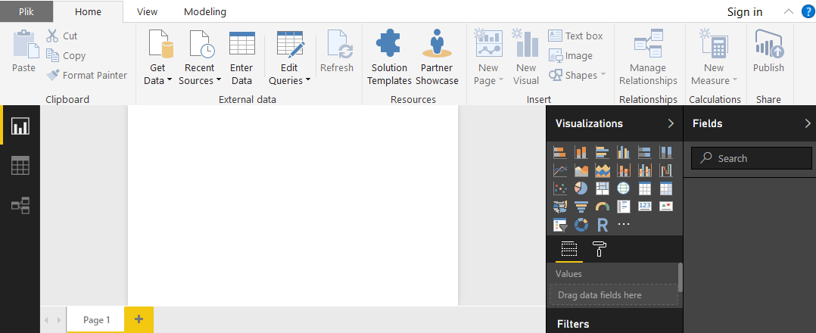

Figure 29. Power BI default view in report mode

There are three views in Power BI Desktop: Report view, Data view (Figure 29), and Relationships view (Figure 30).

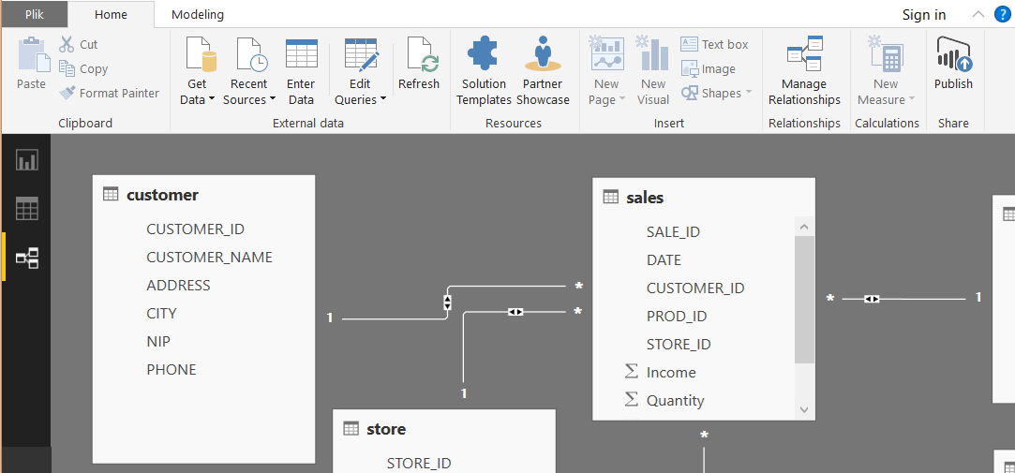

Figure 30. Relationships view

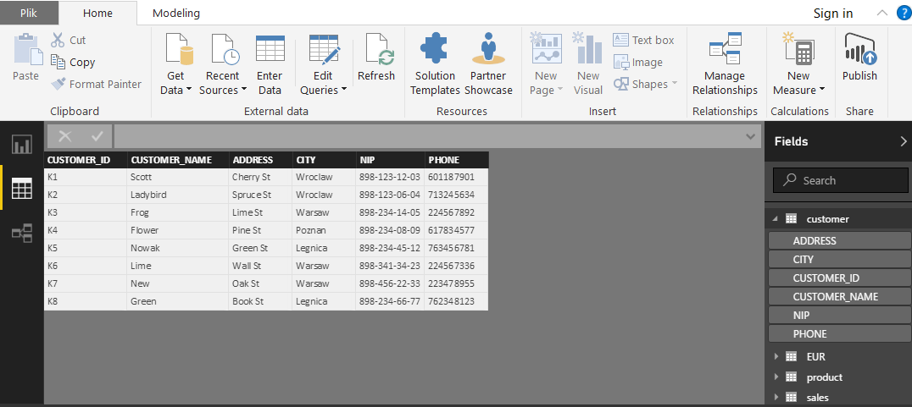

Figure 31. Data view.

In the default view, we can see 3 icons along the left of the Power BI Desktop: Report, Data, and Relationships, from top to bottom. The currently displayed view is indicated by the yellow bar on the left. In the case of Figure 31, Report view is currently displayed. You can change views by selecting any of those three icons. Power BI Desktop also includes Query Editor (Figure 32), which opens in a separate window. In Query Editor, you can build queries and transform data, then load that refined data model into Power BI Desktop, and create reports.

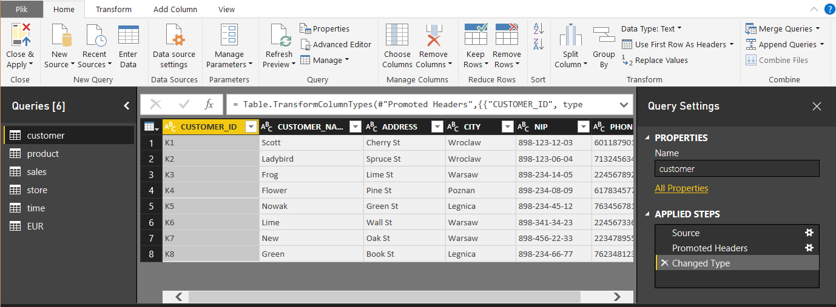

Figure 32. Query Editor.

## Typical scenario of analysis creation

Typical scenario includes the following stages:

Connect to Data

Shape and Combine Data

Remove unnecessary columns

Adapting data types

Remove unnecessary lines

Removing duplicates

Data transformation

Replace values

Merge / Split column (by delimiter or number of characters)

Calculate aggregation

Merge queries

Append queries

Transpose

Pivot columns

Add custom column (conditional, calculation)

Add measures

Building a model - an indication of references between data sets

Visualizations:

Definition of charts

Definition of filters

With Power BI Desktop installed, you’re ready to connect to various sources of data. There are all sorts of data sources available in the Query window. The following image shows how to connect to data, by selecting the Home ribbon, then Get Data > More[131].

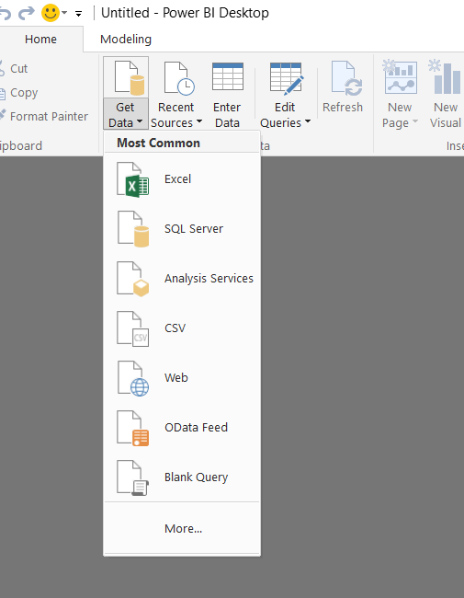

Figure 33. The most common data sources.

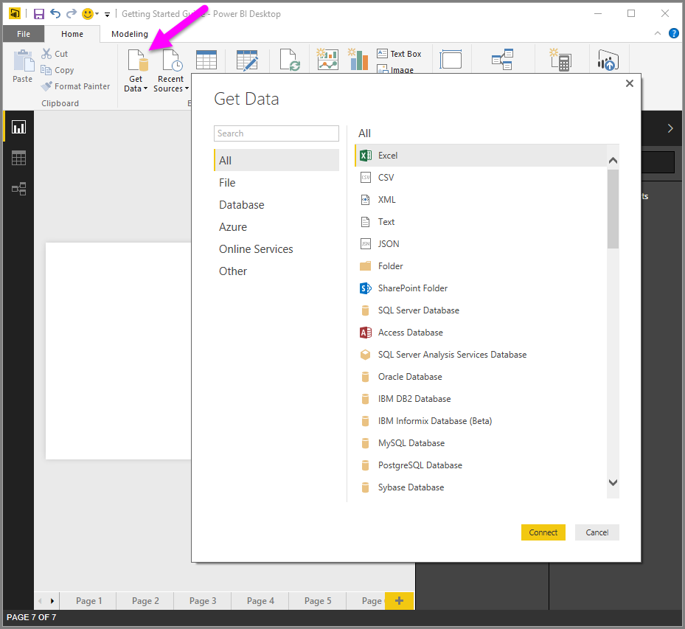

Figure 34. All available data sources.

We can distinguish the following groups of data sources:

File data sources

Databases

Online Services

Among File data sources we can find:

Excel

CSV

XML

Text

JSON

Folder

SharePoint Folder[132]

There are the following databases available:

SQL Server Database

Access Database

SQL Server Analysis Services Database

Oracle Database

IBM DB2 Database

IBM Informix Database (Beta)

MySQL Database

PostgreSQL Database

Sybase Database

Teradata Database

SAP HANA Database

SAP Business Warehouse

Amazon Redshift (Beta)

Impala (Beta)

Snowflake (Beta)

We can also import data from the following Online Services:

Web

Odata

ODBC

Facebook

Google Analytics[133]

After indicating the chosen data source the Navigator window returns the preview of data. Then we can load it directly or we can edit the query before loading the table, by selecting Edit from the bottom of the window, or we can load the table.

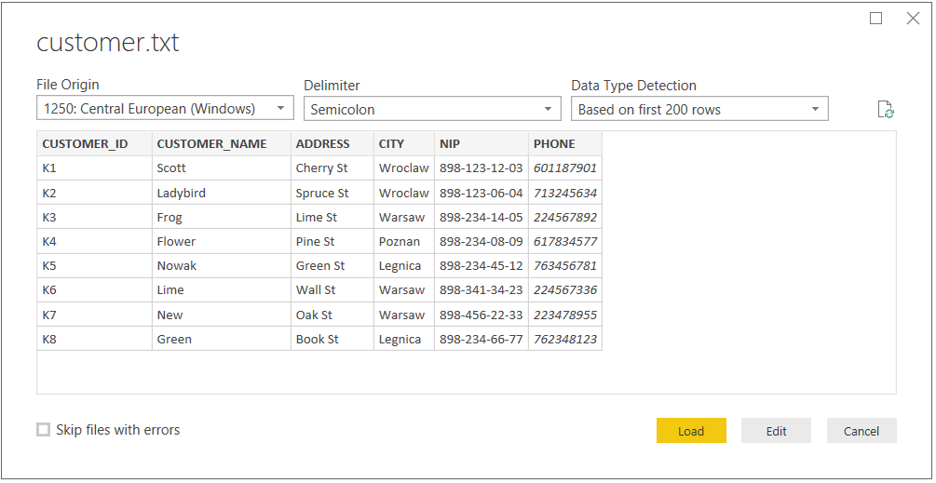

Figure 35. Navigator window – example of a text file

If we select Edit, the table is loaded and Query Editor is launched. The Query Settings pane is displayed (if it’s not, you can select View from the ribbon, then Show > Query Settings to display the Query Settings pane)[134].

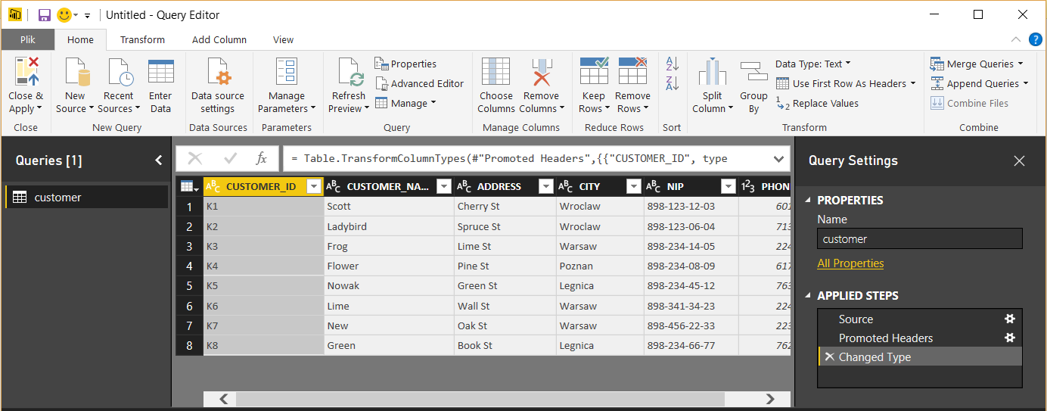

Figure 36. Query Editor Window.

At this stage, we can perform the following operations to prepare data for further processing.

Change a data type of selected column.

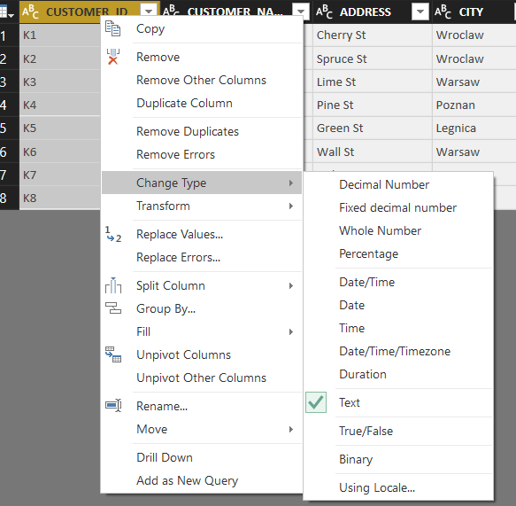

Figure 37. Changing data type.

Keep or remove columns

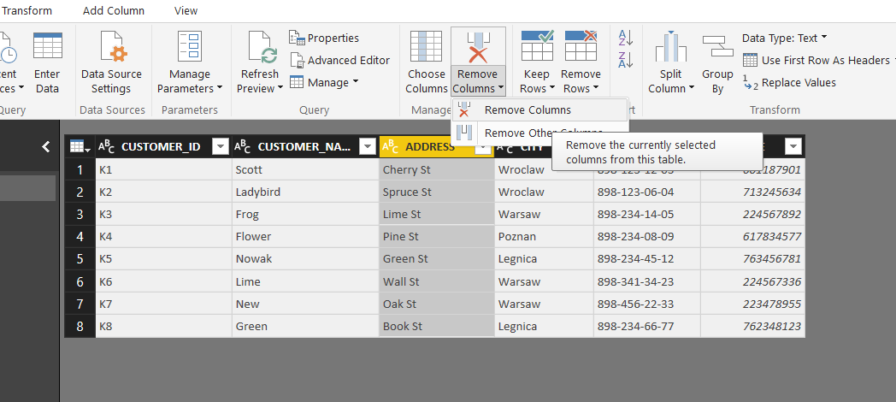

Figure 38. An example of column removal

Shaping data – changing the structure by the following options:

Use the first row as header

Remove the first column

Remove rows

Replacing . With ,

Changing data type

Change data source name

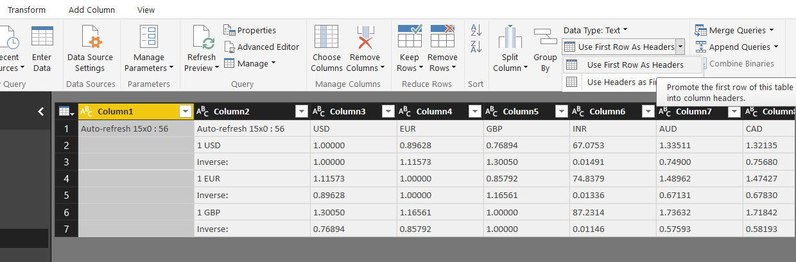

Figure 39. Available options of shaping data.

In Query Settings, the Applied Steps will reflect any changes that were made. As you make additional changes to the data, Query Editor will record those changes in the Applied Steps section, which you can adjust, revisit, rearrange, or delete as necessary[135].

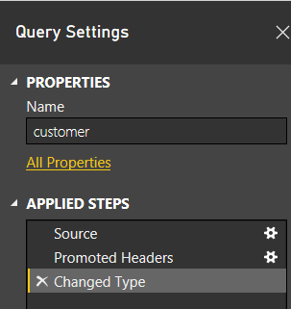

Figure 40. Management of applied steps during data shaping.

Additional changes to the table can still be made after it’s loaded, but for now, this will do. When we're done we select Close & Apply from the Home ribbon, and Power BI Desktop applies our changes and closes Query Editor[136].

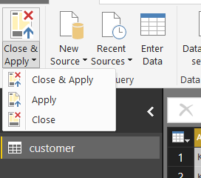

Figure 41. Close and apply option

Prepared data are the basis of further analysis creation.

## Resources

Getting started with Power BI Desktop, https://powerbi.microsoft.com/en-us/documentation/powerbi-desktop-getting-started/

Guided Learning, https://powerbi.microsoft.com/en-us/guided-learning/

Alberto Ferrari, Marco Russo, Introducing Microsoft Power BI, Microsoft Press, 2016

Adam Aspin, Pro Power BI Desktop, Apress, 2016

M.O. Cuddley, INTRODUCTION TO MICROSOFT POWER BI: BRING YOUR DATA TO LIFE! , 2016

# Analysis with Power BI *(Maciej Pondel)*

## Building models

Before performing the analysis in MS Power BI we need to build a data model and perform all necessary data transformation. The previous chapter presented how to load data into Power BI and how to shape them in order to receive a useful data set.

Power BI Desktop has three views:

• Report view – where you use queries you create to build compelling visualizations, arranged as you want them to appear, and with multiple pages, that you can share with others

• Data view – see the data in your report in data model format, where you can add measures, create new columns, and manage relationships

• Relationships view – get a graphical representation of the relationships that have been established in your data model, and manage or modify them as needed.

These views are accessed by selecting one of the three icons along the left side of Power BI Desktop. In the following image, Report view is selected, indicated by the yellow band beside the icon[137].

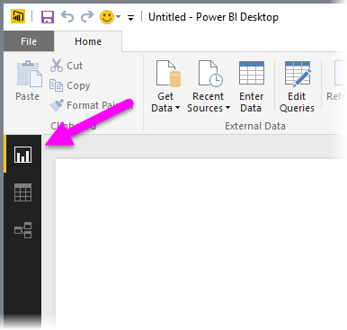

Figure 42. Selection of a view mode[138].

Data View helps you inspect, explore, and understand data in your Power BI Desktop model. It's different from how you view tables, columns, and data in Query Editor. With Data View, you’re looking at your data after it has been loaded into the model.

When you’re modeling your data, sometimes you want to see what’s actually in a table or column without creating a visual on the report canvas, often right down to the row level. This is especially true when you’re creating measures and calculated columns, or you need to identify a data type or data category[139].

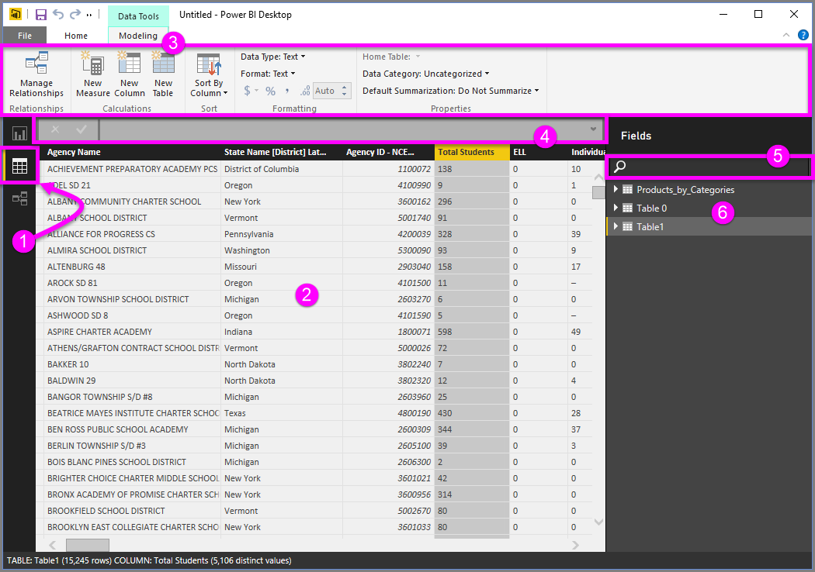

Figure 43. Main working areas in PowerBI.

1. Data View icon – Click to enter Data View.

2. Data Grid – Shows the selected table and all columns and rows in it. Columns hidden from Report View are grayed out. You can right-click on a column for options.

3. Modeling ribbon – Manage relationships, create calculations, change the data type, format, data category for a column.

4. Formula Bar – Enter DAX formulas for Measures and Calculated columns.

5. Search – Search for a table or column in your model.

6. Fields list – Select a table or column to view in the data grid[140],[141].

## New columns and measures

In order to perform more efficient analysis, we can enrich our data set by a new calculated column and a new measure.

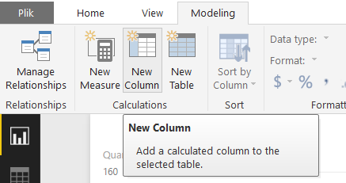

Figure 44. Adding a new column or measure.

With calculated columns, you can add new data to a table already in your model. But instead of querying and loading values into your new column from a data source, you create a Data Analysis Expressions (DAX) formula that defines the column’s values. In Power BI Desktop, calculated columns are created by using the New Column feature in Report View.

Calculated columns you create appear in the Fields list just like any other field, but they’ll have a special icon showing its values are the result of a formula. You can name your columns whatever you want, and add them to a report visualization just like other fields.

The calculated column always corresponds to the row in the selected table. For example, when we have orders in the table and there are unit price and quantity, but no total amount, we can add such a column as a calculated column.[142]

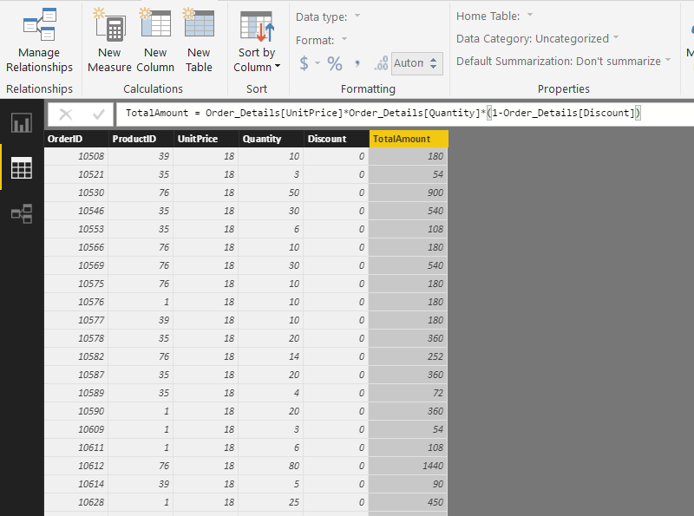

Figure 45. An example of a calculated column.

Measures are used in some of the most common data analysis; for example, sums, averages, minimum or maximum values, counts, or more advanced calculations you create yourself using a DAX formula. The calculated results of measures are always changing in response to your interaction with your reports, allowing for fast and dynamic ad-hoc data exploration.

In Power BI Desktop, measures are created and used in Report View or Data View. Measures you create yourself appear in the Fields list with a calculator icon. You can name measures whatever you want, and add them to a new or existing visualization just like any other field[143].

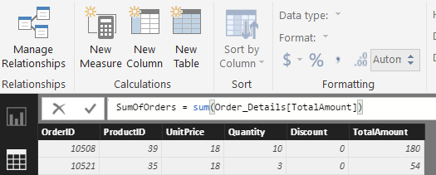

Figure 46. An example of a measure.

Both column and measures appear in the Fields list.

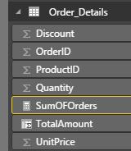

Figure 47. Field list.

## Relationships

Relationship View shows all of the tables, columns, and relationships in your model. This can be especially helpful when your model has complex relationships between many tables.

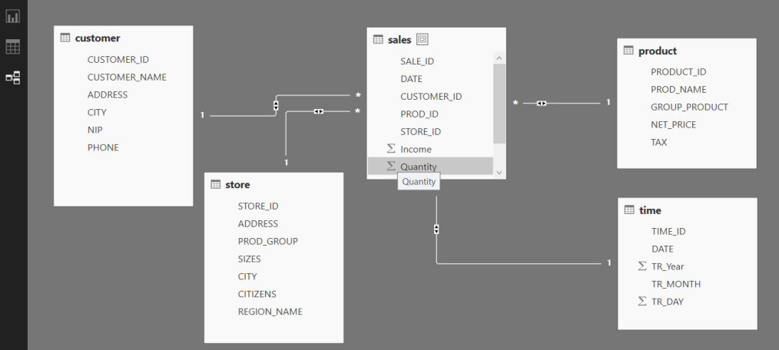

Figure 48. Relationship view.

Relationship View icon – Click to show your model in Relationship View Relationship – You can hover your cursor over a relationship to show the columns used. Double-click on a relationship to open it in the Edit Relationship dialog box.

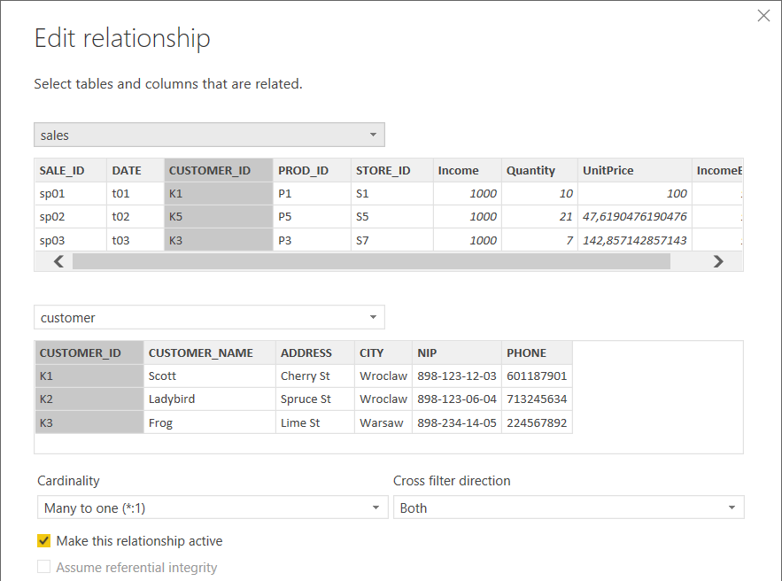

Figure 49. Edit relationship view

## Creation of visualizations

When you first load data in Power BI Desktop, you’ll see Report View with a blank canvas.

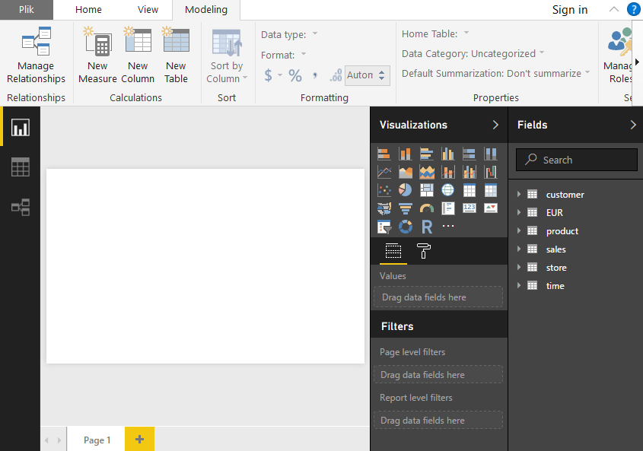

Figure 50. Report view

.

To add a visualization to report page you should:

1. Click on a selected type of visualization – empty visualization will be added to a current page.

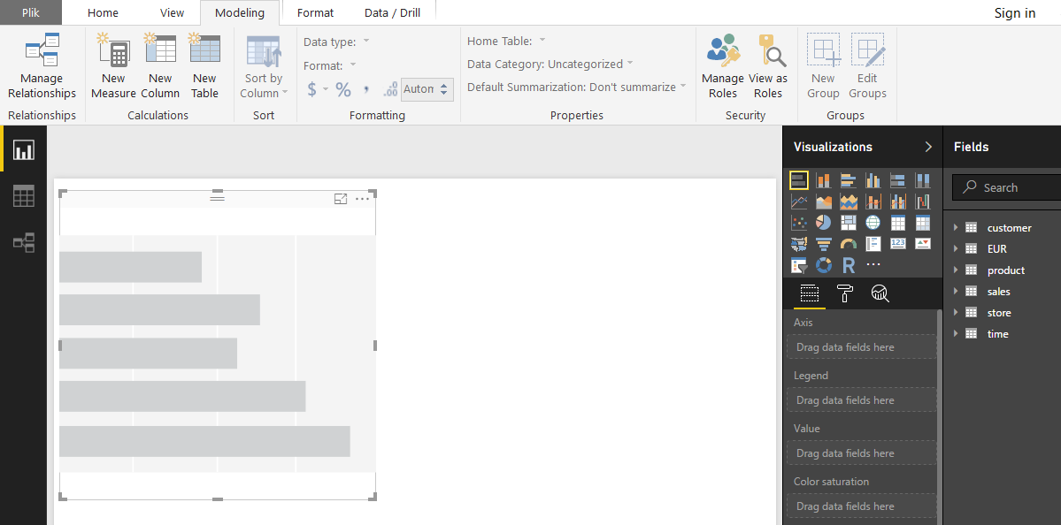

Figure 51. Report view with empty visualization.

2. Select data fields to:

a. Axis

b. Legend

c. Value

d. Color saturation of current visualization

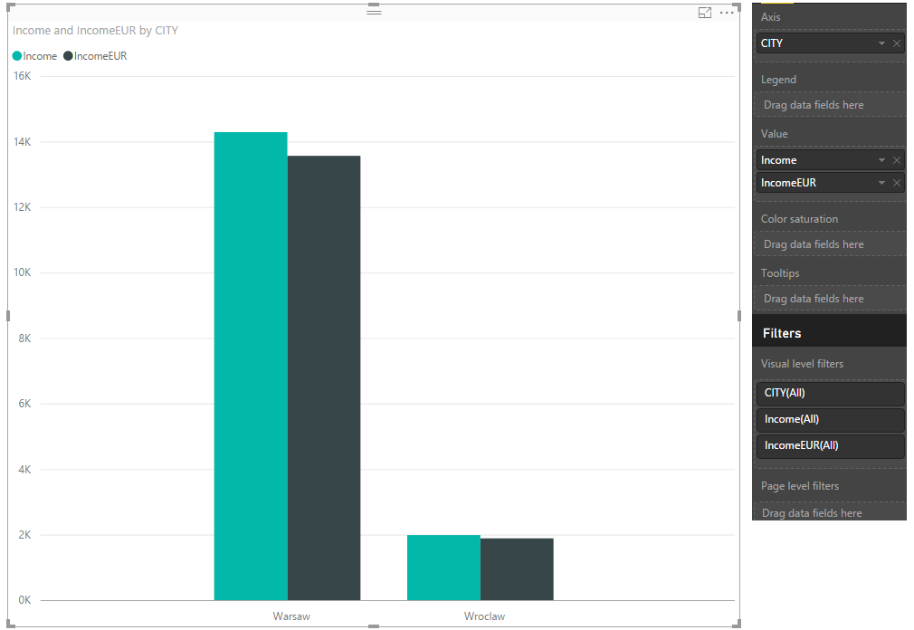

Figure 44. Report view with defined visualization and its configuration.

To change the type of visualization, you can select it from the Visualization group in the ribbon or you can right click and select a different one from the Change visualization type icon.

A report will have at least one blank page to start. Pages appear in the navigator pane just to the left of the canvas. You can add all sorts of visualizations to a page, but it's important not to overdo it. Too many visualizations on a page will make it look busy and difficult to find the right information. You can add new pages to your report, just click New Page on the ribbon[144].

The following visualizations are available in Power BI:

• stack bar/column charts,

• clustered bar/column charts,

• 100% stack bar/column charts,

• line chart,

• area chart,

• stacked area chart,

• line & stack column chart,

• line & clustered column chart,

• waterfall chart,

• scatter chart,

• pie chart,

• tree map,

• map,

• table,

• matrix,

• filled map,

• funnel,

• gauge,

• cards,

• KPI,

• slicers,

• donut chart,

• R – Studio (enter R code)[145],

Figure 45. Area charts: Basic (Layered) and Stacked[146].

Tip: The Basic Area chart is based on the line chart with the area between the axis and line filled in.

Figure 46. Bar and column charts.

Tip: Bar charts are the standard for looking at a specific value across different categories.



Figure 47. Cards: Multi row



Figure 48. Cards: Single number.

Figure 49. Combo charts.

Tip: A Combo chart combines a column chart and a line chart. Choose from Line and Stacked Column and Line and Clustered Column.

Figure 50. Doughnut charts.

Tip: Doughnut charts are similar to Pie charts. They show the relationship of parts to a whole.

Figure 51. Funnel charts

Tip: Funnels help visualize a process that has stages and items flow sequentially from one stage to the next. Use a funnel when there is a sequential flow between stages, such as a sales process that starts with leads and ends with purchase fulfillment.

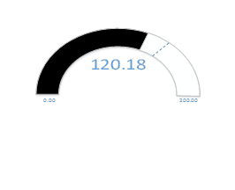

Figure 52. Funnel charts.

Tip: Display current status in the context of a goal.

KPI visual presents the last month’s indicator value towards the goal value also referring to last months. Line in background is just a presentation of the actual value without a reference to the goal value. The time scale is also not present by design. The role of this visual is only to present current month value against the goal.

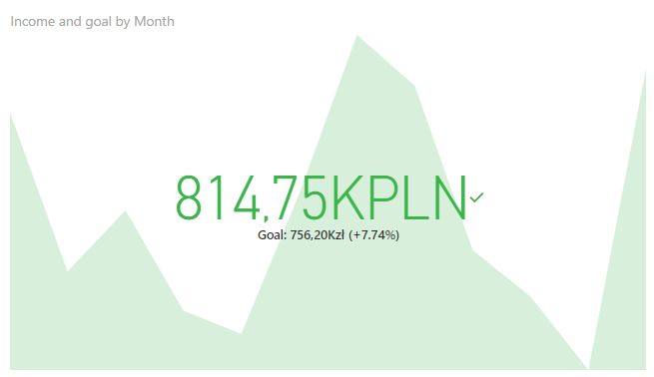

Figure 53. KPIs.

Tip: If you would like to display progress toward a measurable goal with a reference to time – use line charts.

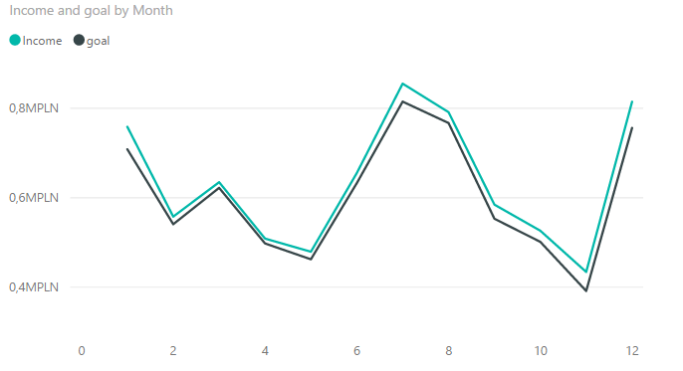

Figure 54. Line charts.

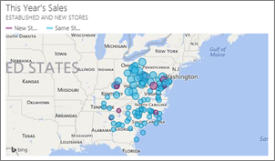

Figure 55. Maps: Basic maps.

Tip: used to associate both categorical and quantitative information with spatial locations.

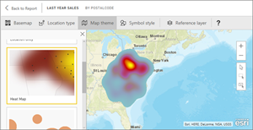

Figure 56. Maps: ArcGIS maps

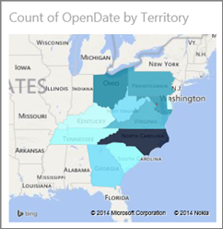

Figure 57. Maps: Filled maps (Choropleth).

Tip: The more intense the color, the larger the value.

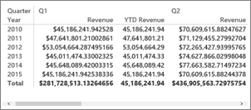

Figure 58. Matrix.

.

Figure 59. Pie charts.

Figure 60. Scatter and Bubble charts

Tip: display relationships between 2 (scatter) or 3 (bubble) quantitative measures -- whether or not, in which order, etc.



Figure 61. Slicers.

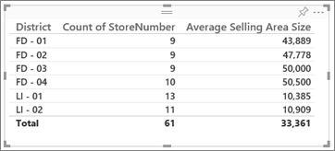

Figure 62. Tables.

Tip: work well with quantitative comparisons among items where there are many categories.



Figure 63. Tree Maps.

Tip: are charts of colored rectangles, with size representing value. They can be hierarchical, with rectangles nested within the main rectangles[147].

## Resources

***Literature:***

Getting started with Power BI Desktop, <https://powerbi.microsoft.com/en-us/documentation/powerbi-desktop-getting-started/>

Guided Learning, <https://powerbi.microsoft.com/en-us/guided-learning/>

Alberto Ferrari, Marco Russo, Introducing Microsoft Power BI, Microsoft Press, 2016

Adam Aspin, Pro Power BI Desktop, Apress, 2016

M.O. Cuddley, INTRODUCTION TO MICROSOFT POWER BI: BRING YOUR DATA TO LIFE!, 2016

Teo Lachev, Applied Microsoft Power BI: Bring your data to life!, Prologika Press, 2015

***Videos:***

[Online], Available at: <https://www.youtube.com/watch?v=jkCCnwvO_fg&ab_channel=TechnologyAdvice>,

,Accessed [11 August 2017].

[Online], Available at: <https://www.youtube.com/watch?v=rfW1qSKqxfk&ab_channel=AudiobookChannel> Accessed [11 August 2017].

[Online], Available at: <https://www.youtube.com/watch?v=L-LP3Ho9Mlk&ab_channel=SageERPSolutions>, Accessed [11 August 2017].

[Online], Available at: <https://www.youtube.com/watch?v=oqFPx4ru7o8&ab_channel=AshishMathur> , Accessed [11 August 2017].

[Online], Available at: <https://www.youtube.com/watch?v=NB2ZSZ_qwjE&ab_channel=e2bteknologies> , Accessed [11 August 2017].

[Online], Available at: <https://www.youtube.com/watch?v=BfowBtIxNu4&ab_channel=edureka%21> , Accessed [11 August 2017].

[Online], Available at: <https://www.youtube.com/watch?v=WBebD49pKFA&ab_channel=JigsawAcademy> , Accessed [11 August 2017].

[Online], Available at: <https://www.youtube.com/watch?v=ObbJJ4CjN4M&ab_channel=CloudHound> , Accessed [11 August 2017].

[Online], Available at: <https://www.youtube.com/watch?v=DW5NZHTZlPw&ab_channel=PragmaticWorks> , Accessed [11 August 2017].

[Online], Available at: <https://www.youtube.com/watch?v=h6AIAxMEDiw&ab_channel=Efficiency365> , Accessed [11 August 2017].

[Online], Available at: <https://www.youtube.com/watch?v=TMMOByVrgzY&ab_channel=DustinRyan> , Accessed [11 August 2017].

[Online], Available at: <https://www.youtube.com/watch?v=e2wDqspleNk&ab_channel=MelvinL>, Accessed [11 August 2017].

[Online], Available at: <https://www.youtube.com/watch?v=VV1aXQTbUxs&ab_channel=GuyinaCube>, Accessed [11 August 2017].

[Online], Available at: <https://www.youtube.com/watch?v=O6r0fJ-bizk&ab_channel=BharatiDWConsultancy>, Accessed [11 August 2017].

[Online], Available at: <https://www.youtube.com/watch?v=hRbf-L8ORVU&ab_channel=MicrosoftPowerBI> , Accessed [11 August 2017].

[Online], Available at: <https://www.youtube.com/watch?v=s8VGQaRhoow&ab_channel=Curbal> , Accessed [11 August 2017].

[Online], Available at: <https://www.youtube.com/watch?v=p-6rYtve-ls&ab_channel=kalmstrom.com>, Accessed [11 August 2017].

[Online], Available at: <https://www.youtube.com/watch?v=PzshpJbc8CE&ab_channel=ExcelIsFun> , Accessed [11 August 2017].

Documents in pdf and ppt format:

[Online], Available at:<https://www.slideshare.net/sujithkylm007/business-intelligence-ppt>Accessed [11 August 2017].

[Online], Available at:<https://www.slideshare.net/rla1022/business-intelligence>Accessed [11 August 2017].

[Online], Available at:<http://www.cs.ubbcluj.ro/~anca/bi/slides/curs01.ppt>Accessed [11 August 2017].

[Online], Available at:<https://www.google.pl/url?sa=t&rct=j&q=&esrc=s&source=web&cd=5&cad=rja&uact=8&ved=0ahUKEwjS9MT60czVAhVFQBQKHcmEAgQQFghKMAQ&url=https%3A%2F%2Fwww.isaca.org%2Fchapters1%2Fphoenix%2Fevents%2FDocuments%2Fbusiness_intelligence_overview.ppt&usg=AFQjCNHURUu4wJYdRz-n0jwG_Vtfyx5L6w>Accessed [11 August 2017].

[Online], Available at:<https://www.google.pl/url?sa=t&rct=j&q=&esrc=s&source=web&cd=6&cad=rja&uact=8&ved=0ahUKEwjS9MT60czVAhVFQBQKHcmEAgQQFghQMAU&url=http%3A%2F%2Fwww.cse.ust.hk%2F~qyang%2F4332%2FPPT%2FBIIntro.ppt&usg=AFQjCNE3Hgji46IVJLNGaWqbYqz9q3X_8Q>Accessed [11 August 2017].

[Online], Available at:<https://pdfs.semanticscholar.org/ce99/fdcae5bdc9ce6f60c2e7f2b95ab10f7c29c7.pdf>Accessed [11 August 2017].

[Online], Available at:<http://svapa.org/images/meeting/091913/svapa_presentation.pptx>Accessed [11 August 2017].

[Online], Available at:<https://powerbi.microsoft.com/en-us/documentation/powerbi-service-publish-to-powerpoint/>Accessed [11 August 2017].

<https://www.crmug.com/HigherLogic/System/DownloadDocumentFile.ashx?DocumentFileKey=5011d1ea-f570-6560-6a95-6a8799f3e895&forceDialog=1>Accessed [11 August 2017].

[Online], Available at:<https://www.slideshare.net/ArchanaTiwari3/crm-business-intelligence>Accessed [11 August 2017].

[Online], Available at:<https://www.google.pl/url?sa=t&rct=j&q=&esrc=s&source=web&cd=2&cad=rja&uact=8&ved=0ahUKEwjQt4LU1czVAhWD0xQKHQnEA9UQFgguMAE&url=http%3A%2F%2Fcbafiles.unl.edu%2Fpublic%2Fcbainternal%2FfacStaffUploads%2FHour7.ppt&usg=AFQjCNHk3FrL8LVAe_Zo-DIcGIA-O8VoBw>Accessed [11 August 2017].

[Online], Available at:<http://www.pass.org/DownloadFile.aspx?File=58a65c69>Accessed [11 August 2017].

[Online], Available at:[http://www.cpp.edu/~raguthrie/CIS310/ppts/BigData.pptx](https://l.facebook.com/l.php?u=http%3A%2F%2Fwww.cpp.edu%2F~raguthrie%2FCIS310%2Fppts%2FBigData.pptx&h=ATNLrkRU3gzjeL5s-2Xi81ot-TqokqBIJKJ8ivLVdh7ujM9EEBEQOHIH7TVGHLtQEJGaDt9fNpdKUVFwXGoOwa5-5Onh9ms1sdvHfUw1htwmQ_rduh-utyOwAEP_0oAaH9sI0r770AFRPw) Accessed [11 August 2017].

[Online], Available at:<https://www.slideshare.net/Netwoven/power-bi-overview-41399411>Accessed [11 August 2017].

[Online], Available at:<https://oasisky.com/wp-content/uploads/2015/05/The-Two-Types-of-Business-Intelligence.pdf>Accessed [11 August 2017].

[Online], Available at:<http://www.dbjournal.ro/archive/14/14_2.pdf>

[Online], Available at:<http://www.win.tue.nl/~mpechen/courses/TIES443/handouts/lecture02.pdf>Accessed [11 August 2017].

[Online], Available at:<http://analytics.ncsu.edu/sesug/2008/BI-001.pdf>

[Online], Available at: <http://illumiti.com/wp-content/uploads/2013/12/TDWI_Checklist_BI_for_SME_0611-document42.pdf> , Accessed [11 August 2017].

[Online], Available at: <http://hosteddocs.ittoolbox.com/ibmcognosovumbiandanalyticsfundamentals.pdf> , Accessed [11 August 2017].

[Online], Available at: <http://www.clearpeaks.com/pdf/course_outlines/ClearPeaks_BusinessIntelligence_BIFundamentals.pdf> , Accessed [11 August 2017].[Online], Available at: <http://www.win.tue.nl/~mpechen/courses/TIES443/handouts/lecture02.pdf> , Accessed [11 August 2017].

[Online], Available at: <http://resources.idgenterprise.com/original/AST-0066459_YTW03194CAEN.pdf> , Accessed [11 August 2017].

[Online], Available at: <http://analytics.ncsu.edu/sesug/2008/BI-001.pdf> , Accessed [11 August 2017].

[Online], Available at: <http://enos.itcollege.ee/~gseier/D.L.Wells_TDWI_M%C3%BCnchen.pdf> , Accessed [11 August 2017].

[Online], Available at: <http://www.dbjournal.ro/archive/14/14_2.pdf> , Accessed [11 August 2017].

[Online], Available at: <http://www.jatit.org/volumes/research-papers/Vol9No1/9Vol9No1.pdf> , Accessed [11 August 2017].[Online], Available at: <https://pdf.s.semanticscholar.org/ce99/fdcae5bdc9ce6f60c2e7f2b95ab10f7c29c7.pdf> , Accessed [11 August 2017].

[Online], Available at: <http://support.sas.com/publishing/pubcat/chaps/57587.pdf> , Accessed [11 August 2017].

[Online], Available at: <https://doc.lagout.org/Others/Data%20Mining/Business%20Intelligence%20and%20Data%20Mining%20%5BMaheshwari%202014-12-31%5D.pdf> , Accessed [11 August 2017].

[Online], Available at: <http://www.dbjournal.ro/archive/20/20_5.pdf> , Accessed [11 August 2017].

[Online], Available at: <http://www.iraj.in/journal/journal_file/journal_pdf/2-240-14592560501-5.pdf> , Accessed [11 August 2017].

# Summary *(Mieczysław L. Owoc)*

The presented version of an active book covered selected essential topics identified with the area of Business Intelligence. Some of these chapters can be extended via new approaches to BI including more detailed description of applying new technologies and integration of the existing solutions.

It means that all knowledge delivered and capabilities obtained should be gradually improved also in terms of updating new approaches or changing the tools available.

Active books should be also integrated with the teaching methods presented in the separate documents.

# List of Tables

Table 1. Differences between Homogeneous Technology and Service Oriented Approach 20

Table 2. Web 1.0/2.0/3.0 in Business 30

Table 3. Comparative Analysis of Virtualization and Cloud Computing 39

Table 4. Communication 47

Table 5. Networking. 47

Table 6. Marketing. 48

Table 7. Commerce. 48

Table 8. Logistics. 48

Table 9. Other solutions. 49

Table 10. Mobile BI vs. Traditional BI 51

Table 11. A comparison between ERP, BI and CRM reports. 59

Table 12. Frequencies by years. 64

Table 13. Descriptives 65

Table 14. ANOVA 65

Table 15. Descriptives 67

Table 16. Independent Samples Test. 67

Table 17. Factors influencing revenues. 68

Table 18. Factors influencing revenues in the year 2007 69

Table 19. Paired Samples Statistics 70

Table 20a. Paired Samples Statistics. 70

Table 21. Paired Samples Test. 70

# List of Figures

Figure 1 Management level of information. 8

Figure 2. ICT system, organization, people and technology. 12

Figure 3. ICT system, company, people, and technology. 13

Figure 4. Distance management of SMEs using ICT 14

Figure 5. Blended Management Methodology. 15

Figure 6. Global Storage Capacity. 17

Figure 7. Services. 18

Figure 8. From Mainframe to SOA. 21

Figure 9. Schema of “Publish, Find, Use” triangle. 21

Figure 10. Schema of SOA Combined with IT Architecture 21

Figure 11. Supply Chain of SOA. 22

Figure 12. Example of Architecture In Company. 23

Figure 13. SOA in the context of business, architecture, implementation 23

Figure 14. Schema of Web 1.0 25

Figure 15. Schema of Web 2.0. 26

Figure 16. Features of Web 1.0 and Web 2.0 28

Figure 17. Schema of Web 3.0 31

Figure 18. Trends in BI 32

Figure 19. A model of Cloud Computing of IT and telecommunication systems for SMEs in the future 42

Figure 20. A cloud computing structure. 50

Figure 21. Domains which contain BII4 54

Figure 22. Examples of BI functions 54

Figure 23. Areas of business management 55

Figure 24. Areas of CRM systems, own elaboration111 56

Figure 25. ERP, BI and CRM systems 58

Figure 26. Integration of ERP, CRM, and Bi systems21. 61

Figure 27. Power BI general architecture. 79

Figure 28. Power BI components. 80

Figure 29. Power BI default view in report mode 81

Figure 30. Relationships view 81

Figure 31. Data view. 82

Figure 32. Query Editor. 82

Figure 33. The most common data sources. 83

Figure 34. All available data sources. 84

Figure 35. Navigator window – example of a text file 85

Figure 36. Query Editor Window. 85

Figure 37. Changing data type. 86

Figure 38. An example of column removal 86

Figure 39. Available options of shaping data. 87

Figure 40. Management of applied steps during data shaping. 87

Figure 41. Close and apply option 88

Figure 42. Selection of a view mode. 89

Figure 43. Main working areas in PowerBI. 90

Figure 44. Report view with defined visualization and its configuration. 95

Figure 45. Area charts: Basic (Layered) and Stacked. 96

Figure 46. Bar and column charts. 97

Figure 47. Cards: Multi row 97

Figure 48. Cards: Single number. 98

Figure 49. Combo charts. 98

Figure 50. Doughnut charts. 98

Figure 51. Funnel charts 99

Figure 52. Funnel charts. 99

Figure 53. KPIs. 100

Figure 54. Line charts. 100

Figure 55. Maps: Basic maps. 101

Figure 56. Maps: ArcGIS maps 101

Figure 57. Maps: Filled maps (Choropleth). 101

Figure 58. Matrix. 102

Figure 59. Pie charts. 102

Figure 60. Scatter and Bubble charts 102

Figure 61. Slicers. 103

Figure 62. Tables. 103

Figure 63. Tree Maps. 104

1. Extended material related to this chapter has been presented during the scientific conference in Guangzohu, China September, 2016 within dissemination of the DIMBI project
2. [Online],Available at: [https://www.slideshare.net/greenliondigital/types-of-business-intelligence-tools](https://l.facebook.com/l.php?u=https%3A%2F%2Fwww.slideshare.net%2Fgreenliondigital%2Ftypes-of-business-intelligence-tools&h=ATPB9YzwdcO_LECEWlznNFdPq9672xVGeXeGZXqEsiEVlLvMXh9gjZp3nfyEV2e2SnrEYEkZV07Pmce4oDXpoCmQn5T8DWcuuGq5mJg4fzs428bPnpl46cQR5RWC4ACe7H4U8eE_jDNNjw) ,Accessed [21 August 2017]
3. [Online],Available at: [http://www.studfiles.ru/preview/5330480/page:2/](https://l.facebook.com/l.php?u=http%3A%2F%2Fwww.studfiles.ru%2Fpreview%2F5330480%2Fpage%3A2%2F&h=ATPB9YzwdcO_LECEWlznNFdPq9672xVGeXeGZXqEsiEVlLvMXh9gjZp3nfyEV2e2SnrEYEkZV07Pmce4oDXpoCmQn5T8DWcuuGq5mJg4fzs428bPnpl46cQR5RWC4ACe7H4U8eE_jDNNjw),Accessed [21 August 2017]
4. [Online],Available at: [http://slideplayer.com/slide/6336413/](https://l.facebook.com/l.php?u=http%3A%2F%2Fslideplayer.com%2Fslide%2F6336413%2F&h=ATPB9YzwdcO_LECEWlznNFdPq9672xVGeXeGZXqEsiEVlLvMXh9gjZp3nfyEV2e2SnrEYEkZV07Pmce4oDXpoCmQn5T8DWcuuGq5mJg4fzs428bPnpl46cQR5RWC4ACe7H4U8eE_jDNNjw),Accessed [21 August 2017]
5. [Online],Available at: [https://www.slideshare.net/greenliondigital/types-of-business-intelligence-tools](https://l.facebook.com/l.php?u=https%3A%2F%2Fwww.slideshare.net%2Fgreenliondigital%2Ftypes-of-business-intelligence-tools&h=ATPB9YzwdcO_LECEWlznNFdPq9672xVGeXeGZXqEsiEVlLvMXh9gjZp3nfyEV2e2SnrEYEkZV07Pmce4oDXpoCmQn5T8DWcuuGq5mJg4fzs428bPnpl46cQR5RWC4ACe7H4U8eE_jDNNjw) ,Accessed [21 August 2017]
6. [Online],Available at: [https://www.slideshare.net/greenliondigital/types-of-business-intelligence-tools](https://l.facebook.com/l.php?u=https%3A%2F%2Fwww.slideshare.net%2Fgreenliondigital%2Ftypes-of-business-intelligence-tools&h=ATPB9YzwdcO_LECEWlznNFdPq9672xVGeXeGZXqEsiEVlLvMXh9gjZp3nfyEV2e2SnrEYEkZV07Pmce4oDXpoCmQn5T8DWcuuGq5mJg4fzs428bPnpl46cQR5RWC4ACe7H4U8eE_jDNNjw) ,Accessed [21 August 2017]
7. [Online],Available at: [http://ijo.iaurasht.ac.ir/article_529145_d1bfe68e8bb29997ade9757ad9f14342.p](https://l.facebook.com/l.php?u=http%3A%2F%2Fijo.iaurasht.ac.ir%2Farticle_529145_d1bfe68e8bb29997ade9757ad9f14342.p&h=ATPB9YzwdcO_LECEWlznNFdPq9672xVGeXeGZXqEsiEVlLvMXh9gjZp3nfyEV2e2SnrEYEkZV07Pmce4oDXpoCmQn5T8DWcuuGq5mJg4fzs428bPnpl46cQR5RWC4ACe7H4U8eE_jDNNjw), Accessed [21 August 2017]
8. Presented during International Conference on Mathematics and Decision Sciences, September 12-15, 2016, Guangzhou, China
9. Leyla Norman, What Are the Four Basic Functions That Make Up the Management Process?, Small Business Chron, [Online], Available at: http://smallbusiness.chron.com/four-basic-functions-make-up-management-process-23852.html, Accessed [07 August 2017].
10. Kenneth C. Laudon and Jane P. Laudon, Essentials of business information systems, seventh edition,Prentice-Hall, NY, 2006.
11. ICT system, organization, people and technology, Laudon & Laudon, 2006
12. ICT system, company, people and technology, Mráz, 2012, [Online], Available at: http://archive.unicornsystems.eu/en/news/article/what-is-the-task-of-ict-in-a-company-or-organization.html, Accessed [07 August 2017].
13. JiříMráz, What is the task of ICT in a company or organization?, Unicorn Systems, [Online], Available at: http://www.unicornsystems.eu/en/news/article/what-is-the-task-of-ict-in-a-company-or-organization.html, Accessed [07 August 2017].
14. Rekimoto J, Saitoh M, Augmented surfaces: a spatially continuous work space for hybrid computing environments, Proceedings of the SIGCHI conference on Human Factors in Computing Systems, 1999.
15. Randy Garrison D., Heather Kanuka, Blended learning: Uncovering its transformative potential in higher education, The Internet and Higher Education, Volume 7, Issue 2, 2nd Quarter 2004, Pages 95–105 Elsevier.
16. Altman J.C., Alleviating poverty in remote Indigenous Australia: The role of the hybrid economy, 2007, [Online], Available at: <http://caepr.anu.edu.au/sites/default/files/Publications/topical/Altman_Poverty.pdf>, Accessed [07 August 2017].
17. Bizshifts-trends, Blended Management Styles– Changing, Adapting–Take Best of Each: Create a Hybrid That Works for Your Organization…, 2013, [Online], Available at: http://bizshifts-trends.com/2013/09/09/blended-management-styles-changing-adapting-take-best-create-hybrid-works-organization/, Accessed [07 August 2017].
18. Boundless, A Blended Approach to Leadership, Boundless Management. Boundless, [Online], Available at: https://www.boundless.com/management/textbooks/boundless-management-textbook/leadership-9/types-of-leaders-72/a-blended-approach-to-leadership-358-3470/, Accessed [07 August 2017].
19. Blended Management Methodology, own elaboration
20. [Online],Available at: [http://ijo.iaurasht.ac.ir/article_529145_d1bfe68e8bb29997ade9757ad9f14342.p](https://l.facebook.com/l.php?u=http%3A%2F%2Fijo.iaurasht.ac.ir%2Farticle_529145_d1bfe68e8bb29997ade9757ad9f14342.p&h=ATPB9YzwdcO_LECEWlznNFdPq9672xVGeXeGZXqEsiEVlLvMXh9gjZp3nfyEV2e2SnrEYEkZV07Pmce4oDXpoCmQn5T8DWcuuGq5mJg4fzs428bPnpl46cQR5RWC4ACe7H4U8eE_jDNNjw), Accessed [21 August 2017].
21. Hilbert M., Lopez P., "The World's Technological Capacity to Store, Communicate and Compute Information", Science, 332(6025), 60-65, [Online], Available at: <http://www.martinhilbert.net/WorldInfoCapacity.html/>, Accessed [08 August 2016].
22. [Online],Available at: [http://www.yourdictionary.com/soa](https://l.facebook.com/l.php?u=http%3A%2F%2Fwww.yourdictionary.com%2Fsoa&h=ATPB9YzwdcO_LECEWlznNFdPq9672xVGeXeGZXqEsiEVlLvMXh9gjZp3nfyEV2e2SnrEYEkZV07Pmce4oDXpoCmQn5T8DWcuuGq5mJg4fzs428bPnpl46cQR5RWC4ACe7H4U8eE_jDNNjw), Accessed [21 August 2017]
23. Service Oriented Architecture (SOA), [Online], Available at: <http://www.thirdpillar.com/content/architecture>, Accessed [08 August 2017].
24. Raghu R. Kodali, From What is service-oriented architecture?, Junе 13 2005, [Online] Available at: <http://www.javaworld.com/article/2071889/soa/what-is-service-oriented-architecture.html>, Accessed [08 August 2017].
25. [Online],Available at: [https://flatworldbusiness.wordpress.com/flat-education/previously/web-1-0-vs-web-2-0-vs-web-3-0-a-bird-eye-on-the-definition/](https://l.facebook.com/l.php?u=https%3A%2F%2Fflatworldbusiness.wordpress.com%2Fflat-education%2Fpreviously%2Fweb-1-0-vs-web-2-0-vs-web-3-0-a-bird-eye-on-the-definition%2F&h=ATPB9YzwdcO_LECEWlznNFdPq9672xVGeXeGZXqEsiEVlLvMXh9gjZp3nfyEV2e2SnrEYEkZV07Pmce4oDXpoCmQn5T8DWcuuGq5mJg4fzs428bPnpl46cQR5RWC4ACe7H4U8eE_jDNNjw), Accessed [21 August 2017]
26. [Online],Available at: [https://flatworldbusiness.wordpress.com/flat-education/previously/web-1-0-vs-web-2-0-vs-web-3-0-a-bird-eye-on-the-definition/](https://l.facebook.com/l.php?u=https%3A%2F%2Fflatworldbusiness.wordpress.com%2Fflat-education%2Fpreviously%2Fweb-1-0-vs-web-2-0-vs-web-3-0-a-bird-eye-on-the-definition%2F&h=ATPB9YzwdcO_LECEWlznNFdPq9672xVGeXeGZXqEsiEVlLvMXh9gjZp3nfyEV2e2SnrEYEkZV07Pmce4oDXpoCmQn5T8DWcuuGq5mJg4fzs428bPnpl46cQR5RWC4ACe7H4U8eE_jDNNjw), Accessed [21 August 2017]
27. Lamar University, Presentation for MAIS, [Online], 7 Nov 2014, Available at <https://www.slideshare.net/dianemason/mais-workshop-presentationnov2014final>

    Accessed [15 August 2017].
28. [Online],Available at: [https://flatworldbusiness.wordpress.com/flat-education/previously/web-1-0-vs-web-2-0-vs-web-3-0-a-bird-eye-on-the-definition/](https://l.facebook.com/l.php?u=https%3A%2F%2Fflatworldbusiness.wordpress.com%2Fflat-education%2Fpreviously%2Fweb-1-0-vs-web-2-0-vs-web-3-0-a-bird-eye-on-the-definition%2F&h=ATPB9YzwdcO_LECEWlznNFdPq9672xVGeXeGZXqEsiEVlLvMXh9gjZp3nfyEV2e2SnrEYEkZV07Pmce4oDXpoCmQn5T8DWcuuGq5mJg4fzs428bPnpl46cQR5RWC4ACe7H4U8eE_jDNNjw), Accessed [21 August 2017]
29. Sangita Sahu, April 24 2010 , Available at : <https://seofreelancingindia.wordpress.com/tag/difference-between-web-2-0-web-3-0/>
30. Schema of Web 2.0 , own elaboration
31. Lach J. Defining Business Intelligence 3.0, YellowFin, 26 July 2016, Available at:

    <https://www.yellowfinbi.com/blog/2014/04/yfcommunitynews-defining-business-intelligence-3-0-159445> Accessed [15 August 2017].
32. [Online],Available at: [https://flatworldbusiness.wordpress.com/flat-education/previously/web-1-0-vs-web-2-0-vs-web-3-0-a-bird-eye-on-the-definition/](https://l.facebook.com/l.php?u=https%3A%2F%2Fflatworldbusiness.wordpress.com%2Fflat-education%2Fpreviously%2Fweb-1-0-vs-web-2-0-vs-web-3-0-a-bird-eye-on-the-definition%2F&h=ATPB9YzwdcO_LECEWlznNFdPq9672xVGeXeGZXqEsiEVlLvMXh9gjZp3nfyEV2e2SnrEYEkZV07Pmce4oDXpoCmQn5T8DWcuuGq5mJg4fzs428bPnpl46cQR5RWC4ACe7H4U8eE_jDNNjw), Accessed [21 August 2017]
33. Ray K., Web 1.0 vs Web 2.0 vs Web 3.0 vs Web 4.0 vs Web 5.0 – A bird’s eye on the evolution and definition, [Online], 25 July 2016 , Available at:<https://flatworldbusiness.wordpress.com/flat-education/previously/web-1-0-vs-web-2-0-vs-web-3-0-a-bird-eye-on-the-definition> Accessed [11 August 2017].
34. [Online],Available at: [https://flatworldbusiness.wordpress.com/flat-education/previously/web-1-0-vs-web-2-0-vs-web-3-0-a-bird-eye-on-the-definition/](https://l.facebook.com/l.php?u=https%3A%2F%2Fflatworldbusiness.wordpress.com%2Fflat-education%2Fpreviously%2Fweb-1-0-vs-web-2-0-vs-web-3-0-a-bird-eye-on-the-definition%2F&h=ATPB9YzwdcO_LECEWlznNFdPq9672xVGeXeGZXqEsiEVlLvMXh9gjZp3nfyEV2e2SnrEYEkZV07Pmce4oDXpoCmQn5T8DWcuuGq5mJg4fzs428bPnpl46cQR5RWC4ACe7H4U8eE_jDNNjw), Accessed [21 August 2017]
35. Johan Blomme, Trends in business intelligence 2012, SlideShare, Data Insights, 9 April 2012 , Available at: <https://www.slideshare.net/johblom/trends-in-businessintelligence2012>
36. Source: Knights M., Using Web 2.0 for Business, ComputerWeekly, 12 Sep 2007, Available at: <http://www.computerweekly.com/news/2240082941/Using-Web-20-for-business>, Danielle Ralston, Summer 2012, <https://lcccis125wsummer2012.wikispaces.com/Web+2.0+and+good+business+since>

    Accessed [11 August 2017].
37. Miya Knights, 12 September 2007, Available at: : <http://www.computerweekly.com/news/2240082941/Using-Web-20-for-business>

    Accessed [11 August 2017].
38. Miya Knights, 12 September 2007, Available at : <http://www.computerweekly.com/news/2240082941/Using-Web-20-for-business>

    Accessed [11 August 2017].
39. Business Intelligence Advantages, Web 2.0, Aminemekkaoui , May 14,2008, Available at: <http://aminemekkaoui.typepad.com/business_intelligence/web_20_bi/>

    Accessed [11 August 2017].
40. [Online], Available at: [http://aminemekkaoui.typepad.com/business_intelligence/web_20_bi/](https://l.facebook.com/l.php?u=http%3A%2F%2Faminemekkaoui.typepad.com%2Fbusiness_intelligence%2Fweb_20_bi%2F&h=ATPB9YzwdcO_LECEWlznNFdPq9672xVGeXeGZXqEsiEVlLvMXh9gjZp3nfyEV2e2SnrEYEkZV07Pmce4oDXpoCmQn5T8DWcuuGq5mJg4fzs428bPnpl46cQR5RWC4ACe7H4U8eE_jDNNjw), Accessed [21 August 2017].
41. [Online], Available at: [http://www.b-eye-network.com/view/7168](https://l.facebook.com/l.php?u=http%3A%2F%2Fwww.b-eye-network.com%2Fview%2F7168&h=ATPB9YzwdcO_LECEWlznNFdPq9672xVGeXeGZXqEsiEVlLvMXh9gjZp3nfyEV2e2SnrEYEkZV07Pmce4oDXpoCmQn5T8DWcuuGq5mJg4fzs428bPnpl46cQR5RWC4ACe7H4U8eE_jDNNjw), Accessed [21 August 2017].
42. Mike Ferguson on April 2, 2008 Available at: <http://www.b-eye-network.com/view/7168> Accessed [11 August 2017].
43. Journal Article, Pólkowski Z., Cloud Computing in SMEs in Poland, in: Information systems post-implementation and change management 2012, ed. M.B. Nunes, G.Ch. Peng, J. Roth, H. Weghorn and P. Isaias, IADIS, Lizbona, 17-23 July 2012, pp. 95-99, ISBN 978-972-8939-73-1.
44. Nycz M., Pólkowski Z., Cloud Computing In Government Units, in: 5th International Conference Advanced Computing and Communication Technologies, ACCT-15, RG Education Society (REGD), Rohtak, India. 21-22 February 2015, pp. 513-520, 978-1-4799-8487-9, available: <http://ieeexplore.ieee.org/xpl/articleDetails.jsp?arnumber=7079137&refinements%3D4228338542%26filter%3DAND%28p_IS_Number%3A7079031%29>
45. Chmura prywatna Microsoft: więcej niż wirtualizacja, [in:] Newsy, analizy i perspektywy dla var-ów i integratorów, CRN, 2012, pp. 11. Accessed [31 July 2017].
46. Smoktunowicz, Urszula, Strach przed chmurą, [in:] Newsy, analizy i perspektywy dla var-ów i integratorów, CRN, 2012, pp. 28 Accessed [31 July 2017].
47. Życzyński, Wojciech, Usługi w chmurze – rewolucja dla partnerów firm sektora MSP, [in:] Historia. Wydanie okolicznościowe, CRN, 2013, pp. 49. Accessed [31 July 2017].
48. Zhang Tao, Jiao Long, The Research and Application of Network Teaching Platform Based on Cloud Computing, 2011, [Online], Available at: <http://www.ijiet.org/papers/37-K10016.pdf>, Accessed [07 August 2017].
49. Ajith Singh. N, Hemalatha M., An approach on semi-distributed load balancing algorithm for cloud computing system,2012, [Online], Available at: <http://www.ijcaonline.org/archives/volume56/number12/8941-3083>,

    Accessed [07 August 2017].
50. Łapiński K., Wyżnikiewicz B., Cloud computing: wpływ na konkurencyjność przedsiębiorstw i gospodarkę Polski: raport, 2011, [Online], Available at: <http://www.ibngr.pl/Publikacje/Raporty-IBnGR/Cloud-Computing-wplyw-na-konkurencyjnosc-przedsiebiorstw-i-gospodarke-Polski>, Accessed [07 August 2017].
51. Smoktunowicz, Urszula, Strach przed chmurą, [in:] Newsy, analizy i perspektywy dla var-ów i integratorów, CRN, 2012, pp. 28
52. [Online],Available at: [http://www.service-architecture.com/articles/cloud-computing/cloud_computing_definition.html](https://l.facebook.com/l.php?u=http%3A%2F%2Fwww.service-architecture.com%2Farticles%2Fcloud-computing%2Fcloud_computing_definition.html&h=ATPB9YzwdcO_LECEWlznNFdPq9672xVGeXeGZXqEsiEVlLvMXh9gjZp3nfyEV2e2SnrEYEkZV07Pmce4oDXpoCmQn5T8DWcuuGq5mJg4fzs428bPnpl46cQR5RWC4ACe7H4U8eE_jDNNjw) , Accessed [21 August 2017]
53. [Online],Available at: [http://www.identity.pt/cloud-computing/](https://l.facebook.com/l.php?u=http%3A%2F%2Fwww.identity.pt%2Fcloud-computing%2F&h=ATPB9YzwdcO_LECEWlznNFdPq9672xVGeXeGZXqEsiEVlLvMXh9gjZp3nfyEV2e2SnrEYEkZV07Pmce4oDXpoCmQn5T8DWcuuGq5mJg4fzs428bPnpl46cQR5RWC4ACe7H4U8eE_jDNNjw), Accessed [21 August 2017]
54. Lefanowicz, Arkadiusz, Fundacja IT Leader Club Polska, 2014, [Online] Available at: <http://www.itleader.pl/uploads/Analizy_Chmura/Analiza_Chmura_Rzadowa_w_Polsce_v_1_0_draft_FundacjaITLeaderClubPolska.pdf>, Accessed [18 July 2016]
55. Nycz M. Polkowski Z., The Use of ICT in a Local Government Unit, 2014, pp 12.
56. Smoktunowicz, Urszula, Strach przed chmurą, [in:] Newsy, analizy i perspektywy dla var-ów i integratorów, CRN, 2012, pp. 28
57. Nycz M. Polkowski Z., The Use of ICT in a Local Government Unit, 2014, pp 12.
58. Radosiński E., Systemy informatyczne w dynamicznej analizie decyzyjnej, PWN, Warszawa, 2013.
59. Radosiński E., Systemy informatyczne w dynamicznej analizie decyzyjnej, PWN, Warszawa, 2013.
60. Życzyński, Wojciech, Usługi w chmurze – rewolucja dla partnerów firm sektora MSP, [in:] Historia. Wydanie okolicznościowe, CRN, 2013, pp. 49.
61. Rainer Zimmermann, Towards a European Cloud Computing Strategy,2011, [Online], Available at: <https://ec.europa.eu/digital-single-market/en/blog/towards-a-cloud-computing-strategy-for-europe-matching-supply-and-demand>, Accessed [07 August 2017].
62. Sorell M., 2010., [Online] Available at: XYZ..... Accessed [10 August 2017].
63. Bokhari R., 2010., [Online] Available at: XYZ..... Accessed [10 August 2017].
64. Gazda P., 2011., [Online] Available at: XYZ..... Accessed [10 August 2017].
65. Bryja T.,Nowa odsłona iFaktury24 dla jednoosobowych i małych firm, 2012,[Online], Available at: <https://www.dobreprogramy.pl/Nowa-odslona-iFaktury24-dla-jednoosobowych-i-malych-firm,News,31391.html>, Accessed [07 August 2017].
66. Golański A., 2011., [Online] Available at: XYZ..... Accessed [10 August 2017].
67. A model of Cloud Computing of IT and telecommunication systems for SMEs in the future, [Online] Available at: XYZ..... Accessed [10 August 2017].
68. L. Columbus, IDC's Top Ten Technology Predictions For 2014 , [Online], Available at: <http://www.forbes.com/sites/louiscolumbus/2013/12/03/idcs-top-ten-technology-predictions-for-2014-cloud-spending-will-exceed-100b/>, Accessed [07 August 2017].
69. L. Columbus, IDC's Top Ten Technology Predictions For 2014, [Online], Available at: <http://www.forbes.com/sites/louiscolumbus/2013/12/03/idcs-top-ten-technology-predictions-for-2014-cloud-spending-will-exceed-100b/>, Accessed [07 August 2017].
70. Łapiński K., Wyżnikiewicz B., Raport Cloud Computing wpływ na konkurencyjność przedsiębiorstw i gospodarkę Polski, 2011, Retrieved: 7 March 2012, [Online], Available at: <http://pkpplewiatan.pl/opinie/gospodarka/1/_files/2011_06/Raport_CC_final_1_.pdf>, Accessed [18 July 2016].
71. [Online],Available at: [http://ijo.iaurasht.ac.ir/article_529145_d1bfe68e8bb29997ade9757ad9f14342.pdf](https://l.facebook.com/l.php?u=http%3A%2F%2Fijo.iaurasht.ac.ir%2Farticle_529145_d1bfe68e8bb29997ade9757ad9f14342.pdf&h=ATPB9YzwdcO_LECEWlznNFdPq9672xVGeXeGZXqEsiEVlLvMXh9gjZp3nfyEV2e2SnrEYEkZV07Pmce4oDXpoCmQn5T8DWcuuGq5mJg4fzs428bPnpl46cQR5RWC4ACe7H4U8eE_jDNNjw), Accessed[21 August 2017]
72. Lefanowicz, Arkadiusz, Fundacja IT Leader Club Polska, 2014, [Online], Available at: <http://www.itleader.pl/uploads/Analizy_Chmura/Analiza_Chmura_Rzadowa_w_Polsce_v_1_0_draft_FundacjaITLeaderClubPolska.pdf>, Accessed [18 July 2016].
73. * Article, Pólkowski Z., Corina Savulescu, Nitul Dutta, Myhkailo Shtefanitsa, Mobile Solutions in Small and Medium Enterprises, International Conference Electronics, ECAI - 2016, Ploiesti, Romania.

   
74. [Online],Available at: [Online],Available at: [http://www.housingsupportpro.co.uk/publications/watch-and-download-movie-guardians-of-the-galaxy-vol-2-2017/](https://l.facebook.com/l.php?u=http%3A%2F%2Fwww.housingsupportpro.co.uk%2Fpublications%2Fwatch-and-download-movie-guardians-of-the-galaxy-vol-2-2017%2F&h=ATPB9YzwdcO_LECEWlznNFdPq9672xVGeXeGZXqEsiEVlLvMXh9gjZp3nfyEV2e2SnrEYEkZV07Pmce4oDXpoCmQn5T8DWcuuGq5mJg4fzs428bPnpl46cQR5RWC4ACe7H4U8eE_jDNNjw) , Accessed[ 21 August 2017]

    , Accessed[ 22 August 2017]
75. [Online],Available at: [http://www.housingsupportpro.co.uk/publications/watch-and-download-movie-guardians-of-the-galaxy-vol-2-2017/](https://l.facebook.com/l.php?u=http%3A%2F%2Fwww.housingsupportpro.co.uk%2Fpublications%2Fwatch-and-download-movie-guardians-of-the-galaxy-vol-2-2017%2F&h=ATPB9YzwdcO_LECEWlznNFdPq9672xVGeXeGZXqEsiEVlLvMXh9gjZp3nfyEV2e2SnrEYEkZV07Pmce4oDXpoCmQn5T8DWcuuGq5mJg4fzs428bPnpl46cQR5RWC4ACe7H4U8eE_jDNNjw) , Accessed[ 21 August 2017]
76. Qureshi R., Mobile Business Trends, November 2015

    [Online], Available at: http://www.gsmamobileeconomy.com/GSMA_Global_Mobile_Economy_Report_2015.pdfAccessed [07 August 2017].
77. [Goodwin](http://www.knowyourmobile.com/authors/richard-goodwin) R., The History of Mobile Phones From 1973 To 2008: The Handsets That Made It ALL Happen,6 Mar 2017

    [Online], Available at: http://www.knowyourmobile.com/nokia/nokia-3310/19848/history-mobile-phones-1973-2008-handsets-made-it-all-happen, Accessed [07 August 2017].
78. Piejko P., Mobile technology trends to watch for in 2016, 13 January 2016, [Online], Available at: <https://mobiforge.com/news-comment/mobile-technology-trends-2016>, Accessed [07 August 2017].
79. Gazeta prawna (2014): msp. mobile internet for small and medium -sized enterprise. polska. infor w dniu 2014, Accessed [07 August 2017].
80. Deloitte (2014): MŚP stanowią napęd dla innowacyjnych technologii. dziennik internautów. Polska, [Online], Available at: <http://di.com.pl/news/49843,0,msp_stanowia_naped_dla_innowacyjnych>, Accessed [07 August 2017].
81. [Online], Available at: [https://www.linkedinsights.com/5-fabulous-and-free-linkedin-apps/](https://l.facebook.com/l.php?u=https%3A%2F%2Fwww.linkedinsights.com%2F5-fabulous-and-free-linkedin-apps%2F&h=ATO4tOpbkUWxzeB3akvn8kleLZ4xeuguJcr5A_zxth5aWiwXXXUj7c37lSq8h-ZKnfxq2hK_howZ-OW3QXYdMUqyZSVOYOn9XcS_Y4ssA09Pno8dis1SlyMGIheeK585klvEvreIG9kFKQ) , Accessed [22 August 2017]
82. [Online], Available at: [https://www.linkedinsights.com/5-fabulous-and-free-linkedin-apps/](https://l.facebook.com/l.php?u=https%3A%2F%2Fwww.linkedinsights.com%2F5-fabulous-and-free-linkedin-apps%2F&h=ATO4tOpbkUWxzeB3akvn8kleLZ4xeuguJcr5A_zxth5aWiwXXXUj7c37lSq8h-ZKnfxq2hK_howZ-OW3QXYdMUqyZSVOYOn9XcS_Y4ssA09Pno8dis1SlyMGIheeK585klvEvreIG9kFKQ) , Accessed [22 August 2017]
83. [Online],Available at: [https://www.linkedinsights.com/5-fabulous-and-free-linkedin-apps/](https://l.facebook.com/l.php?u=https%3A%2F%2Fwww.linkedinsights.com%2F5-fabulous-and-free-linkedin-apps%2F&h=ATO4tOpbkUWxzeB3akvn8kleLZ4xeuguJcr5A_zxth5aWiwXXXUj7c37lSq8h-ZKnfxq2hK_howZ-OW3QXYdMUqyZSVOYOn9XcS_Y4ssA09Pno8dis1SlyMGIheeK585klvEvreIG9kFKQ), Accessed [22 August 2017]
84. A cloud computing structure, own elaboration
85. CWT Travel Management Institute, Business travel is moving!, 28 [January 2016](https://www.roamingbyme.com/blog/business-travel-is-moving/), [Online], Available at: <https://www.roamingbyme.com/blog/business-travel-is-moving/>, Accessed [07 August 2017].
86. Krishna R. V., Introduction to Mobile Business Intelligence, 7 Mar 2012, [Online], Available at: http://www.slideshare.net/vamshi4001/introduction-to-mobile-business-intelligence, Accessed [07 August 2017].
87. [Online],Available at: [https://www.ihs.com/Info/0116/fingerprint-sensors.html](https://l.facebook.com/l.php?u=https%3A%2F%2Fwww.ihs.com%2FInfo%2F0116%2Ffingerprint-sensors.html&h=ATO4tOpbkUWxzeB3akvn8kleLZ4xeuguJcr5A_zxth5aWiwXXXUj7c37lSq8h-ZKnfxq2hK_howZ-OW3QXYdMUqyZSVOYOn9XcS_Y4ssA09Pno8dis1SlyMGIheeK585klvEvreIG9kFKQ) , Accessed [22 August 2017]
88. IHS Markit, Fingerprint sensors transform mobile consumer devices market, 2017, [Online], Available at: <https://www.ihs.com/Info/0116/fingerprint-sensors.html>, Accessed [07 August 2017].
89. Article, The Integration of BI, ERP and CRM Systems, Zdzisław Pólkowski, Damian Constantin, Anghel Ionut Raducu, Blidaru Catalina Elena, in: Studia z Nauk Technicznych, Piesiak S., Polkowski Z. UJW Polkowice December 2016,
90. Newseria, Raport Salesforce – jak dostęp do informacji warunkuje wyniki i rozwój firm, Newseria, 2015, [Online], Available at: <http://www.biznes.newseria.pl/komunikaty/raport_salesforce_jak,b914488693>, Accessed [20 July 2016], The full report is Available at: https://www.salesforce.com/form/conf/2015-state-of-analytics.jsp
91. Ministerstwo transportu, budownictwa i gospodarki morskiej, Słownik pojęć transportowych SRT. Załącznik 1 do strategii Rozwoju Transportu do 2020 roku (z perspektywą do 2030 roku), 2011, [dostęp: 20.09.2015], [Online], Available at: <http://bip.transport.gov.pl/pl/bip/projekty_aktow_prawnych/projekty_inne/proj_strat_rozw_trans_do_roku_2020_w_persp_do_2030/px_11.12.12_zal_01_slownik_transportowy_srt_final.pdf>, Accessed [20 July 2016].
92. Balint A. O.,From the traditional to the modern and complex agricultural companies that are using business intelligence tools, University of Economic Studies , Bucharest, MPRA Paper No. 53810, posted 20. February 2014, [Online], Available at: https://mpra.ub.uni-muenchen.de/53810/1/MPRA_paper_53810.pdf, Accessed [20 July 2016]
93. Business Intelligence, [Online], Available at: http://ie2.wikispaces.com/Business+Intelligence, Accessed [20 July 2016]
94. Nycz M., (2013), Business Intelligence 2.0 as a support technology for decision-making process in a modern enterprise: Refereed Proceedings, Novi Sad, Serbia: Publication of the International Institute for Applied Knowledge Management.
95. Management Study Guide, Business Intelligence - Architecture, [Online], Available at: http://www.managementstudyguide.com/business-intelligence.htm#, Accessed [20 July 2016]
96. Genkiosk, Business Intelligence, [Online], Available at: http://www.genkiosk.com/genkiosk-blog/business-intelligence-defined/, Accessed [20 July 2016].
97. Cloud Computing. The storing and accessing of applications and computer data often through a Web browser rather than running installed software on your personal computer or office server,
98. [Online],Available at: [https://www.phocassoftware.com/business-intelligence-vs-erp-which-tool-is-better](https://l.facebook.com/l.php?u=https%3A%2F%2Fwww.phocassoftware.com%2Fbusiness-intelligence-vs-erp-which-tool-is-better&h=ATO4tOpbkUWxzeB3akvn8kleLZ4xeuguJcr5A_zxth5aWiwXXXUj7c37lSq8h-ZKnfxq2hK_howZ-OW3QXYdMUqyZSVOYOn9XcS_Y4ssA09Pno8dis1SlyMGIheeK585klvEvreIG9kFKQ), Accessed [22 August 2017]
99. Phocas Software, Business Intelligence vs. ERP: Which Tool is Better?, Phocas Software, 2016, [Online], Available at: https://www.phocassoftware.com/Business-Intelligence-vs-ERP-Which-tool-is-better, Accessed [21 July 2016].
100. Kicinger, A.. Biznes w czasach niepewności: Rozwiązania BI SAS a systemy ERP. Warszawa, (2009).
101. Adamczyk J., CRM w ujęciu klasycznym i internetowym, Electronic Commerce: "Teoria i zastosowania", Politechnika Gdańska, Gdańsk - listopad 2002, s. 13-20, [Online], Available at: http://www.e-marketing.pl/artyk/artyk63.php, Accessed [21 July 2016]
102. Kisielnicki J., Zarządzanie i Informatyka, Placet, Warszawa, 2014, s. 16.
103. Przybylak P., Wirtualna infrastruktura– nowe podejście do systemów, Zeszyty naukowe, Warszawaska Wyższa Szkoła Informatyki, 2010, 11-18, [Online], Available at: http://zeszyty-naukowe.wwsi.edu.pl/zeszyty/zeszyt4/Wirtualna_Infrastruktura_-_Nowe_Podejscie_Do_Systemow.pdf, Accessed [21 July 2016].
104. Online],Available at: [http://www.ijoma.org/article_16510_f496c6ac41c6ad6f43bf90ac5b7c7d8d.pdf](https://l.facebook.com/l.php?u=http%3A%2F%2Fwww.ijoma.org%2Farticle_16510_f496c6ac41c6ad6f43bf90ac5b7c7d8d.pdf&h=ATO4tOpbkUWxzeB3akvn8kleLZ4xeuguJcr5A_zxth5aWiwXXXUj7c37lSq8h-ZKnfxq2hK_howZ-OW3QXYdMUqyZSVOYOn9XcS_Y4ssA09Pno8dis1SlyMGIheeK585klvEvreIG9kFKQ), Accessed [22 August 2017]
105. Rahimia E., Abbasi Rostamib N., Enterprise Resource Planning and Business Intelligence: The Importance of Integration, International Journal of Management Academy, 3 (4): 7-14, 2015, [Online], Available at: http://www.ijoma.org/article_16510_f496c6ac41c6ad6f43bf90ac5b7c7d8d.pdf, Accessed [21 July 2016].
106. Dunaway M.M., Bristow S.E., Importance and Impact of ERP Systems on Industry and Organization, University of Arkansas, 2010, [Online], Available at: http://web.calstatela.edu/faculty/pthomas/sap/Readings_on_ERP_chapter01.pdf, Accessed [21 July 2016].
107. Maxcer C., Paul L.G., Integrating CRM and ERP in the Cloud: Strategies for Getting It Right, TechTarget, 2012, [Online], Available at: http://www.inficron.com/content/integrating-crm-and-erp-in-the-cloud.pdf, Accessed [22 July 2016].
108. JeBaO, System ERP a CRM - różnice, JeBaO.com.pl, [Online], Available at: http://www.jebao.com.pl/system-erp-crm.html, Accessed [21 July 2016].
109. [Online],Available at: [http://www.b-eye-network.com/view/4572](https://l.facebook.com/l.php?u=http%3A%2F%2Fwww.b-eye-network.com%2Fview%2F4572&h=ATO4tOpbkUWxzeB3akvn8kleLZ4xeuguJcr5A_zxth5aWiwXXXUj7c37lSq8h-ZKnfxq2hK_howZ-OW3QXYdMUqyZSVOYOn9XcS_Y4ssA09Pno8dis1SlyMGIheeK585klvEvreIG9kFKQ) , Accessed[ 22 August 2017]
110. [Online],Available at: [https://www.phocassoftware.com/business-intelligence-vs-erp-which-tool-is-better](https://l.facebook.com/l.php?u=https%3A%2F%2Fwww.phocassoftware.com%2Fbusiness-intelligence-vs-erp-which-tool-is-better&h=ATO4tOpbkUWxzeB3akvn8kleLZ4xeuguJcr5A_zxth5aWiwXXXUj7c37lSq8h-ZKnfxq2hK_howZ-OW3QXYdMUqyZSVOYOn9XcS_Y4ssA09Pno8dis1SlyMGIheeK585klvEvreIG9kFKQ) , Accessed[ 22 August 2017]
111. [Online],Available at: [http://www.seniorerp.ro/en/a-business-intelligence-solution-helps-you-discover-the-added-value-of-an-erp/](https://l.facebook.com/l.php?u=http%3A%2F%2Fwww.seniorerp.ro%2Fen%2Fa-business-intelligence-solution-helps-you-discover-the-added-value-of-an-erp%2F&h=ATO4tOpbkUWxzeB3akvn8kleLZ4xeuguJcr5A_zxth5aWiwXXXUj7c37lSq8h-ZKnfxq2hK_howZ-OW3QXYdMUqyZSVOYOn9XcS_Y4ssA09Pno8dis1SlyMGIheeK585klvEvreIG9kFKQ) , Accessed[ 22 August 2017]
112. SeniorSoftware, A Business Intelligence solution helps you discover the added value of an ERP, SeniorSoftware, 2014, [Online], Available at: <http://www.seniorerp.ro/en/a-business-intelligence-solution-helps-you-discover-the-added-value-of-an-erp/> , Accessed [21 July 2016].
113. ComputerWorld, Integracja ERP z CRM z chmury, [Online], Available at: <http://www.computerworld.pl/news/402005/Integracja.ERP.z.CRM.z.chmury.html>, Accessed [22 July 2016].
114. Pacific Business Consulting, Data integration between ERP and CRM, Pacific Business Consulting, [Online], Available at: <http://www.pbc.co.jp/en/service/integration.html>, Accessed [22 July 2016].
115. [Online],Available at: [http://www.mrc-productivity.com/blog/2012/06/6-big-business-intelligence-trends-of-the-near-future/](https://l.facebook.com/l.php?u=http%3A%2F%2Fwww.mrc-productivity.com%2Fblog%2F2012%2F06%2F6-big-business-intelligence-trends-of-the-near-future%2F&h=ATO4tOpbkUWxzeB3akvn8kleLZ4xeuguJcr5A_zxth5aWiwXXXUj7c37lSq8h-ZKnfxq2hK_howZ-OW3QXYdMUqyZSVOYOn9XcS_Y4ssA09Pno8dis1SlyMGIheeK585klvEvreIG9kFKQ) ,Accessed [22 August 2017]
116. [Online],Available at: [http://www.mrc-productivity.com/blog/2012/06/6-big-business-intelligence-trends-of-the-near-future/](https://l.facebook.com/l.php?u=http%3A%2F%2Fwww.mrc-productivity.com%2Fblog%2F2012%2F06%2F6-big-business-intelligence-trends-of-the-near-future%2F&h=ATO4tOpbkUWxzeB3akvn8kleLZ4xeuguJcr5A_zxth5aWiwXXXUj7c37lSq8h-ZKnfxq2hK_howZ-OW3QXYdMUqyZSVOYOn9XcS_Y4ssA09Pno8dis1SlyMGIheeK585klvEvreIG9kFKQ) ,Accessed [22 August 2017]
117.
118. Hazewinkel, Michiel*,* ["Normal Distribution"](https://www.encyclopediaofmath.org/index.php?title=p/n067460)*,*[Encyclopedia of Mathematics](https://en.wikipedia.org/wiki/Encyclopedia_of_Mathematics), ed.(2001).
119. Hadzhiev, V. Statistical and econometric software, Varna: Science and economics, et. al, 2009.
120. [Online],Available at: [http://slideplayer.com/slide/8355327/](https://l.facebook.com/l.php?u=http%3A%2F%2Fslideplayer.com%2Fslide%2F8355327%2F&h=ATO4tOpbkUWxzeB3akvn8kleLZ4xeuguJcr5A_zxth5aWiwXXXUj7c37lSq8h-ZKnfxq2hK_howZ-OW3QXYdMUqyZSVOYOn9XcS_Y4ssA09Pno8dis1SlyMGIheeK585klvEvreIG9kFKQ) , Accessed [22 August 2017]
121. [Online], Available at: [http://www.uefap.com/writing/function/stats.htm](https://l.facebook.com/l.php?u=http%3A%2F%2Fwww.uefap.com%2Fwriting%2Ffunction%2Fstats.htm&h=ATO4tOpbkUWxzeB3akvn8kleLZ4xeuguJcr5A_zxth5aWiwXXXUj7c37lSq8h-ZKnfxq2hK_howZ-OW3QXYdMUqyZSVOYOn9XcS_Y4ssA09Pno8dis1SlyMGIheeK585klvEvreIG9kFKQ),Accessed [22 August 2017]
122. [Online],Available at: [http://libguides.library.kent.edu/SPSS/IndependentTTest](https://l.facebook.com/l.php?u=http%3A%2F%2Flibguides.library.kent.edu%2FSPSS%2FIndependentTTest&h=ATO4tOpbkUWxzeB3akvn8kleLZ4xeuguJcr5A_zxth5aWiwXXXUj7c37lSq8h-ZKnfxq2hK_howZ-OW3QXYdMUqyZSVOYOn9XcS_Y4ssA09Pno8dis1SlyMGIheeK585klvEvreIG9kFKQ) , Accessed [22 August 2017]
123. Pallant, J., SPSS SURVIVAL MANUAL : A step by step guide to data analysis using SPSS, Allen and Unwin, 2011.
124. [Online], Available at: [http://slideplayer.com/slide/8355327/](https://l.facebook.com/l.php?u=http%3A%2F%2Fslideplayer.com%2Fslide%2F8355327%2F&h=ATO4tOpbkUWxzeB3akvn8kleLZ4xeuguJcr5A_zxth5aWiwXXXUj7c37lSq8h-ZKnfxq2hK_howZ-OW3QXYdMUqyZSVOYOn9XcS_Y4ssA09Pno8dis1SlyMGIheeK585klvEvreIG9kFKQ),Accessed [22 August 2017]
125. [Online], Available at: [http://slideplayer.com/slide/8355327/](https://l.facebook.com/l.php?u=http%3A%2F%2Fslideplayer.com%2Fslide%2F8355327%2F&h=ATO4tOpbkUWxzeB3akvn8kleLZ4xeuguJcr5A_zxth5aWiwXXXUj7c37lSq8h-ZKnfxq2hK_howZ-OW3QXYdMUqyZSVOYOn9XcS_Y4ssA09Pno8dis1SlyMGIheeK585klvEvreIG9kFKQ),Accessed [22 August 2017]
126.
127. Power BI general architecture, [Online], Available at: <https://powerbi.microsoft.com/en-us/guided-learning/powerbi-learning-0-0-what-is-power-bi/>. Accessed [07 August 2017].
128. Power BI general architecture, [Online], Available at: https://powerbi.microsoft.com/en-us/guided-learning/powerbi-learning-0-0-what-is-power-bi/ Accessed [22 August 2017].
129. Power BI components, [Online], Available at: <https://powerbi.microsoft.com/en-us/guided-learning/powerbi-learning-0-0-what-is-power-bi/> , Accessed [07 August 2017].
130. Power BI components, [Online], Available at: <https://powerbi.microsoft.com/en-us/guided-learning/powerbi-learning-0-0-what-is-power-bi/> , Accessed [07 August 2017].
131. Power BI components, [Online], Available at: <https://powerbi.microsoft.com/en-us/guided-learning/powerbi-learning-0-0-what-is-power-bi/> , Accessed [22 August 2017].
132. [Online], Available at: [http://slideplayer.com/slide/10073826/](https://l.facebook.com/l.php?u=http%3A%2F%2Fslideplayer.com%2Fslide%2F10073826%2F&h=ATO4tOpbkUWxzeB3akvn8kleLZ4xeuguJcr5A_zxth5aWiwXXXUj7c37lSq8h-ZKnfxq2hK_howZ-OW3QXYdMUqyZSVOYOn9XcS_Y4ssA09Pno8dis1SlyMGIheeK585klvEvreIG9kFKQ) , Accessed [22 August 2017].
133. [Online], Available at: [http://slideplayer.com/slide/10073826/](https://l.facebook.com/l.php?u=http%3A%2F%2Fslideplayer.com%2Fslide%2F10073826%2F&h=ATO4tOpbkUWxzeB3akvn8kleLZ4xeuguJcr5A_zxth5aWiwXXXUj7c37lSq8h-ZKnfxq2hK_howZ-OW3QXYdMUqyZSVOYOn9XcS_Y4ssA09Pno8dis1SlyMGIheeK585klvEvreIG9kFKQ) , Accessed [22 August 2017].
134. Power BI components, [Online], Available at: <https://powerbi.microsoft.com/en-us/guided-learning/powerbi-learning-0-0-what-is-power-bi/> , Accessed [22 August 2017].
135. Power BI components, [Online], Available at: <https://powerbi.microsoft.com/en-us/guided-learning/powerbi-learning-0-0-what-is-power-bi/> , Accessed [22 August 2017].
136. Power BI components, [Online], Available at: <https://powerbi.microsoft.com/en-us/guided-learning/powerbi-learning-0-0-what-is-power-bi/> , Accessed [22 August 2017].
137. 137[Online],Available at: [https://www.slideshare.net/jainema23/power-bi-66497254](https://l.facebook.com/l.php?u=https%3A%2F%2Fwww.slideshare.net%2Fjainema23%2Fpower-bi-66497254&h=ATO4tOpbkUWxzeB3akvn8kleLZ4xeuguJcr5A_zxth5aWiwXXXUj7c37lSq8h-ZKnfxq2hK_howZ-OW3QXYdMUqyZSVOYOn9XcS_Y4ssA09Pno8dis1SlyMGIheeK585klvEvreIG9kFKQ) , Accessed [22 August 2017]
138. 138Own elaboration.
139. [Online],Available at: [https://powerbi.microsoft.com/en-us/documentation/powerbi-desktop-data-view/](https://l.facebook.com/l.php?u=https%3A%2F%2Fpowerbi.microsoft.com%2Fen-us%2Fdocumentation%2Fpowerbi-desktop-data-view%2F&h=ATO4tOpbkUWxzeB3akvn8kleLZ4xeuguJcr5A_zxth5aWiwXXXUj7c37lSq8h-ZKnfxq2hK_howZ-OW3QXYdMUqyZSVOYOn9XcS_Y4ssA09Pno8dis1SlyMGIheeK585klvEvreIG9kFKQ) , Accessed [22 August 2017]
140. [Online],Available at: [https://powerbi.microsoft.com/en-us/documentation/powerbi-desktop-data-view/](https://l.facebook.com/l.php?u=https%3A%2F%2Fpowerbi.microsoft.com%2Fen-us%2Fdocumentation%2Fpowerbi-desktop-data-view%2F&h=ATO4tOpbkUWxzeB3akvn8kleLZ4xeuguJcr5A_zxth5aWiwXXXUj7c37lSq8h-ZKnfxq2hK_howZ-OW3QXYdMUqyZSVOYOn9XcS_Y4ssA09Pno8dis1SlyMGIheeK585klvEvreIG9kFKQ) , Accessed [22 August 2017]
141. Own elaboration.
142. [Online],Available at: [https://powerbi.microsoft.com/en-us/documentation/powerbi-desktop-data-view/](https://l.facebook.com/l.php?u=https%3A%2F%2Fpowerbi.microsoft.com%2Fen-us%2Fdocumentation%2Fpowerbi-desktop-data-view%2F&h=ATO4tOpbkUWxzeB3akvn8kleLZ4xeuguJcr5A_zxth5aWiwXXXUj7c37lSq8h-ZKnfxq2hK_howZ-OW3QXYdMUqyZSVOYOn9XcS_Y4ssA09Pno8dis1SlyMGIheeK585klvEvreIG9kFKQ) , Accessed [22 August 2017]
143. [Online],Available at: [https://powerbi.microsoft.com/en-us/documentation/powerbi-desktop-data-view/](https://l.facebook.com/l.php?u=https%3A%2F%2Fpowerbi.microsoft.com%2Fen-us%2Fdocumentation%2Fpowerbi-desktop-data-view%2F&h=ATO4tOpbkUWxzeB3akvn8kleLZ4xeuguJcr5A_zxth5aWiwXXXUj7c37lSq8h-ZKnfxq2hK_howZ-OW3QXYdMUqyZSVOYOn9XcS_Y4ssA09Pno8dis1SlyMGIheeK585klvEvreIG9kFKQ) , Accessed [22 August 2017]
144. [Online],Available at: [https://powerbi.microsoft.com/en-us/documentation/powerbi-desktop-data-view/](https://l.facebook.com/l.php?u=https%3A%2F%2Fpowerbi.microsoft.com%2Fen-us%2Fdocumentation%2Fpowerbi-desktop-data-view%2F&h=ATO4tOpbkUWxzeB3akvn8kleLZ4xeuguJcr5A_zxth5aWiwXXXUj7c37lSq8h-ZKnfxq2hK_howZ-OW3QXYdMUqyZSVOYOn9XcS_Y4ssA09Pno8dis1SlyMGIheeK585klvEvreIG9kFKQ) , Accessed [22 August 2017]
145. [Online],Available at: [http://scholarship.shu.edu/cgi/viewcontent.cgi?article=1001&context=research-library-databases](https://l.facebook.com/l.php?u=http%3A%2F%2Fscholarship.shu.edu%2Fcgi%2Fviewcontent.cgi%3Farticle%3D1001%26context%3Dresearch-library-databases&h=ATO4tOpbkUWxzeB3akvn8kleLZ4xeuguJcr5A_zxth5aWiwXXXUj7c37lSq8h-ZKnfxq2hK_howZ-OW3QXYdMUqyZSVOYOn9XcS_Y4ssA09Pno8dis1SlyMGIheeK585klvEvreIG9kFKQ) , Accessed [22 August 2017]
146. [Online],Available at: [https://powerbi.microsoft.com/en-us/documentation/powerbi-desktop-data-view/](https://l.facebook.com/l.php?u=https%3A%2F%2Fpowerbi.microsoft.com%2Fen-us%2Fdocumentation%2Fpowerbi-desktop-data-view%2F&h=ATO4tOpbkUWxzeB3akvn8kleLZ4xeuguJcr5A_zxth5aWiwXXXUj7c37lSq8h-ZKnfxq2hK_howZ-OW3QXYdMUqyZSVOYOn9XcS_Y4ssA09Pno8dis1SlyMGIheeK585klvEvreIG9kFKQ) , Accessed [22 August 2017]
147. Online],Available at: [https://powerbi.microsoft.com/en-us/documentation/powerbi-desktop-data-view/](https://l.facebook.com/l.php?u=https%3A%2F%2Fpowerbi.microsoft.com%2Fen-us%2Fdocumentation%2Fpowerbi-desktop-data-view%2F&h=ATO4tOpbkUWxzeB3akvn8kleLZ4xeuguJcr5A_zxth5aWiwXXXUj7c37lSq8h-ZKnfxq2hK_howZ-OW3QXYdMUqyZSVOYOn9XcS_Y4ssA09Pno8dis1SlyMGIheeK585klvEvreIG9kFKQ) , Accessed [22 August 2017]